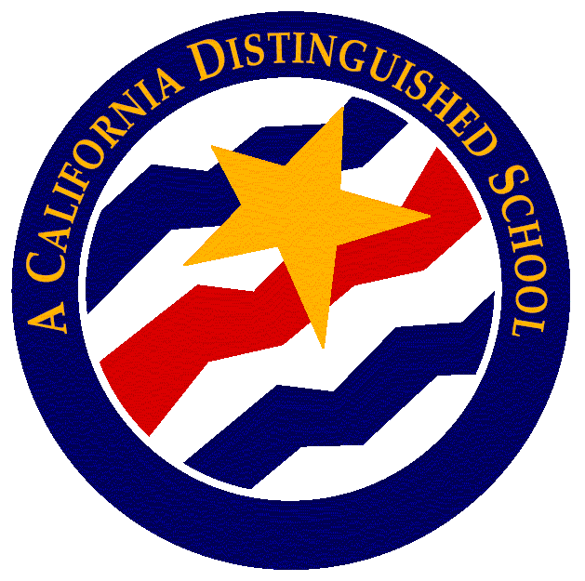
El Diamante High School
A California Distinguished School & Home of the Miners!
Daily Bulletin

Friday – December 4, 2017

CAMPUS INFORMATION

Student Attendance - If you need to call Attendance to clear an absence or have your student released for an appointment, please call your Attendance person directly using the information below:

All 12th Grade Students | Grades 9-11  Last Names A-K | Grades 9-11  Last Names L-Z
Mrs. Gomez  735-3516 | Mrs. Stack  735-3501 | Mrs. Gates  735-3517

- Miner Emporium: Come by the Miner Emporium (student store) and check out the new gear. We have beanies, bucket hats, hoodies and t-shirts with our new logo. Get them while supplies last.

- The Marines will be on campus on Mondays in the quad area, the Army will be on campus on Tuesdays in front of the Career Center, the Navy will be on campus on Wednesdays in front of the Career Center.

STUDENT NOTES

- 1st SEMESTER FINALS will be on Wednesday December 13th; Thursday December 14th and Friday December 15th. WINTER BREAK BEGINS ON MONDAY DECEMBER 18thAND RETURN ON MONDAY JANUARY 8th.
- Finals Schedule:
- Monday 12/11: Regular Schedule
- Tuesday 12/12: All Periods Schedule (1-6)
- Wednesday 12/13: Finals 1st and 3rd
- Thursday 12/14: Finals 5th and 6th
- Friday 12/15: Finals 2nd and 4th

Finals Schedule
1st Sem: 12/13-12/15
Pre-First* | 7:14-8:09 | 55 min.
Period 1/5/2 | 8:15-10:20 | 125 min.
Passing | 10:20-10:30 | 10 min.
Period 3/6/4 | 10:30-12:35 | 125 min.
Total Minutes |  | 250
*1st Sem. 12/14 & 15; 2nd Sem. 5/31 & 6/1

- NO SCHOOL MONDAY, DECEMBER 18- JANUARY 5. Have a great Winter Break. Classes resume on Monday, January 8, 2018.

- Beanies are allowed during the colder months from November 1st to March 1st and must be of a solid color with no logo or lettering however may contain the school logo. All approved headgear must not cover the face and shall be worn as intended to provide protection outdoors only and may not be worn indoors. The school or district is not responsible for lost, stolen, or damaged headgear.
- Boys Golf try-outs- All those interested in trying out for boys golf there will be a meeting at lunch on Dec. 6th in room 368. Bring your lunch. All current girl players are invited to discuss a joint fund raiser opportunity for the golf programs.

- Tis' the season for many joyous things but unfortunately pet abandonment is also on the rise during the harsh winter months. Animal Charity Club is having a food drive for pets to support our local SPCA during this influx. Donations may be sent to room 605 by Dec 6th. They will take those opened yet rejected packages, as long as they are bagged or taped.

- Happy Holidays to all. CSF is sending holiday grams to spread the holiday cheer. For a donation of $1 to our scholarship fund, you can send a cheerful gram to a special someone. See us in the Quad at lunchtime. Don't be a Grinch this Holiday Season. Send JOY!

- On December 12, we will be celebrating the end of the semester with an Ugly Holiday Sweater Day. We will have music and games at lunch with prizes for the Ugliest, Most Creative and Best Overall Holiday Theme. You will even get a chance to enter the name of the staff member that has the Ugliest Sweater as well. Must be present to win.

COLLEGE/UNIVERSITY VISITS

Juniors & Seniors
Sign-ups are available in the Student Services Office

SENIOR NOTES

- Cap & Gowns: Seniors if you missed your opportunity to place your orders, you have 3 options to ensure you order in time for graduation.
1) Online at Jostens.com
2) Calling 1-800-JOSTENS
3) Mailing to or dropping off at our local Visalia office – 1222 W Murray Ave Visalia CA 93291

- Scholarship Workshop: Seniors—Ms. Bitney is hosting an ongoing scholarship workshop on Mondays and Wednesdays after school in room 605 from 3:30 to 4:30. This is a great resource for assistance and information about scholarships, so make sure to go by and see her.
- College Application Workshops: Seniors and parents! See the attached list of College Application Workshops as well as other helpful workshops and informational meetings that will be held at El Diamante and the District Office throughout the year. We will advertise events at El Diamante individually as they come up.

- Seniors: Transcript request forms are available in the Student Services Office. If you need an official transcript, please fill this out and allow 2-4 days for Mrs. Davis to process your requests.

SEE ATTACHMENT FOR ALL SCHOLARSHIP INFORMATION

CLUB NOTES

- Sign Language Club: Meetings every Tuesday in Room 365. Bring your lunch.
- Fashion Club: meeting in room 607 today Dec 4th at 12:50.

SPORTS

Week of December 4 – December 9

Sport | Levels | Day | Date | Opponent/Destination | Out of Class | Bus Leaves | Game Time | Return
Girls Soccer | ALL | Tues | 12/5 | Monache | n/a | n/a | 4:30 JV  6:00 V | n/a
Girls Basketball | ALL | Tues | 12/5 | Porterville @ Home | n/a | n/a | 4:30pm Frosh  6:00 JV  7:30 V | n/a
Boys Basketball | All | Tues. | 12/5 | Porterville @ Porterville | 1:45pm | 2:15pm | 4:30pm Frosh  6:00 JV  7:30 V | 11:00pm
Boys Basketball | JV | Wed. | 12/6 | CVC Tournament | n/a | n/a | 5:45 (Mission Oak) | n/a
Wrestling | All | Wed. | 12/6 | Tulare Union @ Tulare | 2:30pm | 3:00pm | 5:00pm | 10:00pm
Boys Soccer | All | Wed. | 12/6 | Monache @ Monache (JV)  Granite for Varsity | 2:00pm | 2:30pm | 4:30 JV  6:30 V | 11:00PM
Boys Basketball | All | Thur. | 12/7 | Tulare Union @ Tulare Union | n/a | n/a | 4:30pm Frosh  6:00 JV  7:30 V | n/a
Girls Basketball | JV | Thur. | 12/7 | Corcoran @ TW tournament | 3:00PM | 3:30PM | 5:30PM | 8:00PM
Boys Basketball | JV | Fri. | 12/8 | CVC Tournament | 1:15pm | 1:45pm | 3:15PM | Drop off
Boys Soccer | V | Fri. | 12/8 | Lemoore Tournament | 8:30AM | 9:00am | 11:00 (Sierra Pacific)  1:45 TBA | 6:00pm
Girls Soccer | V | Fri. | 12/8 | Hoover Tournament | All Day | 7:45am | 9:50 (Central)  12:30 (Sierra Pacific) | 3:30pm
Girls Basketball | JV | Fri. | 12/8 | TW tournament | TBA | TBA | TBA | TBA
Wrestling | JV | Fri. | 12/8 | Madera Tournament | TBA | TBA | TBA | TBA
Boys Soccer | V | Sat. | 12/9 | Lemoore Tournament | TBA | TBA | TBA | TBA
Girls Soccer | V | Sat. | 12/9 | Hoover Tournament | TBA | TBA | TBA | TBA
Girls Basketball | JV | Sat. | 12/9 | TW tournament | TBA | TBA | TBA | TBA
Wrestling | V | Sat. | 12/9 | Madera Tournament | TBA | TBA | TBA | TBA

PARENT NOTES

- Attention Parents: To purchase Miner Swag please visit the EDHS Fan store on the EDHS Website.
http://vusd.org/ElDiamante
- Like Burritos? CSF is having a Chipotle fundraiser on Wednesday December 6th from 4-8 pm. 50% of proceeds sold during that time will go toward our scholarship fund. So take the night off from cooking and treat the family with some delicious food. Just mention EDHS CSF when you checkout. Thank you for your support.
- Attention Parents of Advanced Placement (AP) Students: All AP exams will be available for purchase beginning December 1, 2017. The cost of each AP exam offered through college-board is $94. You may purchase the exams either in the Finance Office on campus OR on the EDHS web-store online. All test purchases must be made no later than February 15, 2018. No deposit is required, but exams must be paid in full by February 15th for El Diamante to order your exam from CollegeBoard. If your student is taking multiple exams you can purchase one exam at a time to help break up the payments. (If your student currently qualifies for free OR reduced lunch they can inquire about a reduced test price in the Student Services Office). Any student who does not purchase their exams IN FULL by February 15th will not have an exam ordered due to ordering deadlines and procedures implemented by the Collegeboard.

To subscribe or unsubscribe to the bulletin http://mailman.visalia.k12.ca.us/mailman/listinfo/edhs-bulletin

