**Health Sciences Business and Finance Computer Science**

**Animal Science Education Arts**

**Law and Justice Transportation Agriculture**

**Culinary Engineering**

**Career Industry Panel Session**

**\*Prior to the event there will be the A&W ice cream float truck & a taco truck  
 on campus to purchase dinner\***

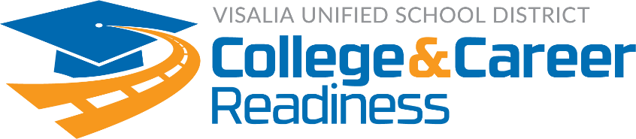

As parents and guardians, you often have conversations with your children about how they are doing in school! How often do you have conversations about potential careers?

We are inviting you to attend with your child and ignite their curiosity! Join industry professionals for conversations about their professions, training needed, and education requirements.

The evening will begin in the Redwood Cafeteria with introductions, followed by multiple career industry panel sessions of your choice. The panels will consist of 3-4 professionals in each career listed below.

**After the conclusion of the career industry panels, join us in the cafeteria for a drawing for prizes, including tickets to Six Flags Magic Mountain! Prize drawing tickets will only be given at 6:00 p.m. You must be present to win.**

For questions, please call Paige Loverin or Jolene Martin at 730-7449

**Don’t miss this opportunity to**

**IGNITE your CURIOSITY!**

**Audience: 5th-12th grade students & their parents/guardians**

**Location: Redwood High School Cafeteria**

**Date: Monday, October 15, 2018**

**Time: 6:00-8:00 p.m.**