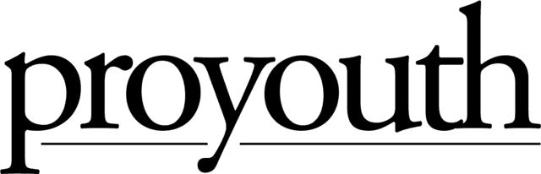
ProYouth

Education & Enrichment Platforms

Acknowledgement and Consent

Education & Enrichment Platforms – Acknowledgement and Consent

Dear Parents and Guardians:

As a result of the Coronavirus (COVID-19), ProYouth is providing educational and enrichment opportunities to aid your student with ongoing access to learning. This form identifies educational and enrichment opportunities, or platforms ProYouth may use, and asks for you to sign and return the attached form for your student to participate in these opportunities.

Our academic and enrichment programs may require instruction in which the student and instructor are in different locations. This may include but is not limited to video or audio instruction in which the primary mode of communication between the student and instructor is online interaction, instructional television, video, tele- courses or conferences, or other instruction that relies on computer, virtual or communications technologies. It may also include the use of print materials incorporating activities that are the subject of written or oral feedback. The aim of our programs is to allow educators and providers, in collaboration with ProYouth and the respective school district, to provide ongoing and high-quality educational and enrichment opportunities.

ProYouth will be utilizing the following platform to support your student during this period:

- Zoom by Zoom Video Communications, Inc.- https://zoom.us/terms

The use of technology for the provision of educational and enrichment opportunities may result in the creation of pupil records not in ProYouth’s control, as well as student-generated content, and may result in the unintended revelation of personally identifiable student information beyond ProYouth’s control. ProYouth acknowledges that many technology platforms maintain data shared on their platforms and want to provide you notice of the same. ProYouth will attempt to work with the technology companies utilized in the provision of educational and enrichment opportunities to ensure the privacy of students is maintained consistent with all relevant federal and state laws, including the Federal Educational Rights and Privacy Act (FERPA). ProYouth expects these companies will act consistently with common standards of student privacy used when providing educational services. Additionally, ProYouth will make efforts to ensure the collection and use of any student data is limited to educational purposes only and seek to prevent the unauthorized release of student information or use of student data for marketing purposes.

DISTANCE LEARNING – ACKNOWLEDGEMENT AND CONSENT
I understand and acknowledge:

  - My child has the right to confidentiality as it pertains to educational and enrichment opportunities.

ProYouth
Distance Learning Platforms- Acknowledgement and Consent- CONTINUED

  - I understand, by law, there are exceptions to confidentiality, including mandated reporting of child, elder, and dependent adult abuse as well as safety concerns related to danger to self and danger to others. I understand my provider may have to break confidentiality under these circumstances.

  - My teacher and/or service provider will conduct educationally related instruction in a confidential setting.

  - My child will remain in a confidential setting during receipt of educational and enrichment opportunities to the extent possible, and within ProYouth’s control.

  - I further understand it is illegal to record any instruction or educational session without the prior written consent of the principal and teacher/service provider and ProYouth.

  - Telephone/audio/video transmission will not be retained by ProYouth in any medium.

  - I have the right to discuss any of this information with the teacher/service provider, principal and/or ProYouth and to ask questions I may have.

  - I acknowledge and reaffirm my agreement under both the school district and ProYouth’s Policies, Acceptable Use Policy, and the District’s rights to monitor, regulate bullying, and sets expectations for good behavior while using this platform.

  - I can withdraw my consent to this form at any time by providing written notice to ProYouth

  - I have read and understand the information provided in this correspondence.

My signature below indicates I have read this consent form, understand, and agree to ProYouth’s program guidelines, use of technology, including online, virtual and communications platforms to provide high quality educational and enrichment opportunities to my child.

Student Name (Please print) Grade:

ID Number:

School:

Parent Signature: Date:

