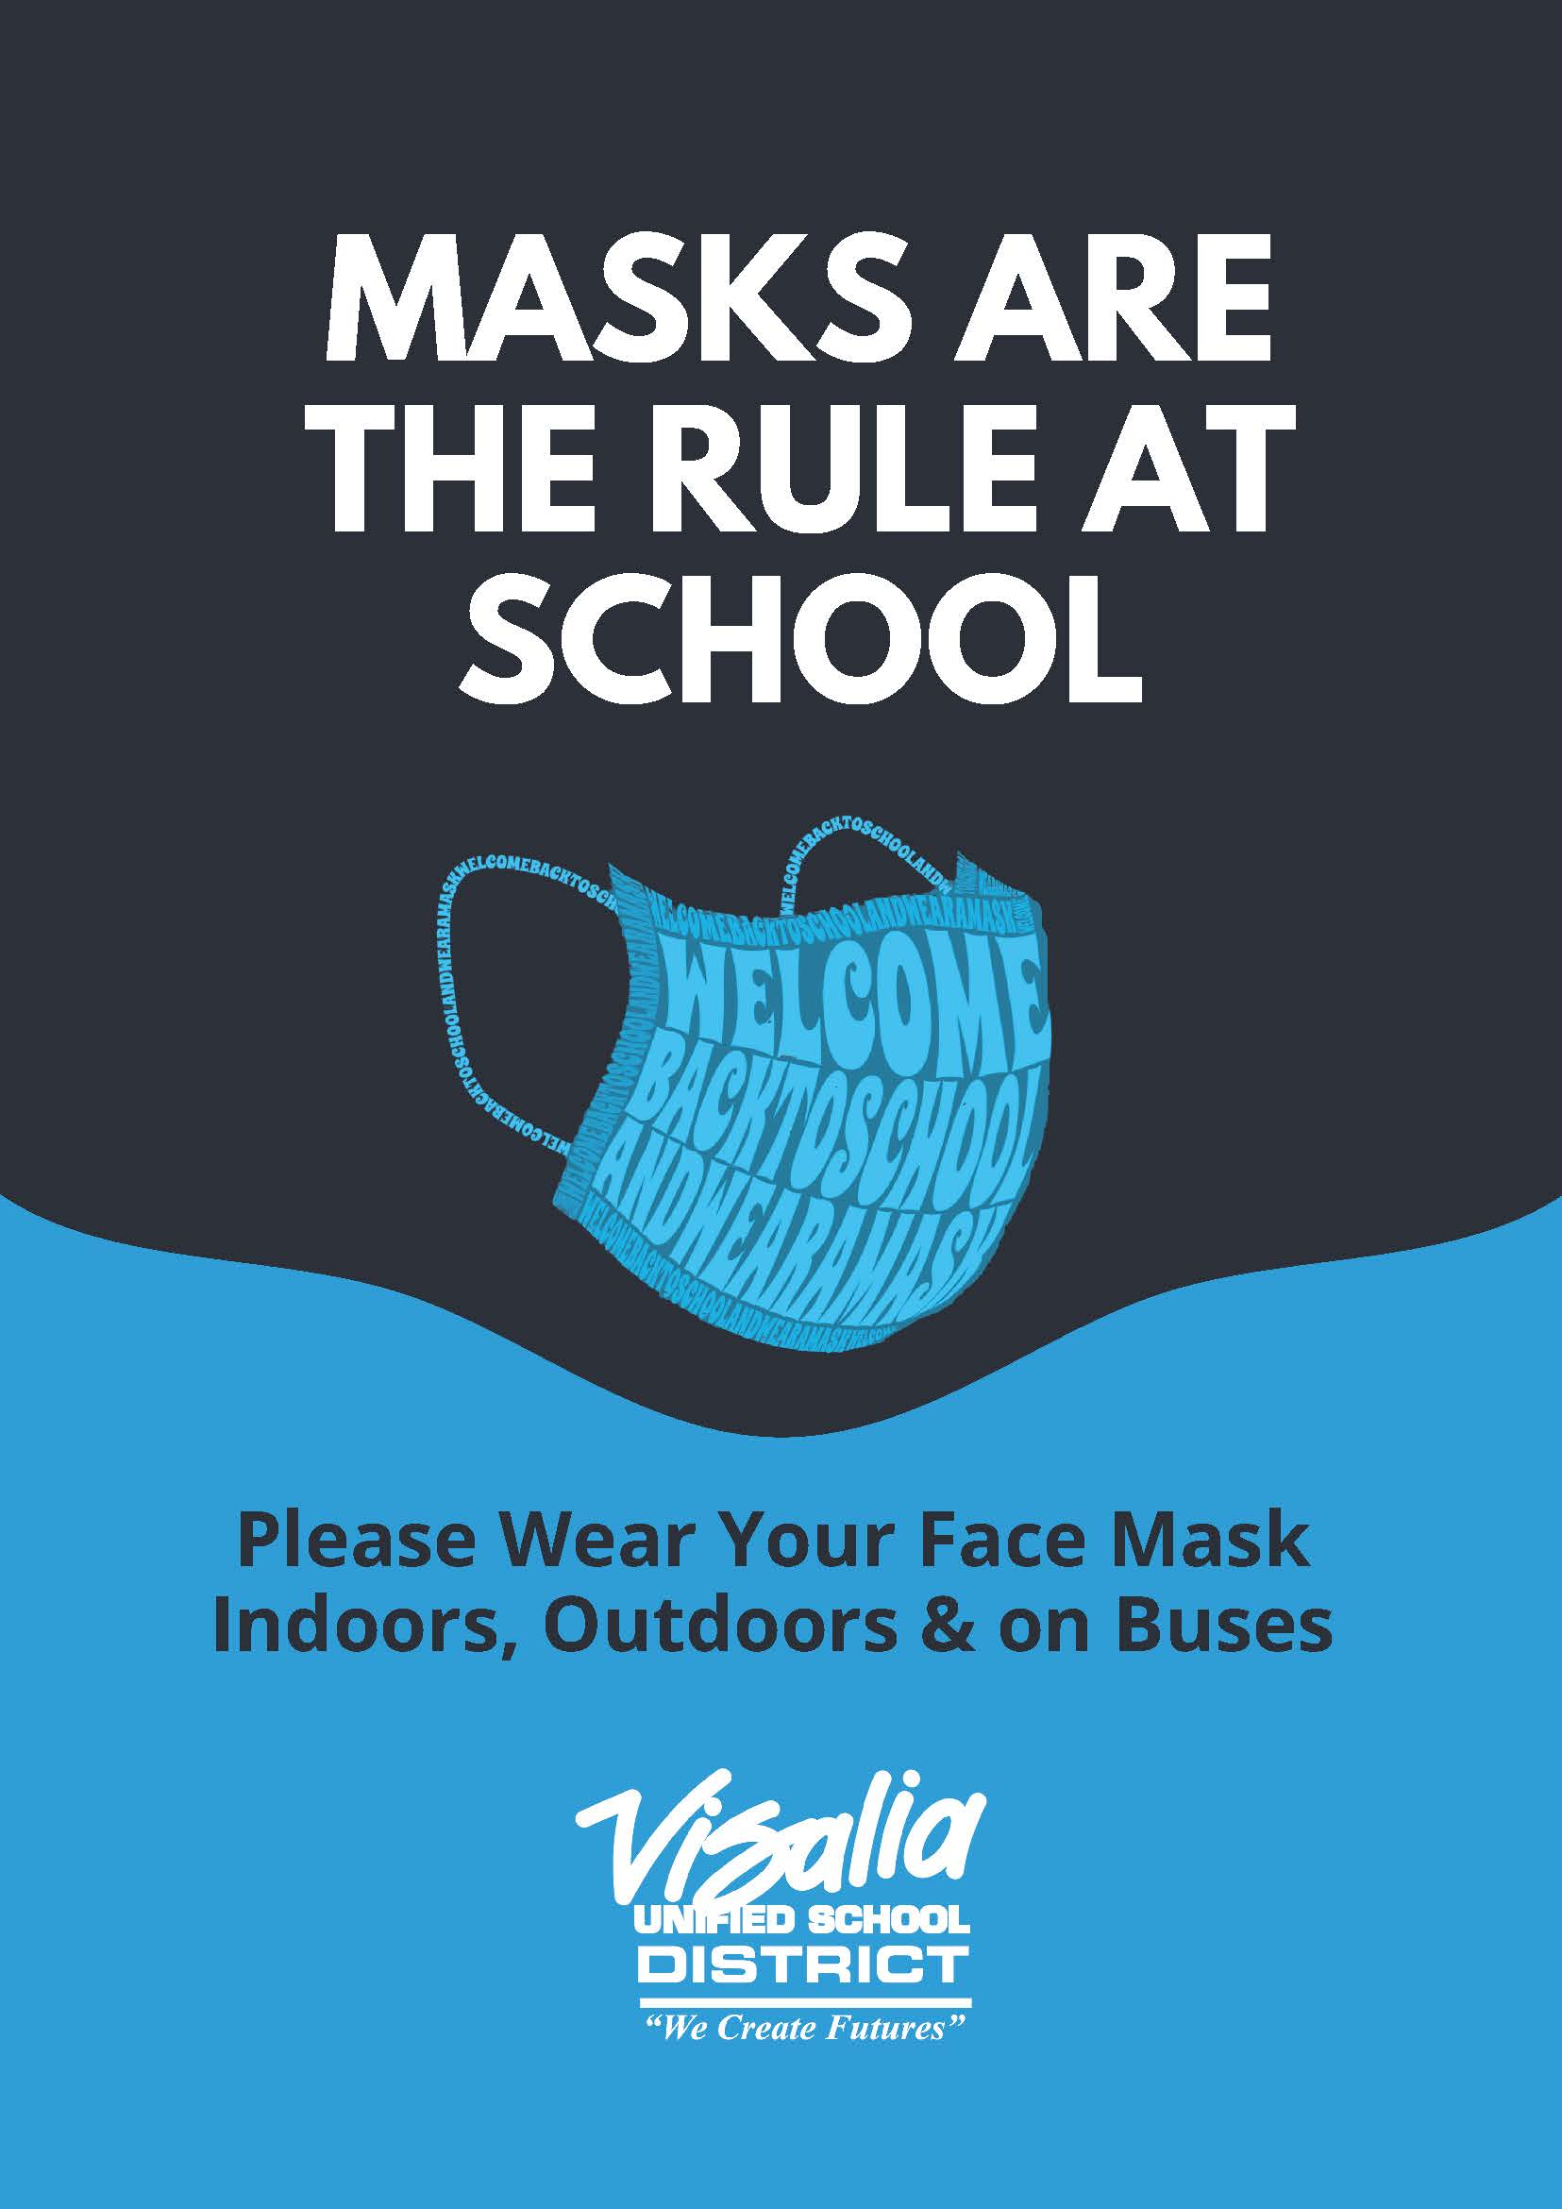
Thursday, August 19th, 2021
Today is a regular bell schedule

Good morning Explorers, let’s remember to have La Joya PRIDE in everything we do!

STUDENT ANNOUNCEMENTS

Tomorrow is our school wide picture day! Student Pictures will be taken during PE classes in the Gymnasium. Make sure to wear your best smile.

P. E. Clothes

PE clothes will be available for purchase Monday and Tuesday of next week only. Please see your PE teacher during class time. P.E. clothes will not be available for purchase today or tomorrow.

Shirt only 15.00
Shorts only 15.00
Shirt and short set 25.00
Sweat pants 25.00
Sweat shirt 25.00

Campus PRIDE

At La Joya, we are very proud of our campus. Please make sure that any trash goes into the trash cans, and walk only on the cement. Our amazing groundskeeper works very hard, so let’s show respect and La Joya PRIDE by staying off of the grass.

Safety

Remember to walk your bike off campus and do not ride your bike on the sidewalk, or into traffic, your safety is important. Please remember to only use the crosswalks when crossing the street, and make sure that you look both ways before crossing. If there is a crossing guard, wait until you are told to cross.

PRIDE Store

Looking for student volunteers to help with the PRIDE store on Tuesday and Thursday mornings before school. You'll receive a treat or points for your help. Please talk to Ms. Rodriguez in RM 401 if you are interested.

Come Prepared!

Please bring water and your Chromebook with charger each day!

Deliveries

We are unable to accept deliveries for students. Please make sure they have what they need when they come to school. Apologies for any inconvenience.

Parking at La Joya

Parents, please use the designated parking spaces at La Joya, and do not park in the unloading or fire zones. Thank you.

Dress Code Reminder

The Visalia Unified School District Student Conduct Code for grades 7-12 reads as follows: Clothes shall be worn as intended and be sufficient to conceal undergarments which shall be worn and covered at all times. See-through or fish-net fabrics, halter tops, tube tops, off-the shoulder and low-cut tops are not acceptable. Other types of dress that expose bare midriffs (stomachs) or cleavage are prohibited. Basketball jersey style tank tops with scooped front, back and armholes are only allowed if worn with a T-shirt with sleeves. Cell phones must be turned off and out of sight.

Cafeteria News

Our snack bar windows will be closed for the first few weeks of school.

If you are interested in being a cafeteria worker for 1st or 2nd lunch, please stop by the cafeteria to see Ms. McLeroy before school or at break.

Sports Announcements

If you’re interested in participating in sports this year, please complete your Family ID registration and your COVID Waiver Release Form. Both forms can be found on our School Website or picked up in the front office.

If you have any questions, please see Mr. Souza.

Football, Volleyball, and Cross Country try-outs will begin on Monday, August 23rd. All paperwork must be completed before trying out. Sign-up sheets can be found inside both locker rooms. Please ask your PE teacher if you need help finding those forms.

Have a Great Day, Explorers! Remember to be present all day, every day, and to show your La Joya PRIDE!

