mwlogo2.jpg.bmpMt. Whitney High Schoolmwlogo2.jpg.bmp

***A California Distinguished School & Home of the Pioneers!***

*Go Pioneers!*

March 13, 2018

Daily Bulletin

cid:image001.jpg@01D0F789.9EFA7A20**Tuesday – March 13, 2018** cid:image001.jpg@01D0F789.9EFA7A20

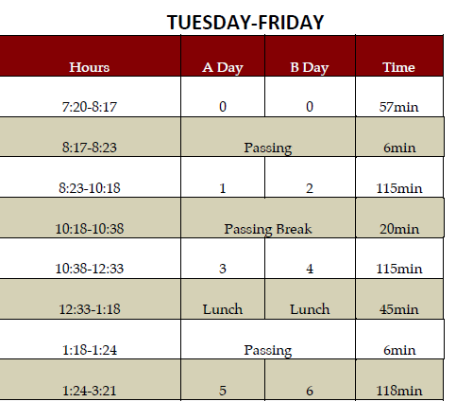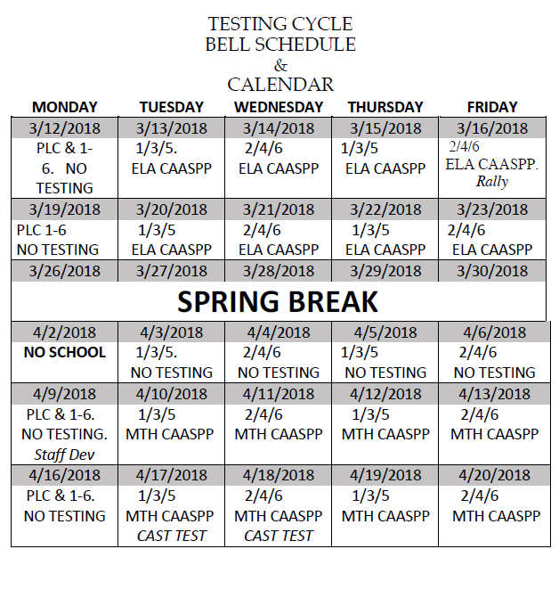

whatsupblue.jpgStudent Noteswhatsupblue.jpg

***1. Do you want to get into Home Games for Free?*** *And get major discounts on dance tickets? Buy an ASB sticker for $30 and save money. ASB stickers are now being sold in the Finance office. They will be sold all year long.*

***2****.* ***Attention Mt. Whitney Students****!! The* ***XL program offers*** *a free snack and a variety of clubs. There is* ***tutoring, Skills Club, Mock Trial, 3D-Printing, Weightlifting, Outdoors Club, Ag Science, Activities Club, Media Arts, Brazilian Jui-Jutsu, and Leadership Club****. To find out more about these clubs come to* ***Rm. S11!!***

*3. Step-Up is collecting donation items for cancer patients. We are accepting donations such as beanies, socks, stuffed animals, and monetary funds. The collection will run from January 9th-April 19th. We will have a donation bin set up in the front office, Room B-204, and a collection table in the quad on Thursdays during lunch. Please come by room B-204 for additional questions or information.*

4. Come watch a free movie every Friday night with your XL. Movies start @ 4pm, in room B-25, every Friday. There will be free food. Bring your friends and your family! Parents and siblings welcome too! Want more info? Come to room S-11

**5. Attention Senior & Junior girls and boys**, the Enchanted Evening Dress Give-Away and Tuxedo Rental is March 17th, 2018. You must sign up with Mrs. Cantu in the counseling office by March 15th! There will be no late sign ups.

6. **Mr. Pioneer Dress Up Days for March 12th – March 16th**:

Monday: Movie Monday

Tuesday: Tropical Tuesday

Wednesday: “It’s Wednesday My Dudes” (Meme Day)

Thursday: Time for College Day (Rep your favorite/future college)

Friday: Prideful Pioneers

7. **SEED – Students Empowered by Exposure to Diversity – ProYouth XL** would like to extend an invitation to all students interested in the film industry to join us at **COS Ponderosa Lecture Hall on March 15th at 4:00pm**. Visit your XL Office after school to pick up a permission slip and turned in by March 14. Transportation from our site to COS is provided by XL. **Met**~**&**~**Greet Actor and Producer** “**Del Zamora.**”

8. Students: Next week juniors will begin taking the state tests in English and Math and seniors will test in Science after Spring Break. These are very important tests, so get lots of rest and nutrition and put your best foot forward!

9. **Attention Students**:  The **College and Career EXPO will be on April 6, 2018 @ 8:30-2:00pm. The Expo** provides students the opportunity to compete in college and career oriented competitions, spend some time on a college campus, and be recognized for achievements in their chosen field of study. College and Career Expo builds upon the momentum that students and schools are creating in college and career awareness, exploration and preparation. The event is open to all students in academies or pathways and is also a unique opportunity to encourage the business community to support local schools and encourage students to consider their futures.

10. Hey Mt. Whitney!  The MW dancers would love for you to come see our annual dance show at LJ Williams Theater next Thursday, March 22 and Friday, March 23.  We will be selling $10 tickets in the quad next week during lunch.  Hope you can come cheer on your favorite dancer!

*MC900014728[1]Sports MC900014728[1]*

***SPORTS BULLETIN***

*MC900446010[1]*

*Club Notes*

1. Link Leaders! See’s Candy Fundraiser forms are in. Come pick up yours in K7 to raise some money for new Link Crew shirts!
2. Sophomores and Juniors, would you like to join Link Crew next year and help Freshmen and new students become part of Mt. Whitney? Link Crew Applications are now available in K7 and the attendance office. Applications are due to Mrs. Bolden in K7 by April 20th.
3. All band and guard members are to meet in the band room to discuss fundraisers and other things.

**Mt. Whitney- Remember to show your Pioneer PRIDE- Positivity, Respect, Integrity, Determination, and Engagement!**

***graduation-cap[1]* Senior Notes *graduation-cap[1]***

***MC900056794[1]College Visit Sign-ups MC900056794[1]***

*None at this time*

College-Money.jpgSenior Scholarships College-Money.jpg

**Cabrillo Civic Clubs of California**

**Deadline:  March 15, 2018 (POSTMARKED) after March 15th will be disqualified**

**Amount:**  $500

**Criteria:**  Portuguese descent, 3.50 GPA, participated in 3 extracurricular activities.

**Application Process:**Accepting scholarship applications from high school seniors. Submit the [application](http://www.cabrillocivicclubs.org/Scholarship/2016%20Master%20Application%20Form.pdf) along with a transcript and three letters of recommendation.  For more information please pick up an application in the counseling office with Ms. Herrera

**Italian Catholic Federation ​**

**Deadline: March 15, 2018**

**Amount:**  Varies​

**Criteria:**  High school senior, minimum GPA of 3.2, and is either a Roman Catholic and of Italian descent or have a parent, grandparent or guardian is a member of the Italian Catholic Federation, and student is Roman Catholic (but need not be of Italian descent)

**Application Process:**  For application and more information visit :[www.icf.org](http://www.icf.org)

**Kiwanis Division 18 Scholarship**

**Deadline:** 03/15/2018 **MUST BE POSTMARKED NO LATER THAN THIS DATE**

**Amount:** $2,000 - $8,000

Two awards provided

* *Agriculture Application* – (*Must* have specific agriculture-related goals)
* *Key Club Application* – (*Must* be a Key Club member within Kiwanis Division 18)

**Criteria:** GPA of 2.5, Community involvement, extracurricular activities,

**Application Process:** Complete application and mail in - must be postmarked by 3/15/18. Click here for [application](https://drive.google.com/open?id=1Mefp5f4bb9F0d65bODPwqU0wwHtheB0M).

**2018 CAWGF Scholarship**

**Deadline:** 03/16/2017

**Amount:** $2,000 - $8,000

**Criteria:**

* Must be a high school senior graduating in 2018
* Plan to attend UC, CSU, or community college in the fall of 2018
* Have a parent or legal guardian employed by a California Vineyard during the 2017-2018 winegrape growing season

**Application Process:** Application packet must include: 1. Complete Application 2. Official transcript, copy of ACT or ACT if applying for a 4 year, letter of recommendation, essay (500 words). Applications must be postmarked no later than march 24, 2017. Send application packets to: **CAWG Foundation** 1121 L Street, Suite 304, Sacramento, CA 95814

**Link:** [**http://cawgfoundation.org/wp-content/uploads/2017/10/CWGGF_APPLICATION_ENG-2018-v1.pdf**](http://cawgfoundation.org/wp-content/uploads/2017/10/CWGGF_APPLICATION_ENG-2018-v1.pdf)

**Tulare County League of Mexican-American Women Scholarship**

**Deadline**: 03/31/18 (**POSTMARKED**)

**Amount**: TBA

**Criteria**: Applicant must plan to attend a college or university in the fall of 2018, have a cumulative GPA of 2.5 or higher and demonstrate financial need.

**Application Process:**Complete application packet: application, financial data & family background form, student autobiography, two scholarship recommendation forms; major must be on [approved list](https://drive.google.com/file/d/0B0jffohvfXxbbW1OS3I1WExnOFE/view?usp=sharing). Include official transcripts and courses currently in progress. Applications must be typed. Must be postmarked by deadline date. Send to: Attn: TCLMAW Scholarship Chairperson PO Box 4453 Visalia, CA 93278

*Applications available in the Counseling Office.*

**Pioneer Aquatics Booster Club**

**Deadline:** 3/30/2018

**Amount:** Up to 4 $250

1.      Member of swim or water polo for 4 semesters

2.      Be a member PABC

3.      Going to a trade school, junior college or university

4.      Students must submit an essay describing how being involved in Pioneer Aquatics has benefited them.

**Application Process**: Applicants must email essays to [christebyerlee@gmail.com](mailto:christebyerlee@gmail.com) by March 30th .

**To unsubscribe or subscribe to the Daily Bulletin:**

<http://mailman.visalia.k12.ca.us/mailman/listinfo/mwhs-bulletin>

Have questions regarding the bulletin? Contact:

**Veronica Reyes, MWHS**

[**vreyes@vusd.org**](mailto:vreyes@vusd.org)