mwlogo2.jpg.bmpMt. Whitney High Schoolmwlogo2.jpg.bmp

***A California Distinguished School & Home of the Pioneers!***

*Go Pioneers!*

March 20, 2018

Daily Bulletin

cid:image001.jpg@01D0F789.9EFA7A20**Tuesday – March 20, 2018** cid:image001.jpg@01D0F789.9EFA7A20

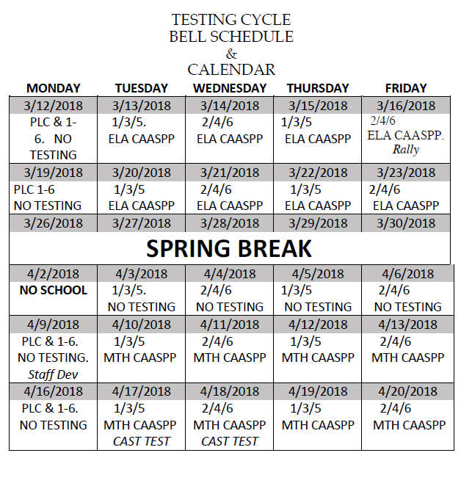

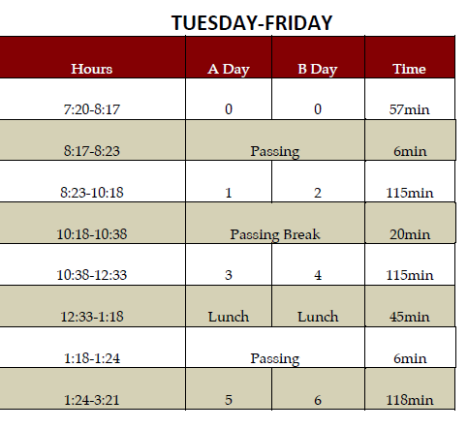

whatsupblue.jpgStudent Noteswhatsupblue.jpg

***1. Do you want to get into Home Games for Free?*** *And get major discounts on dance tickets? Buy an ASB sticker for $30 and save money. ASB stickers are now being sold in the Finance office. They will be sold all year long.*

***2****.* ***Attention Mt. Whitney Students****!! The* ***XL program offers*** *a free snack and a variety of clubs. There is* ***tutoring, Skills Club, Mock Trial, 3D-Printing, Weightlifting, Outdoors Club, Ag Science, Activities Club, Media Arts, Brazilian Jui-Jutsu, and Leadership Club****. To find out more about these clubs come to* ***Rm. S11!!***

*3. Step-Up is collecting donation items for cancer patients. We are accepting donations such as beanies, socks, stuffed animals, and monetary funds. The collection will run from January 9th-April 19th. We will have a donation bin set up in the front office, Room B-204, and a collection table in the quad on Thursdays during lunch. Please come by room B-204 for additional questions or information.*

4. Come watch a free movie every Friday night with your XL. Movies start @ 4pm, in room B-25, every Friday. There will be free food. Bring your friends and your family! Parents and siblings welcome too! Want more info? Come to room S-11

5. Students: Juniors will begin taking the state tests in English and Math and seniors will test in Science after Spring Break. These are very important tests, so get lots of rest and nutrition and put your best foot forward!

6. **Attention Students**:  The **College and Career EXPO will be on April 6, 2018 @ 8:30-2:00pm. The Expo** provides students the opportunity to compete in college and career oriented competitions, spend some time on a college campus, and be recognized for achievements in their chosen field of study. College and Career Expo builds upon the momentum that students and schools are creating in college and career awareness, exploration and preparation. The event is open to all students in academies or pathways and is also a unique opportunity to encourage the business community to support local schools and encourage students to consider their futures.

7. Hey Mt. Whitney!  The MW dancers would love for you to come see our annual dance show at LJ Williams Theater next Thursday, March 22 and Friday, March 23.  We will be selling $10 tickets in the quad next week during lunch.  Hope you can come cheer on your favorite dancer!

8. Students, check your school email for a link to a Google Form to nominate a Mt. Whitney Staff member who has shown Pioneer PRIDE during the month of March.

9. Come join the video club EVERY Thursday after school. Come learn about videography, editing, photography, and graphic design in ROOM B-204.

*MC900014728[1]Sports MC900014728[1]*

***SPORTS BULLETIN***

*MC900446010[1]*

*Club Notes*

1. Sophomores and Juniors, would you like to join Link Crew next year and help Freshmen and new students become part of Mt. Whitney? Link Crew Applications are now available in K7 and the attendance office. Applications are due to Mrs. Bolden in K7 by April 20th.

***graduation-cap[1]* Senior Notes *graduation-cap[1]***

1. **Attention Seniors**- Josten’s Delivery and Pick up will be TODAY, Tuesday from 11:15-12:30pm in the Gym. You will be release to report to the gym.

**Mt. Whitney- Remember to show your Pioneer PRIDE- Positivity, Respect, Integrity, Determination, and Engagement!**

***MC900056794[1]College Visit Sign-ups MC900056794[1]***

*None at this time*

College-Money.jpgSenior Scholarships College-Money.jpg

**Sun Pacific #1**

**Deadline:  March 23, 2018 (postmark date)**

**Amount:**  $20,000

**Criteria:**  Children of full-time employees working for Sun Pacific are eligible to apply. This scholarship amount is for students planning to ***pursue a bachelor’s degree***.  Recipients will be selected on the basis of scholastic achievement, extracurricular activities, community activities, leadership, personal interview and financial need.

**Application Process:** [Click Here!](https://drive.google.com/file/d/1iMZYxSEdhC-BnEqbkS_uVIO30AESIfkm/view?usp=sharing)

**Sun Pacific #2**

**Deadline:  March 23, 2018 (postmark date)**

**Amount:**  $3,000

**Criteria:**  Children of full-time employees working for Sun Pacific are eligible to apply. This scholarship amount is for students ***planning to attend an accredited trade school or community college***.  Recipients will be selected on the basis of scholastic achievement, extracurricular activities, community activities, leadership, personal interview and financial need.

**Application Process:**  [Click Here!](https://drive.google.com/file/d/1iMZYxSEdhC-BnEqbkS_uVIO30AESIfkm/view?usp=sharing)

**Tulare County League of Mexican-American Women Scholarship**

**Deadline**: 03/31/18 (**POSTMARKED**)

**Amount**: TBA

**Criteria**: Applicant must plan to attend a college or university in the fall of 2018, have a cumulative GPA of 2.5 or higher and demonstrate financial need.

**Application Process:**Complete application packet: application, financial data & family background form, student autobiography, two scholarship recommendation forms; major must be on [approved list](https://drive.google.com/file/d/0B0jffohvfXxbbW1OS3I1WExnOFE/view?usp=sharing). Include official transcripts and courses currently in progress. Applications must be typed. Must be postmarked by deadline date. Send to: Attn: TCLMAW Scholarship Chairperson PO Box 4453 Visalia, CA 93278

*Applications available in the Counseling Office.*

**Family Healthcare Network Anita de la Vega Scholarship**

**Deadline:  March 30, 2018 (No later than 5:00 pm)**

**Amount:**  $600

**Criteria:**  Female preferred, senior in Tulare County, 2.5 GPA or better, migrant or seasonal farm working family or background, community service involvement, pursuing a degree in health or community health

**Application Process:** Click [here](https://drive.google.com/file/d/0B0jffohvfXxbV1BwLXJod3dUZDA/view?usp=sharing) for the application or pick up a copy in the counseling office

**Link**: <http://www.fhcn.org/about/scholarship-fund/>

**Pioneer Aquatics Booster Club**

**Deadline:** 3/30/2018

**Amount:** Up to 4 $250

1.      Member of swim or water polo for 4 semesters

2.      Be a member PABC

3.      Going to a trade school, junior college or university

4.      Students must submit an essay describing how being involved in Pioneer Aquatics has benefited them.

**Application Process**: Applicants must email essays to [christebyerlee@gmail.com](mailto:christebyerlee@gmail.com) by March 30th .

**To unsubscribe or subscribe to the Daily Bulletin:**

<http://mailman.visalia.k12.ca.us/mailman/listinfo/mwhs-bulletin>

Have questions regarding the bulletin? Contact:

**Veronica Reyes, MWHS**

[**vreyes@vusd.org**](mailto:vreyes@vusd.org)