mwlogo2.jpg.bmpMt. Whitney High Schoolmwlogo2.jpg.bmp

***A California Distinguished School & Home of the Pioneers!***

*Go Pioneers!*

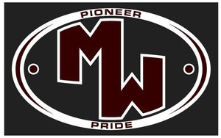April 9, 2018

Daily Bulletin

cid:image001.jpg@01D0F789.9EFA7A20**Monday – April 9, 2018** cid:image001.jpg@01D0F789.9EFA7A20

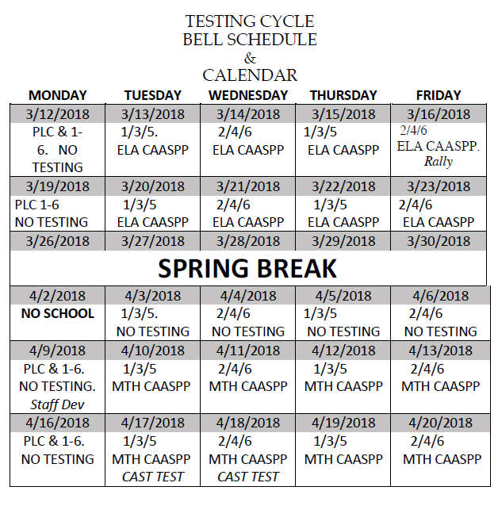 **Monday (Staff Development Day) Schedule-04/09/18**

|  |  |  |  |
| --- | --- | --- | --- |
| Period 0 | 7:18 | - 7:54 | 36 minutes |
| **Collaboration** | **8:00** | **- 9:00** | **60 minutes** |
| Period 1 | 9:06 | - 9:42 | 36 minutes |
| Period 2 | 9:48 | - 10:28 | 40 minutes |
| Period 3 | 10:34 | - 11:10 | 36 minutes |
| Period 4 | 11:16 | - 11:52 | 36 minutes |
| Lunch | 11:52 | - 12:32 | 40 minutes |
| Period 5 | 12:38 | - 1:14 | 36 minutes |
| Period 6 | 1:20 | - 1:56 | 36 minutes |

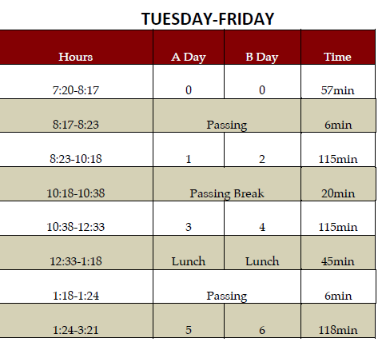

whatsupblue.jpgStudent Noteswhatsupblue.jpg

***1. Do you want to get into Home Games for Free?*** *And get major discounts on dance tickets? Buy an ASB sticker for $30 and save money. ASB stickers are now being sold in the Finance office. They will be sold all year long.*

***2****.* ***Attention Mt. Whitney Students****!! The* ***XL program offers*** *a free snack and a variety of clubs. There is* ***tutoring, Skills Club, Mock Trial, 3D-Printing, Weightlifting, Outdoors Club, Ag Science, Activities Club, Media Arts, Brazilian Jui-Jutsu, and Leadership Club****. To find out more about these clubs come to* ***Rm. S11!!***

*3. Step-Up is collecting donation items for cancer patients. We are accepting donations such as beanies, socks, stuffed animals, and monetary funds. The collection will run from January 9th-April 19th. We will have a donation bin set up in the front office, Room B-204, and a collection table in the quad on Thursdays during lunch. Please come by room B-204 for additional questions or information.*

4. Come watch a free movie every Friday night with your XL. Movies start @ 4pm, in room B-25, every Friday. There will be free food. Bring your friends and your family! Parents and siblings welcome too! Want more info? Come to room S-11

5. Students: Juniors will begin taking the state tests in English and Math and seniors will test in Science after Spring Break. These are very important tests, so get lots of rest and nutrition and put your best foot forward!

6. **Attention Students**:  The **College and Career EXPO will be on April 6, 2018 @ 8:30-2:00pm. The Expo** provides students the opportunity to compete in college and career oriented competitions, spend some time on a college campus, and be recognized for achievements in their chosen field of study. College and Career Expo builds upon the momentum that students and schools are creating in college and career awareness, exploration and preparation. The event is open to all students in academies or pathways and is also a unique opportunity to encourage the business community to support local schools and encourage students to consider their futures.

9. Come join the video club EVERY Thursday after school. Come learn about videography, editing, photography, and graphic design in ROOM B-204.

10. Attention staff and students! Please donate hygiene products to help the homeless in Visalia. This is a community service project organized by one of Mt. Whitney’s foreign exchange students. Support your community and help this project be successful. Boxes for donations are located in attendance, counseling, the library, K-4, K-7, and G-5.

11. **YEARBOOK SPRING SPECIAL!!**  We ordered some extra yearbooks that we can sell and once they are gone…***THERE WILL BE NO MORE!*** The normal price is $90 but for this week ONLY, come to Room B-207 before school or at lunch and save $10 and reserve your book for **only $80!** Payments must be made in ***CASH ONLY*** and this offer is NOT available online. Get yours while you still can!

12. Hey Mt. Whitney!  Would you like to be in a MWHS Dance class next school year?  If so, auditions are Wednesday, April 18.  You can learn the dance at the clinics on April 12 and 17 from 6-7:30pm.  If you would like to be in Intro to Dance, you do not need to audition.  If you’d like to skip Intro and be in Intermediate, Advanced, or Elevate, then make sure you come see Mrs. A in M-10 to pick up an audition packet.  Thank you!

13. After school from 3:30 to 4:00pm at M-4, we are selling fruit slushies for a dollar each every Tuesdays and Thursdays until May 3rd. Please come support SkillsUSA!

14. Current Sophomores and Juniors who are interested in being an Elementary Aide next school year must come in to the counseling office to pick up an application. Even if you returned a packet, you must come fill out an application. **Application deadline is April 27th**.

*MC900014728[1]Sports MC900014728[1]*

***SPORTS BULLETIN***

*MC900446010[1]*

*Club Notes*

1. Sophomores and Juniors, would you like to join Link Crew next year and help Freshmen and new students become part of Mt. Whitney? Link Crew Applications are now available in K7 and the attendance office. Applications are due to Mrs. Bolden in K7 by April 20th.
2. **Medical Careers Club** meeting Tuesday 4/10 in U-3 at 12:45.  We will discuss scholarships, elect officers for 2018, and plan an end of year party!
3. PLS (the poetry club) will meet Tuesday in J-5 at lunch.
4. There will be a Pioneer Partner meeting Tuesday, April 10 at lunch in room G4 to discuss end of year activities.

***graduation-cap[1]* Senior Notes *graduation-cap[1]***

***None at this time***

**Mt. Whitney- Remember to show your Pioneer PRIDE- Positivity, Respect, Integrity, Determination, and Engagement!**

***MC900056794[1]College Visit Sign-ups MC900056794[1]***

*None at this time*

College-Money.jpgSenior Scholarships College-Money.jpg

**Veronica Reyes, MWHS**

[**vreyes@vusd.org**](mailto:vreyes@vusd.org)