mwlogo2.jpg.bmpMt. Whitney High Schoolmwlogo2.jpg.bmp

***A California Distinguished School & Home of the Pioneers!***

*Go Pioneers!*

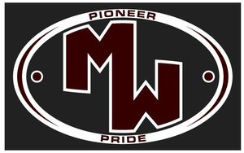April 13, 2018

Daily Bulletin

cid:image001.jpg@01D0F789.9EFA7A20**Friday – April 13, 2018** cid:image001.jpg@01D0F789.9EFA7A20

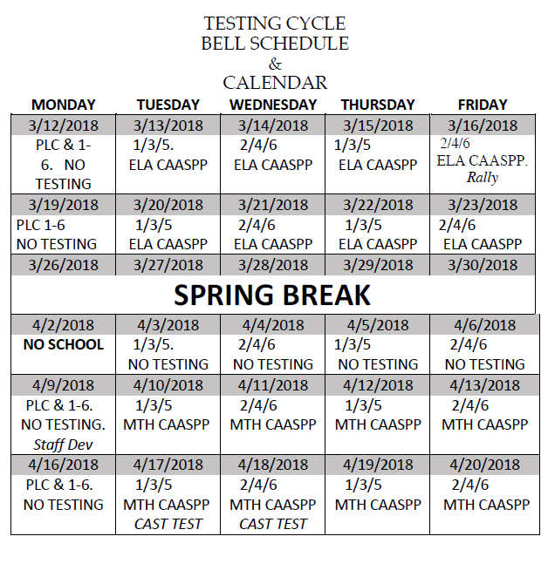 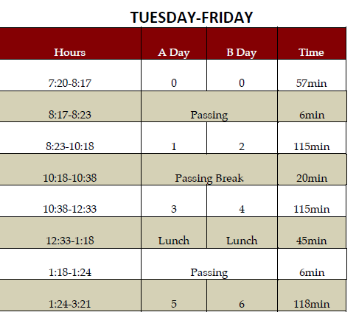

whatsupblue.jpgStudent Noteswhatsupblue.jpg

***1. Do you want to get into Home Games for Free?*** *And get major discounts on dance tickets? Buy an ASB sticker for $30 and save money. ASB stickers are now being sold in the Finance office. They will be sold all year long.*

***2****.* ***Attention Mt. Whitney Students****!! The* ***XL program offers*** *a free snack and a variety of clubs. There is* ***tutoring, Skills Club, Mock Trial, 3D-Printing, Weightlifting, Outdoors Club, Ag Science, Activities Club, Media Arts, Brazilian Jui-Jutsu, and Leadership Club****. To find out more about these clubs come to* ***Rm. S11!!***

*3. Step-Up is collecting donation items for cancer patients. We are accepting donations such as beanies, socks, stuffed animals, and monetary funds. The collection will run from January 9th-April 19th. We will have a donation bin set up in the front office, Room B-204, and a collection table in the quad on Thursdays during lunch. Please come by room B-204 for additional questions or information.*

4. Come watch a free movie every Friday night with your XL. Movies start @ 4pm, in room B-25, every Friday. There will be free food. Bring your friends and your family! Parents and siblings welcome too! Want more info? Come to room S-11

5. Students: Juniors will begin taking the state tests in English and Math and seniors will test in Science after Spring Break. These are very important tests, so get lots of rest and nutrition and put your best foot forward!

6. Come join the video club EVERY Thursday after school. Come learn about videography, editing, photography, and graphic design in ROOM B-204.

7. Attention staff and students! Please donate hygiene products to help the homeless in Visalia. This is a community service project organized by one of Mt. Whitney’s foreign exchange students. Support your community and help this project be successful. Boxes for donations are located in attendance, counseling, the library, K-4, K-7, and G-5.

8. Hey Mt. Whitney!  Would you like to be in a MWHS Dance class next school year?  If so, auditions are Wednesday, April 18.  You can learn the dance at the clinics on April 12 and 17 from 6-7:30pm.  If you would like to be in Intro to Dance, you do not need to audition.  If you’d like to skip Intro and be in Intermediate, Advanced, or Elevate, then make sure you come see Mrs. A in M-10 to pick up an audition packet.  Thank you!

9. After school from 3:30 to 4:00pm at M-4, we are selling fruit slushies for a dollar each every Tuesdays and Thursdays until May 3rd. Please come support SkillsUSA!

10. Current Sophomores and Juniors who are interested in being an Elementary Aide next school year must come in to the counseling office to pick up an application. Even if you returned a packet, you must come fill out an application. **Application deadline is April 27th**.

11. **Attention: Sophomores, Juniors & Seniors***:  Scicon trip  for Annie R. Mitchell is  for the week of April, 30th – May, 4th  . If you are interested in signing up please make sure you meet the criteria. We are looking for students with good attendance, a GPA of 2.5 or higher, someone who can be a great leader and a role model. We would like to send 4 male counselors and 3 female counselors. If you are interested in going please see Miss. Herrera in the counseling office for sign ups.*

12. Grizzly Academy will give a program presentation on Tuesday, April 17th in S12 from 1:30-2:30. Credit Recovery & Military Training- Contact Coach White or Henry Serrrato from Campus Life.

*MC900014728[1]Sports MC900014728[1]*

***SPORTS BULLETIN***

*MC900446010[1]*

*Club Notes*

1. Sophomores and Juniors, would you like to join Link Crew next year and help Freshmen and new students become part of Mt. Whitney? Link Crew Applications are now available in K7 and the attendance office. Applications are due to Mrs. Bolden in K7 by April 20th.
2. All Band and Colorguard members are to meet in the band room this Friday at lunch to finalize cultural food day decisions.

***graduation-cap[1]* Senior Notes *graduation-cap[1]***

***1.* Calling All Seniors**:  Try-outs to give the Senior Commencement speech and Welcome Statements will be **on April 25 after school.**  The Welcome Statement is given in English and Spanish; there will be try-outs for both.  See Mrs. Reyes in the front office for more information and to sign up for the try-outs**.  The deadline for sign-ups is Monday, April 23 at 3:30pm.**

**Mt. Whitney- Remember to show your Pioneer PRIDE- Positivity, Respect, Integrity, Determination, and Engagement!**

***MC900056794[1]College Visit Sign-ups MC900056794[1]***

*None at this time*

College-Money.jpgSenior Scholarships College-Money.jpg

**Veronica Reyes, MWHS**

[**vreyes@vusd.org**](mailto:vreyes@vusd.org)