mwlogo2.jpg.bmpMt. Whitney High Schoolmwlogo2.jpg.bmp

***A California Distinguished School & Home of the Pioneers!***

[](https://www.google.com/url?sa=i&rct=j&q=&esrc=s&source=images&cd=&cad=rja&uact=8&ved=2ahUKEwig4_qhuLzgAhUTHXwKHV2cDwQQjRx6BAgBEAU&url=https://leobaeck.ca/2018/02/12/kindness/&psig=AOvVaw2XJ0OFyWvzDAQkLK2zTBlI&ust=1550275284410451)*Go Pioneers!*

June 4, 2019

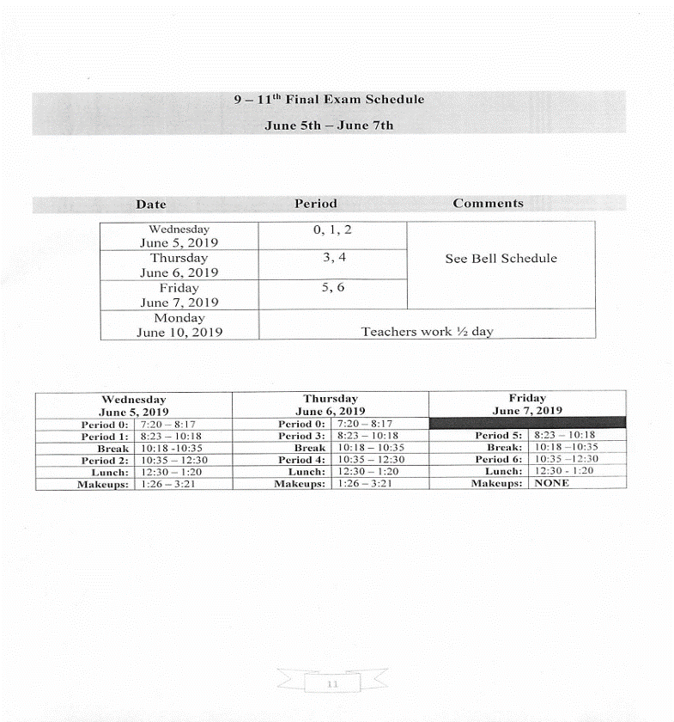

## Tuesday-Friday (Regular) Bell Schedule

|  |  |  |  |
| --- | --- | --- | --- |
| Period 0 | 7:20 | - 8:17 | 57 minutes |
| Period 1 | 8:23 | - 9:20 | 57 minutes |
| Period 2 | 9:26 | - 10:29 | 63 minutes |
| Period 3 | 10:35 | - 11:32 | 57 minutes |
| Period 4 | 11:38 | - 12:35 | 57 minutes |
| Lunch | 12:35 | - 1:15 | 40 minutes |
| Period 5 | 1:21 | - 2:18 | 57 minutes |
| Period 6 | 2:24 | - 3:21 | 57 minutes |

cid:image001.jpg@01D0F789.9EFA7A20cid:image001.jpg@01D0F789.9EFA7A20**­Tusdasy, June 4, 2019**

whatsupblue.jpg Student Noteswhatsupblue.jpg

**1.** Students, please take a few minutes to recognize Pioneers showing PRIDE. You can choose to nominate staff members for Staff of the Month or other students as Everyday Pioneers. Use the Google Form provided. <https://goo.gl/forms/2uDgMSgEMeTA8wMy1>.

**2**. Students – friendly reminder to please continue to pick up trash after breakfast and lunch. Show your MW Pride by keeping our campus clean.

**3.**  1. IF you took a COS or any other college course class THIS semester, please see or email your counselor as soon as possible.

1. If you are a current freshmen and are interested in joining the CADET CORE classes next year, please see your counselor.  CADET CORE is a leadership class geared toward students who might be considering joining the military.

*MC900446010[1]*

*Club Notes*

1. Pioneer Partners and Mrs. Allan's PIVOT/Peer Tutors please come join us during lunch today June 4th during lunch in room G-4 to celebrate your graduation.  We will have a cake and drinks for you!!!  Hope to see you there!

***graduation-cap[1]* Senior Notes *graduation-cap[1]***

1. You will need to have all textbooks, equipment, and materials turned into the Library before you can get a clearance form. All fines must be cleared through the Finance or Library before you can obtain a form from Mrs. Wheaton. We will start giving out “CLEARANCE FORMS” on Monday, June 3rd.  This form will be your TICKET into the bowl for Graduation practice. If you show up without one they will send you back to get one from the Library that morning. There will be no exceptions!!!!  If you have any questions please feel free to talk with Mrs. Wheaton. Congrats to you all!!!!!!
2. Seniors- Just to clarify the **Senior Finals Bell Schedule** as there has been some confusion- **On Monday, June 3rd and Tuesday, June 4th**, you will attend your classes as a regular day, but will take your finals according to our Senior Final Bell Schedule **so please note**, you will be marked absence on all other classes if you do not attend your full day schedule.  **On Wednesday**, **June 5th**, we begin our Finals Bell Schedule where you will ONLY attend 0, 1st, and 2nd periods. Again, ONLY Wednesday, June 5th, you will only attend 0, 1, 2 periods.  I know this may be confusing but you do not want your senior attendance to be affected by your absences on June 3rd and June 4th.  If you are still confused, please see Mrs. Reyes in the front office.

***MC900056794[1]College Visit Sign-ups MC900056794[1]***

*Not at this time*

College-Money.jpgSenior Scholarships College-Money.jpg

*Not at this time*

**To unsubscribe or subscribe to the Daily Bulletin:**

<http://mailman.visalia.k12.ca.us/mailman/listinfo/mwhs-bulletin>

Have questions regarding the bulletin? Contact:

**Veronica Reyes,** **MWHS**

**vreyes@vusd.org**