mwlogo2.jpg.bmpMt. Whitney High Schoolmwlogo2.jpg.bmp

***A California Distinguished School & Home of the Pioneers!***

*Go Pioneers!*

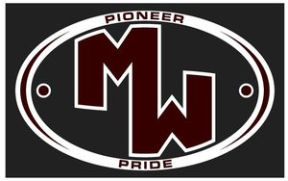September 8, 2020

Daily Bulletin

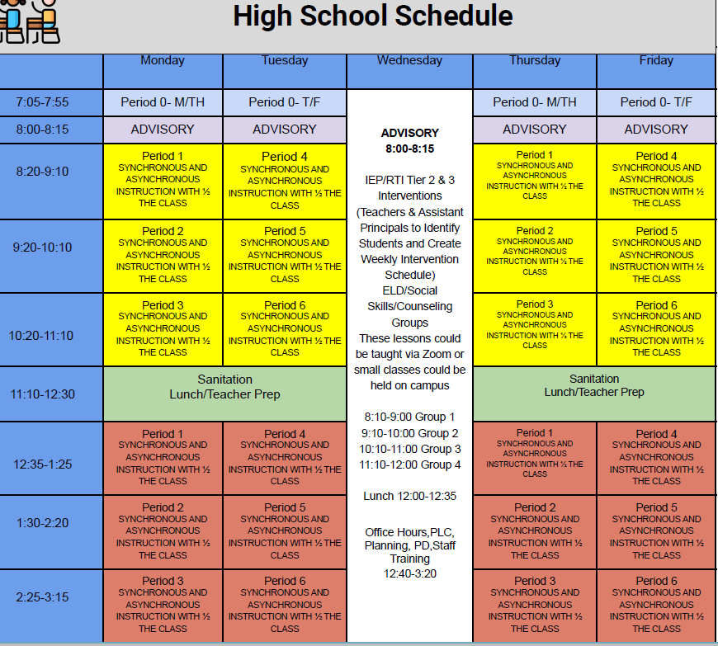

cid:image001.jpg@01D0F789.9EFA7A20**REGULAR TUESDAY September 8, 2020** cid:image001.jpg@01D0F789.9EFA7A20

whatsupblue.jpgStudent Noteswhatsupblue.jpg

1. Landed a job and need a work permit? You must obtain a 2.0 GPA. Come to the front office and pick up an application with Mrs. Reyes

2. MW ASB elections are next Wednesday Sept. 9.  Ballots will be emailed to students via google forms.  Ballots will be open from 8:00 AM until 1:00 PM

3. First Ever MW ASB Virtual Rally will launch Wednesday Sept. 16.  It will be a pre-recorded show with performances from Dance, Band, and Cheer. ASB and students will record skits and games.  Can't wait to see your Pandemic Pioneer Spirit.

*MC900446010[1]*

*Club Notes*

**NONE AT THIS TIME**

***graduation-cap[1]* Senior Notes *graduation-cap[1]***

***MC900056794[1]College Visit Sign-ups MC900056794[1]***

1. **NONE AT THIS TIME**

College-Money.jpgSenior Scholarships College-Money.jpg

**NONE AT THIS TIME**

**To unsubscribe or subscribe to the Daily Bulletin:**

<http://mailman.visalia.k12.ca.us/mailman/listinfo/mwhs-bulletin>

Have questions regarding the bulletin? Contact:

**Veronica Reyes, MWHS**

[**vreyes@vusd.org**](mailto:vreyes@vusd.org)

