mwlogo2.jpg.bmpMt. Whitney High Schoolmwlogo2.jpg.bmp

***A California Distinguished School & Home of the Pioneers!***

*Go Pioneers!*

September 18, 2020

Daily Bulletin

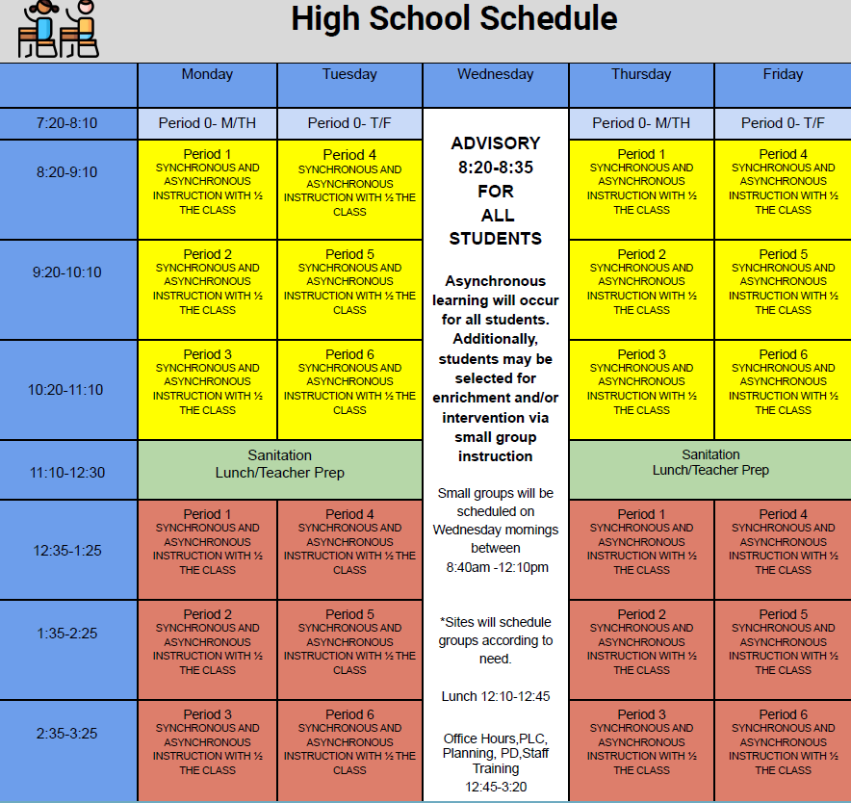cid:image001.jpg@01D0F789.9EFA7A20**REGULAR TUESDAY September 8, 2020** cid:image001.jpg@01D0F789.9EFA7A20



whatsupblue.jpgStudent Noteswhatsupblue.jpg

**1**. Landed a job and need a work permit? You must obtain a 2.0 GPA. Come to the front office and pick up an application with Mrs. Reyes

**2**. Many students need something to be a part of this semester, Fall Play is a great place to start!

**Fall Play is open to any Mt. Whitney Student! For information and Audition packets, please join the Fall Play Google Classroom. The class code is:**

q2t6oww

**3**. ***It’s time for another Yearbook photo contest.  Remember this is your chance to get your picture in the yearbook and win prizes doing it.  Each week, there will be a new topic for the photo contest.  This week, the topics are HOBBIES AND QUARANTINE FAMILY PICTURES.  Send us pics of what you like to do in your free time (make music, games, skateboard, collect something, etc.) or pictures of you and your best quarantine buddies, your family.  Submissions will close next Wed.***

***Congrats to our week one winner ERIC RAGAN!  He will receive a gift card and be entered in a drawing to win a free yearbook at the end of the year.  You never win unless you play!  Thanks for your help, MW!  We can’t do this without you.  Use the link below to submit your pictures***

[***https://docs.google.com/forms/d/e/1FAIpQLScjg9tDnrgDEVdNGSw2rUnwS9MqaXXOIKYRFYCJdu3h3SZeqQ/viewform***](https://docs.google.com/forms/d/e/1FAIpQLScjg9tDnrgDEVdNGSw2rUnwS9MqaXXOIKYRFYCJdu3h3SZeqQ/viewform)

*MC900446010[1]*

*Club Notes*

**NONE AT THIS TIME**

***graduation-cap[1]* Senior Notes *graduation-cap[1]***

***MC900056794[1]College Visit Sign-ups MC900056794[1]***

1. **NONE AT THIS TIME**

College-Money.jpgSenior Scholarships College-Money.jpg

**NONE AT THIS TIME**

**To unsubscribe or subscribe to the Daily Bulletin:**

<http://mailman.visalia.k12.ca.us/mailman/listinfo/mwhs-bulletin>

Have questions regarding the bulletin? Contact:

**Veronica Reyes, MWHS**

[**vreyes@vusd.org**](mailto:vreyes@vusd.org)

