mwlogo2.jpg.bmpMt. Whitney High Schoolmwlogo2.jpg.bmp

***A California Distinguished School & Home of the Pioneers!***

*Go Pioneers!*

September 23, 2020

Daily Bulletin

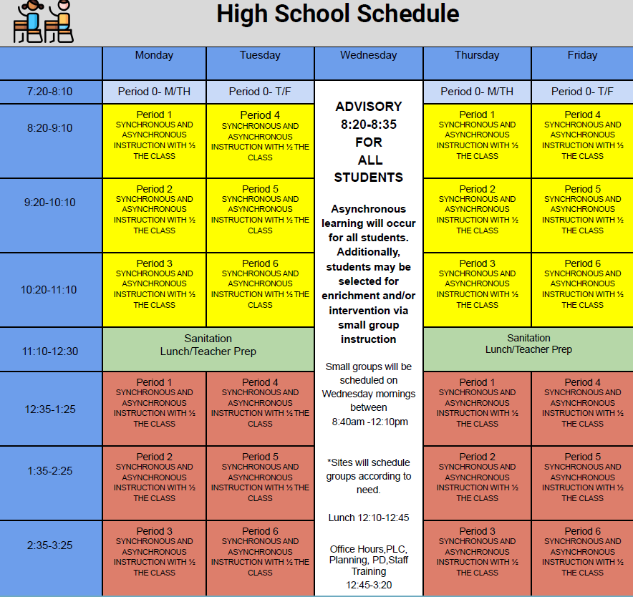



whatsupblue.jpgStudent Noteswhatsupblue.jpg

**1**. Landed a job and need a work permit? You must obtain a 2.0 GPA. Come to the front office and pick up an application with Mrs. Reyes

**2**. Many students need something to be a part of this semester, Fall Play is a great place to start!

**Fall Play is open to any Mt. Whitney Student! For information and Audition packets, please join the Fall Play Google Classroom. The class code is:**

q2t6oww

**3.** Interested in playing frosh football this year.  Please email your first and last name to Coach Saldana at ([gsaldana@vusd.us](mailto:gsaldana@vusd.us)) to be added to the schoology frosh football group.  We will be having a short zoom meeting right after homeroom next Wednesday September 30 at 8:40 am.  See you there.  Go Pioneers.

*MC900446010[1]*

*Club Notes*

**NONE AT THIS TIME**

***graduation-cap[1]* Senior Notes *graduation-cap[1]***

***MC900056794[1]College Visit Sign-ups MC900056794[1]***

1. **NONE AT THIS TIME**

College-Money.jpgSenior Scholarships College-Money.jpg

**NONE AT THIS TIME**

**To unsubscribe or subscribe to the Daily Bulletin:**

<http://mailman.visalia.k12.ca.us/mailman/listinfo/mwhs-bulletin>

Have questions regarding the bulletin? Contact:

**Veronica Reyes, MWHS**

[**vreyes@vusd.org**](mailto:vreyes@vusd.org)

