mwlogo2.jpg.bmpMt. Whitney High Schoolmwlogo2.jpg.bmp

***A California Distinguished School & Home of the Pioneers!***

*Go Pioneers!*

September 30, 2020

Daily Bulletin

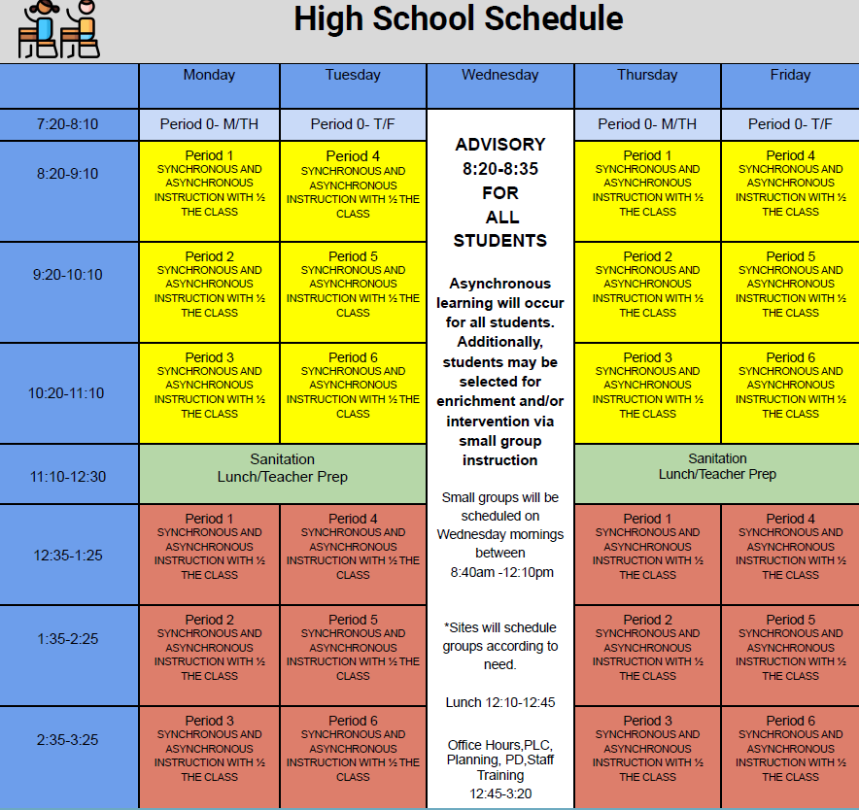



whatsupblue.jpgStudent Noteswhatsupblue.jpg

**1**. Landed a job and need a work permit? You must obtain a 2.0 GPA. Come to the front office and pick up an application with Mrs. Reyes

**2**. Many students need something to be a part of this semester, Fall Play is a great place to start!

**Fall Play is open to any Mt. Whitney Student! For information and Audition packets, please join the Fall Play Google Classroom. The class code is:**

q2t6oww

**3.** Interested in playing frosh football this year.  Please email your first and last name to Coach Saldana at ([gsaldana@vusd.us](mailto:gsaldana@vusd.us)) to be added to the schoology frosh football group.  We will be having a short zoom meeting right after homeroom **TODAY** at 8:40 am.  See you there.  Go Pioneers.

**4**. It’s time for another Yearbook photo contest.  Remember this is your chance to get your picture in the yearbook and win prizes doing it.  Each week, there will be a new topic for the photo contest.  This week's contest is CARS and HOME SCHOOL SETUP----send us pictures of you and your car or of your zoom setup at home. Submissions will close next Wed.

Our week 4 winner will be announced at the end of the week. You never win unless you play!  Thanks for your help, MW! WE CAN’T DO IT WITHOUT YOU.  Use the link below to submit your pictures.

<https://docs.google.com/forms/d/e/1FAIpQLSdBw-LZYjpRY3_6pOveo2rSN8uLbfdHxoVdfudha6Kz4xC2mQ/viewform>

*MC900446010[1]*

*Club Notes*

**NONE AT THIS TIME**

***graduation-cap[1]* Senior Notes *graduation-cap[1]***

1. **Seniors**- **Jostens** will be conducting a Senior class meeting via Zoom on Wednesday, October 14th at 9:00am immediately following Advisory.  Don’t miss out on cap and gown information! The meeting will take approximately 40 minutes, 20 minute slides and 20 minutes for questions.

***MC900056794[1]College Visit Sign-ups MC900056794[1]***

**NONE AT THIS TIME**

College-Money.jpgSenior Scholarships College-Money.jpg

**NONE AT THIS TIME**

**To unsubscribe or subscribe to the Daily Bulletin:**

<http://mailman.visalia.k12.ca.us/mailman/listinfo/mwhs-bulletin>

Have questions regarding the bulletin? Contact:

**Veronica Reyes, MWHS**

[**vreyes@vusd.org**](mailto:vreyes@vusd.org)

