mwlogo2.jpg.bmpMt. Whitney High Schoolmwlogo2.jpg.bmp

***A California Distinguished School & Home of the Pioneers!***

*Go Pioneers!*

October 2, 2020

Daily Bulletin

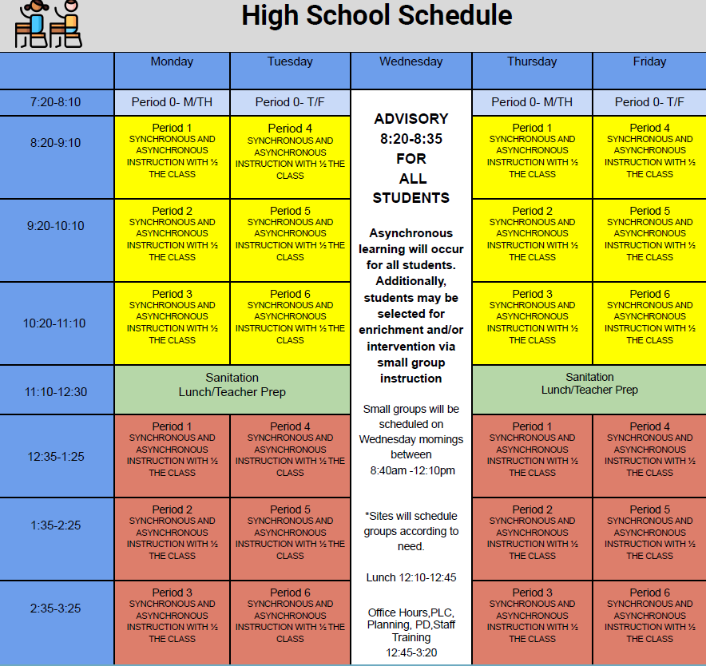



whatsupblue.jpgStudent Noteswhatsupblue.jpg

**1**. Landed a job and need a work permit? You must obtain a 2.0 GPA. Come to the front office and pick up an application with Mrs. Reyes

**2** Hey, Pioneers!! If you've placed a request for a textbook/novel or library book, check your vusd.us account to see if your order has been filled. If so, your request is on a cart ready for pick up! Pick up days are Monday, Wednesday, and Friday from 9am-11am and 1pm - 3pm in circle drive.

3. It’s time for another Yearbook photo contest.  Remember this is your chance to get your picture in the yearbook and win prizes doing it.  Each week, there will be a new topic for the photo contest.  This week's contest is CARS and HOME SCHOOL SETUP----send us pictures of you and your car or of your zoom setup at home. Submissions will close next Wed.

Our week 4 winner will be announced at the end of the week. You never win unless you play!  Thanks for your help, MW! WE CAN’T DO IT WITHOUT YOU.  Use the link below to submit your pictures.

<https://docs.google.com/forms/d/e/1FAIpQLSdBw-LZYjpRY3_6pOveo2rSN8uLbfdHxoVdfudha6Kz4xC2mQ/viewform>

4. Interested in Volleyball please text @mwvball20 to 81010

*MC900446010[1]*

*Club Notes*

**NONE AT THIS TIME**

***graduation-cap[1]* Senior Notes *graduation-cap[1]***

1. **Seniors**- **Jostens** will be conducting a Senior class meeting via Zoom on Wednesday, October 14th at 9:00am immediately following Advisory.  Don’t miss out on cap and gown information! The meeting will take approximately 40 minutes, 20 minute slides and 20 minutes for questions.

***MC900056794[1]College Visit Sign-ups MC900056794[1]***

**NONE AT THIS TIME**

College-Money.jpgSenior Scholarships College-Money.jpg

**NONE AT THIS TIME**

**To unsubscribe or subscribe to the Daily Bulletin:**

<http://mailman.visalia.k12.ca.us/mailman/listinfo/mwhs-bulletin>

Have questions regarding the bulletin? Contact:

**Veronica Reyes, MWHS**

[**vreyes@vusd.org**](mailto:vreyes@vusd.org)

