mwlogo2.jpg.bmpMt. Whitney High Schoolmwlogo2.jpg.bmp

***A California Distinguished School & Home of the Pioneers!***

*Go Pioneers!*

October 7, 2020

Daily Bulletin

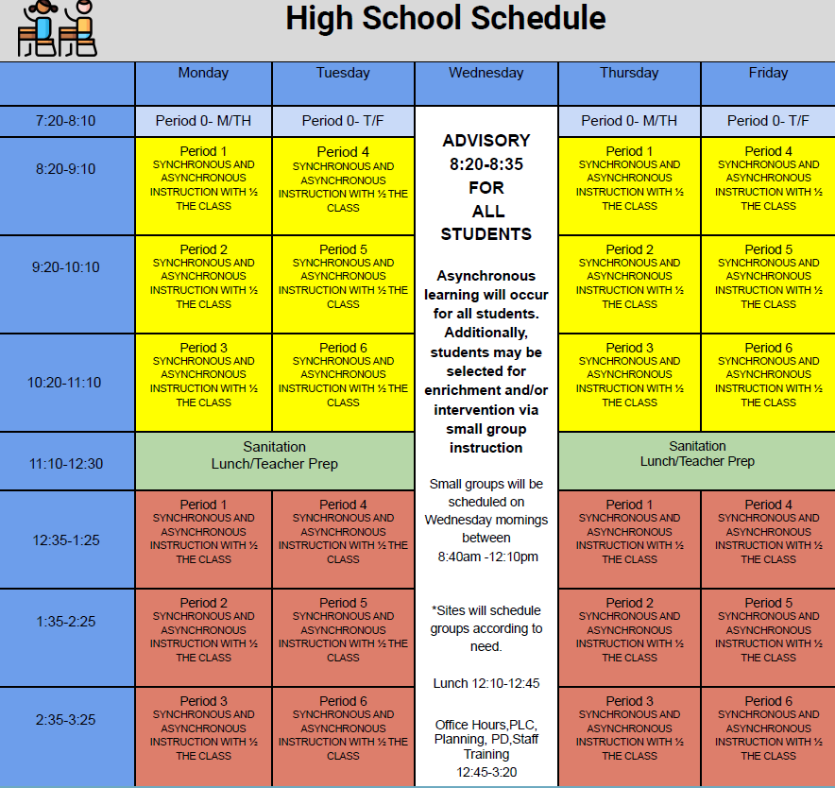



whatsupblue.jpgStudent Noteswhatsupblue.jpg

**1**. Landed a job and need a work permit? You must obtain a 2.0 GPA. Come to the front office and pick up an application with Mrs. Reyes

**2** Hey, Pioneers!! If you've placed a request for a textbook/novel or library book, check your vusd.us account to see if your order has been filled. If so, your request is on a cart ready for pick up! Pick up days are Monday, Wednesday, and Friday from 9am-11am and 1pm - 3pm in circle drive.

**3**. Interested in Volleyball please text @mwvball20 to 81010

*MC900446010[1]*

*Club Notes*

**NONE AT THIS TIME**

***graduation-cap[1]* Senior Notes *graduation-cap[1]***

1. **Seniors**- **Jostens** will be conducting a Senior class meeting via Zoom on Wednesday, October 14th at 9:00am immediately following Advisory.  Don’t miss out on cap and gown information! The meeting will take approximately 40 minutes, 20 minute slides and 20 minutes for questions.

***MC900056794[1]College Visit Sign-ups MC900056794[1]***

**NONE AT THIS TIME**

College-Money.jpgSenior Scholarships College-Money.jpg

**NONE AT THIS TIME**

**To unsubscribe or subscribe to the Daily Bulletin:**

<http://mailman.visalia.k12.ca.us/mailman/listinfo/mwhs-bulletin>

Have questions regarding the bulletin? Contact:

**Veronica Reyes, MWHS**

[**vreyes@vusd.org**](mailto:vreyes@vusd.org)

