mwlogo2.jpg.bmpMt. Whitney High Schoolmwlogo2.jpg.bmp

***A California Distinguished School & Home of the Pioneers!***

*Go Pioneers!*

October 9, 2020

Daily Bulletin

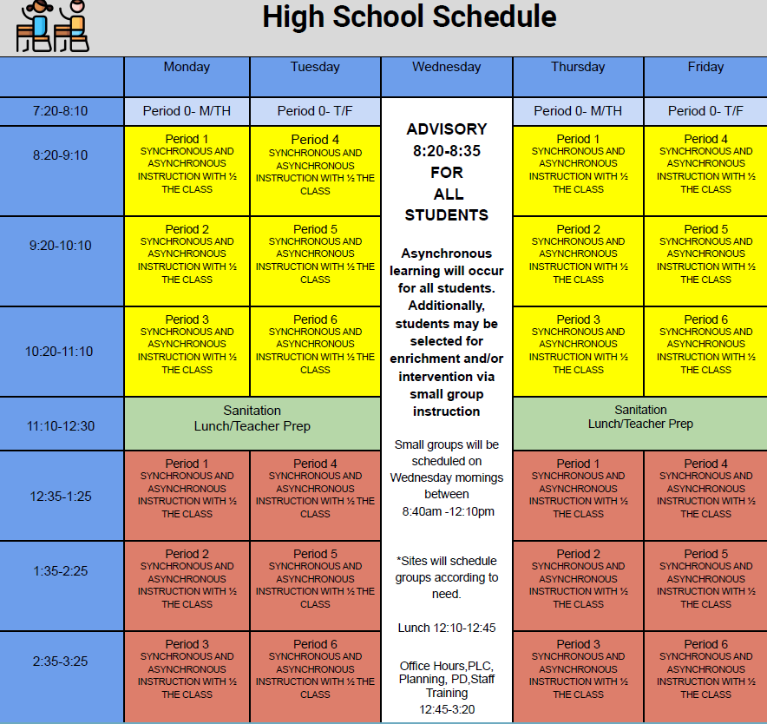



whatsupblue.jpgStudent Noteswhatsupblue.jpg

**1**. Landed a job and need a work permit? You must obtain a 2.0 GPA. Come to the front office and pick up an application with Mrs. Reyes

**2** Hey, Pioneers!! If you've placed a request for a textbook/novel or library book, check your vusd.us account to see if your order has been filled. If so, your request is on a cart ready for pick up! Pick up days are Monday, Wednesday, and Friday from 9am-11am and 1pm - 3pm in circle drive.

**3**. Interested in Volleyball please text @mwvball20 to 81010

4. An FFA cotton judging announcement! My cotton team did great last weekend! Not bad for 1st virtual contest!!! Ever!

Cotton results

A team (Kylee,Filiponi, Karen Martinez, Emma Hultquist) 3rd high team in plants, 4th high in lint.

B team (Aidan brown, Jean maddeaux., Taylor heine, Rachel majarian) 3rd high team overall, Jean 3rd high individual. 4th high in plants, 5th high test, 3rd in bolls, 2nd in lint, 3rd in seeds. Jean was 3rd high in plants, 5th in bolls, Taylor heine was 3rd high in lint

*MC900446010[1]*

*Club Notes*

**NONE AT THIS TIME**

***graduation-cap[1]* Senior Notes *graduation-cap[1]***

1. **Seniors**- **Jostens** will be conducting a Senior class meeting via Zoom on Wednesday, October 14th at 9:00am immediately following Advisory.  Don’t miss out on cap and gown information! The meeting will take approximately 40 minutes, 20 minute slides and 20 minutes for questions.

***MC900056794[1]College Visit Sign-ups MC900056794[1]***

**NONE AT THIS TIME**

College-Money.jpgSenior Scholarships College-Money.jpg

**NONE AT THIS TIME**

**To unsubscribe or subscribe to the Daily Bulletin:**

<http://mailman.visalia.k12.ca.us/mailman/listinfo/mwhs-bulletin>

Have questions regarding the bulletin? Contact:

**Veronica Reyes, MWHS**

[**vreyes@vusd.org**](mailto:vreyes@vusd.org)

