mwlogo2.jpg.bmpMt. Whitney High Schoolmwlogo2.jpg.bmp

***A California Distinguished School & Home of the Pioneers!***

*Go Pioneers!*

October 14, 2020

Daily Bulletin

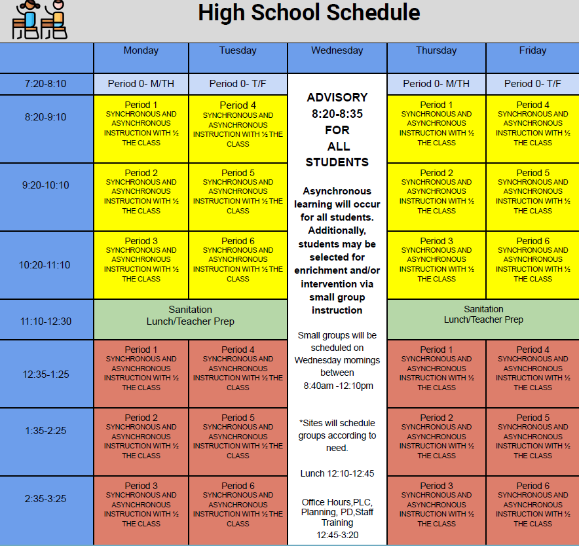



whatsupblue.jpgStudent Noteswhatsupblue.jpg

**1**. Landed a job and need a work permit? You must obtain a 2.0 GPA. Come to the front office and pick up an application with Mrs. Reyes

**2** Hey, Pioneers!! If you've placed a request for a textbook/novel or library book, check your vusd.us account to see if your order has been filled. If so, your request is on a cart ready for pick up! Pick up days are Monday, Wednesday, and Friday from 9am-11am and 1pm - 3pm in circle drive.

**3**. Interested in Volleyball please text @mwvball20 to 81010

**4**. Join me in supporting Mt. Whitney Drama (<https://www.customink.com/fundraising/mt-whitney-drama?utm_campaign=desktop-post-launch-v3&utm_content=mt-whitney-drama&utm_medium=messaging&utm_source=email>)! All funds raised will go directly to Mt. Whitney High School Drama.

*MC900446010[1]*

*Club Notes*

**NONE AT THIS TIME**

***graduation-cap[1]* Senior Notes *graduation-cap[1]***

1. **Seniors**- **Jostens** will be conducting a Senior class meeting via Zoom on Wednesday, October 14th at 9:00am immediately following Advisory.  Don’t miss out on cap and gown information! The meeting will take approximately 40 minutes, 20 minute slides and 20 minutes for questions.
2. On Wednesday, October 21st from 11:00am until 5:00pm, Essence Photography will come to the Mt. Whitney campus and set up 2 drive-thru photography stations in the AG PARKING LOT. These will be for all students who have not taken senior photographs, or who are not planning to take senior photographs on your own.     IF YOU HAVE ALREADY MADE PLANS TO TAKE YOUR OWN PHOTOS WITH ESSENCE, OR HAVE ALREADY TAKEN YOUR PHOTOS, YOU DO NOT NEED TO ATTEND THE PICTURE DAY. Students will need to show up only during your planned times, based on a student's last name in alphabetical order.

A - C    11:00am - 12:00pm

D - H    12:00pm -   1:00pm

I - M       1:00pm -   2:00pm

N - R      2:00pm -   3:00pm

S - T      3:00pm -   4:00pm

U - Z      4:00pm -   5:00pm

Students coming during different times will be turned away and asked to come back at the end of the day at 5:00pm.  Please show up during your assigned times for the fastest help and support.

***MC900056794[1]College Visit Sign-ups MC900056794[1]***

**NONE AT THIS TIME**

College-Money.jpgSenior Scholarships College-Money.jpg

**NONE AT THIS TIME**

**To unsubscribe or subscribe to the Daily Bulletin:**

<http://mailman.visalia.k12.ca.us/mailman/listinfo/mwhs-bulletin>

Have questions regarding the bulletin? Contact:

**Veronica Reyes, MWHS**

[**vreyes@vusd.org**](mailto:vreyes@vusd.org)

