mwlogo2.jpg.bmpMt. Whitney High Schoolmwlogo2.jpg.bmp

***A California Distinguished School & Home of the Pioneers!***

*Go Pioneers!*

October 28, 2020

Daily Bulletin

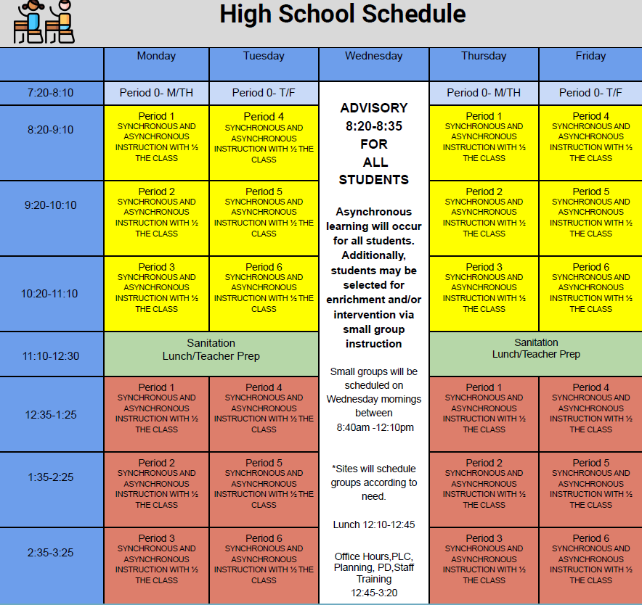



whatsupblue.jpgStudent Noteswhatsupblue.jpg

**1**. Landed a job and need a work permit? You must obtain a 2.0 GPA. Come to the front office and pick up an application with Mrs. Reyes

**2** Hey, Pioneers!! If you've placed a request for a textbook/novel or library book, check your vusd.us account to see if your order has been filled. If so, your request is on a cart ready for pick up! Pick up days are Monday, Wednesday, and Friday from 9am-11am and 1pm - 3pm in circle drive.

**3. The Nightmare on Conyer is our Halloween Homecoming celebration**. That’s right Pioneers nominate your favorite senior boy or girl for Halloween homecoming king or queen.  We are accepting nominations from any MW student, teacher, club or sport.  Please see the link in the homecoming flyer on Instagram or the link below to submit your nominations. If you want to nominate your favorite senior as Halloween Homecoming King or Queen, use the link below:

<https://forms.gle/xJsWdDAqtaqiBVmPA>

**4.** It’s time for another Yearbook photo contest.  Remember this is your chance to get your picture in the yearbook and win prizes doing it.  Each week, there will be a new topic for the photo contest. This week's contest is to send us pictures of you dressed up and participating in our HALLOWEEN HOMECOMING DRESS UP DAYS AND EVENTS.  We want to feature you in our yearbook so help us out!   Submissions will close next Wed

Our week 8 winner will be announced at the end of the week. You never win unless you play!  Thanks for your help, MW! WE CAN’T DO IT WITHOUT YOU.  Use the link below to submit your pictures.

<https://forms.gle/q8hRFNaPdZby1F7P7>

*MC900446010[1]*

*Club Notes*

**NONE AT THIS TIME**

***graduation-cap[1]* Senior Notes *graduation-cap[1]***

NOT AT THIS TIME

***MC900056794[1]College Visit Sign-ups MC900056794[1]***

**NONE AT THIS TIME**

College-Money.jpgSenior Scholarships College-Money.jpg

**NONE AT THIS TIME**

**To unsubscribe or subscribe to the Daily Bulletin:**

<http://mailman.visalia.k12.ca.us/mailman/listinfo/mwhs-bulletin>

Have questions regarding the bulletin? Contact:

**Veronica Reyes, MWHS**

[**vreyes@vusd.org**](mailto:vreyes@vusd.org)

