mwlogo2.jpg.bmpMt. Whitney High Schoolmwlogo2.jpg.bmp

***A California Distinguished School & Home of the Pioneers!***

*Go Pioneers!*

November 4, 2020

[](https://www.google.com/url?sa=i&url=http%3A%2F%2Fniceclipart.com%2F4136%2Fthanksgiving.html%2Fthanksgiving-clipart-8&psig=AOvVaw2gwtKvEVkMvV7n4jcbFSd8&ust=1604532327954000&source=images&cd=vfe&ved=0CAIQjRxqFwoTCODhhvLC5-wCFQAAAAAdAAAAABAD)

Daily Bulletin

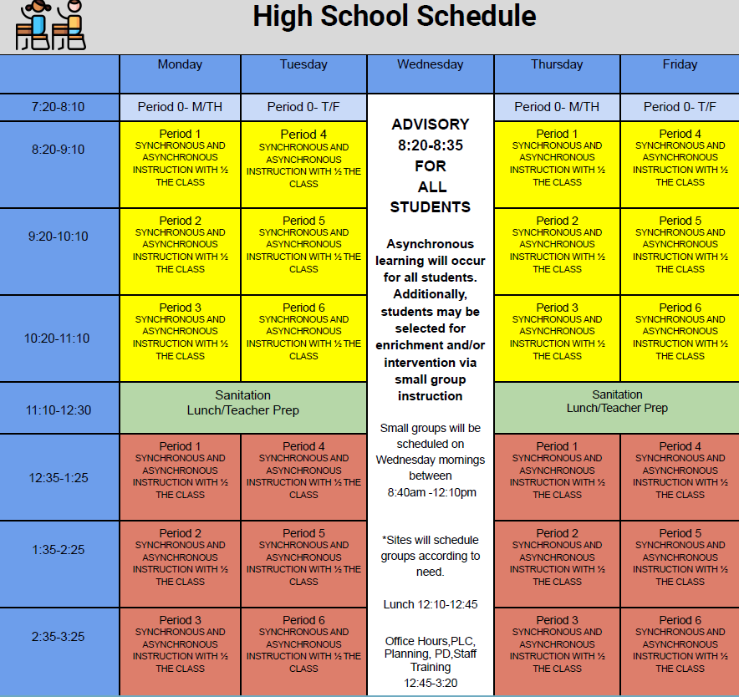



whatsupblue.jpgStudent Noteswhatsupblue.jpg

**1**. Landed a job and need a work permit? Come to the front office and pick up an application with Mrs. Reyes

**2** Hey, Pioneers!! If you've placed a request for a textbook/novel or library book, check your vusd.us account to see if your order has been filled. If so, your request is on a cart ready for pick up! Pick up days are Monday, Wednesday, and Friday from 9am-11am and 1pm - 3pm in circle drive.

**3.** It’s time for another Yearbook photo contest.  Remember this is your chance to get your picture in the yearbook and win prizes doing it.  Each week, there will be a new topic for the photo contest. This week's theme is HALLOWEEN.  SEND US PICTURES OF YOU DRESSED UP AND HAVING A GOOD TIME.  We want to feature you in our yearbook so help us out!   Submissions will close next Wed.

Our week 8 winner will be announced at the end of the week. You never win unless you play!  Thanks for your help, MW! WE CAN’T DO IT WITHOUT YOU.  Use the link below to submit your pictures.

<https://forms.gle/tx9JfKc8VtM9oCud9>

*MC900446010[1]*

*Club Notes*

**NONE AT THIS TIME**

***graduation-cap[1]* Senior Notes *graduation-cap[1]***

1. RE: Senior Portrait retakes.  ***Nov. 18th 1:00pm-3:00pm at the Redwood parking lot on Conyer and Mineral King.* These are Make-up’s for those who didn’t get a picture taken.   These are not “retakes” for kids who would like a better picture.  They will be turned away if they have already taken a senior portrait.**

***MC900056794[1]College Visit Sign-ups MC900056794[1]***

**NONE AT THIS TIME**

College-Money.jpgSenior Scholarships College-Money.jpg

**NONE AT THIS TIME**

**To unsubscribe or subscribe to the Daily Bulletin:**

<http://mailman.visalia.k12.ca.us/mailman/listinfo/mwhs-bulletin>

Have questions regarding the bulletin? Contact:

**Veronica Reyes, MWHS**

[**vreyes@vusd.org**](mailto:vreyes@vusd.org)

