mwlogo2.jpg.bmpMt. Whitney High Schoolmwlogo2.jpg.bmp

***A California Distinguished School & Home of the Pioneers!***

*Go Pioneers!*

December 8, 2020[](https://www.google.com/url?sa=i&url=https://www.123rf.com/photo_67586436_stock-vector-candy-cane-december-lettering.html&psig=AOvVaw1CSMmR77_ImkTkwlfLqx6t&ust=1606926741316000&source=images&cd=vfe&ved=0CAIQjRxqFwoTCPDvxeiare0CFQAAAAAdAAAAABAP)

Daily Bulletin

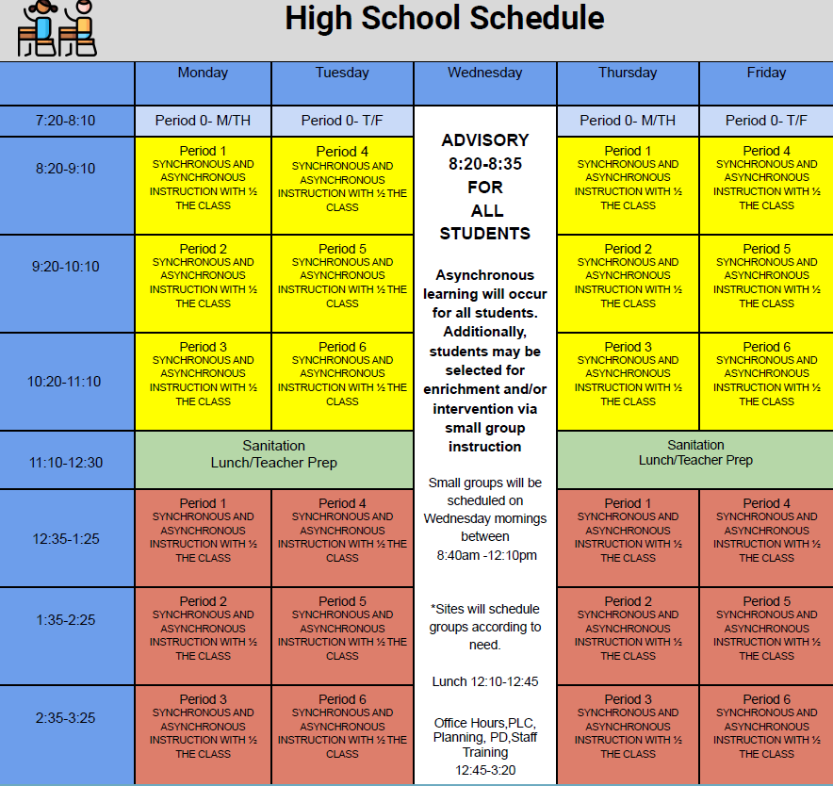



whatsupblue.jpgStudent Noteswhatsupblue.jpg

FINALS BELL SCHEDULE FOR DECEMBER 16-18, 2020

|  |  |  |
| --- | --- | --- |
| **WEDNESDAY** | **THURSDAY** | **FRIDAY** |
| **12/16/20** | **12/17/20** | **12/18/20** |
| Period 0.      7:35-8:20 | Period 0.      7:35-8:20 | Period 0.      Does Not Meet |
| Period 1     8:30 - 10:00 | Period 3     8:30 - 10:00 | Period 5     8:30 - 10:00 |
| Break        10:00 - 10:15 | Break        10:00 - 10:15 | Break        10:00 - 10:15 |
| Period 2     10:15 - 11:45 | Period 4     10:15 - 11:45 | Period 6     10:15 - 11:45 |
| Lunch.     11:45- 12:30 | Lunch.     11:45- 12:30 | Lunch.     11:45- 12:30 |
| Makeups & Grading     12:30-3:20 | Makeups & Grading     12:30-3:20 | Makeups & Grading     12:30-3:20 |
| **\*\*PERIODS 3 & 4 assign a 30 min** | **\*\*PERIODS 5 & 6 assign a 30 min** | **\*\*PERIODS 1 & 2 assign a 30 min** |
| **study guide each** | **study guide each** | **Survey or reflection each** |
|  |  |  |

**1**. Landed a job and need a work permit? Come to the front office and pick up an application with Mrs. Reyes

**2** Hey, Pioneers!! If you've placed a request for a textbook/novel or library book, check your vusd.us account to see if your order has been filled. If so, your request is on a cart ready for pick up! Pick up days are Mondays and Wednesdays from 9am -1pm in circle drive.

**3**. Did you know that the library has an Instagram page?! They post pictures of library books that are currently available for you to check out. We have started the December  reading challenge. The winner of last month’s reading challenge won a $15 Taco Bell gift card, along with 4 students who won a $10 gift card to Subway! This month we have (3) Gift cards to give out for $25.00 each! So be sure to follow @mt_whitney_library on Instagram to participate in the challenges and be entered in drawings for your chance to win!

**4**. See the 2020 Fall Play, The Monologue Show! Don't miss out on Mt. Whitney's first fully virtual theatrical production! Fill out the form to get your copy!

<https://forms.gle/e6SHMAApzt94jK9U7>

*MC900446010[1]*

*Club Notes*

**NONE AT THIS TIME**

***graduation-cap[1]* Senior Notes *graduation-cap[1]***

**NONE AT THIS TIME**

***MC900056794[1]College Visit Sign-ups MC900056794[1]***

**NONE AT THIS TIME**

College-Money.jpgSenior Scholarships College-Money.jpg

**To unsubscribe or subscribe to the Daily Bulletin:**

<http://mailman.visalia.k12.ca.us/mailman/listinfo/mwhs-bulletin>

Have questions regarding the bulletin? Contact:

**Veronica Reyes, MWHS**

[**vreyes@vusd.org**](mailto:vreyes@vusd.org)

[](https://www.google.com/url?sa=i&url=http://clipart-library.com/winter-wonderland-clipart.html&psig=AOvVaw1sqj0IoUF2hsoChj_r4d6X&ust=1606926921416000&source=images&cd=vfe&ved=0CAIQjRxqFwoTCPCWw7ibre0CFQAAAAAdAAAAABAD)