cid:image001.jpg@01D1B831.05320ED0Mt. Whitney High Schoolcid:image001.jpg@01D1B831.05320ED0

***A California Distinguished School & Home of the Pioneers!***

*Go Pioneers!*

Monday, September 27, 2021

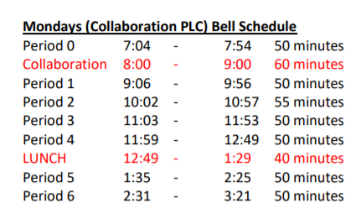

cid:image003.jpg@01D1B831.05320ED0Student Notescid:image003.jpg@01D1B831.05320ED0

**1**. Landed a job and need a work permit? Come to the front office and pick up an application with Mrs. Reyes

**2**. Come hang out after school with XL!!! At XL, you can make new friends, get snack and food service, access our computer lab, get tutoring, discover new hobbies, and play video games.

**3.** **Interested in the Military?** Want to start talking to a recruiter about your future?  Before you decide to venture off into a path that will lead you to great success come by **S14 and talk with Master Sergeant Cervantes**.  I will do my best to answer as many questions as possible about the military and a military life.  Whether you want to serve your country or gain educational benefits, come by and ask as many questions as possible.  If you are not sure about what questions to ask a potential recruiter, this is the place to find your answers.

4.



5. Confused on what you need to do to prepare for college? XL is hosting our “Mapping Out College” workshop. It is for ALL grade levels Freshmen to Seniors. We will go over what you need to be getting done each year in order to be on the right path to go to college. Join XL on September 23rd at 3:30pm in Room S-11 – September 23rd at 3:30pm in Room S-11

6. **STUDENT ATHLETES!..**. XL is hosting Morning tutoring sessions from 7am to 9am every Monday. Please attend to ensure you can keep dominating the competition all season long! XL is also starting a Baseball Program. Come to room S-11 to find out more

7. ***Freshman***-if you purchased an ASB sticker at Orientation please see the Finance Office.

8. Attention Mt. Whitney pioneers we will be hosting our annual homecoming nominations week of October 4th-8th. To get all students involved and excited for the week are happy to announce our dress up week called “Lights, Camera, Action” These are the following dress up days ***for the week 10/4-10/8***:

Monday- Clueless(90’s fashion)

Tuesday- Austin powers(hippie day)

Wednesday-couples costumes(famous couples)

Thursday-Harry potter(class colors)

Friday-Friday night lights

*MC900446010[1]*

*Club Notes*

1. **Tuesday, 9/28/21, Earth Aid** will have a "beautification" meeting at lunch in H-1@ 12:45. Recycle Scavenger Hunt #2 is the goal.

***cid:image007.jpg@01D1B831.05320ED0* Senior Notes 

1. Seniors:  Please check your email to vote for Pacesetter Nominations and Senior Superlatives in the yearbook.  Voting will be open until Friday, Oct. 1.

***cid:image008.png@01D1B831.05320ED0College Visit Sign-ups cid:image009.png@01D1B831.05320ED0***

**NONE AT THIS TIME**

Senior Scholarships 

**To unsubscribe or subscribe to the Daily Bulletin:**

<http://mailman.visalia.k12.ca.us/mailman/listinfo/mwhs-bulletin>

Have questions regarding the bulletin? Contact:

**Veronica Reyes, MWHS**

[**vreyes@vusd.org**](mailto:vreyes@vusd.org)