cid:image001.jpg@01D1B831.05320ED0Mt. Whitney High Schoolcid:image001.jpg@01D1B831.05320ED0

***A California Distinguished School & Home of the Pioneers!***

*Go Pioneers!*

Wednesday, October 13, 2021



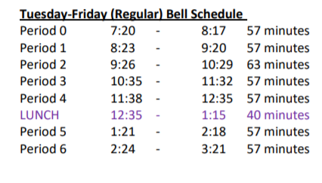

cid:image003.jpg@01D1B831.05320ED0Student Notescid:image003.jpg@01D1B831.05320ED0

**1**. Landed a job and need a work permit? Come to the front office and pick up an application with Mrs. Reyes

**2**. Come hang out after school with XL!!! At XL, you can make new friends, get snack and food service, access our computer lab, get tutoring, discover new hobbies, and play video games.

**3.** **Interested in the Military?** Want to start talking to a recruiter about your future?  Before you decide to venture off into a path that will lead you to great success come by **S14 and talk with Master Sergeant Cervantes**.  I will do my best to answer as many questions as possible about the military and a military life.  Whether you want to serve your country or gain educational benefits, come by and ask as many questions as possible.  If you are not sure about what questions to ask a potential recruiter, this is the place to find your answers.

**4. Student replacement IDs are $10**. Please see Mrs. Reyes for a half sheet with instructions.

**5.**

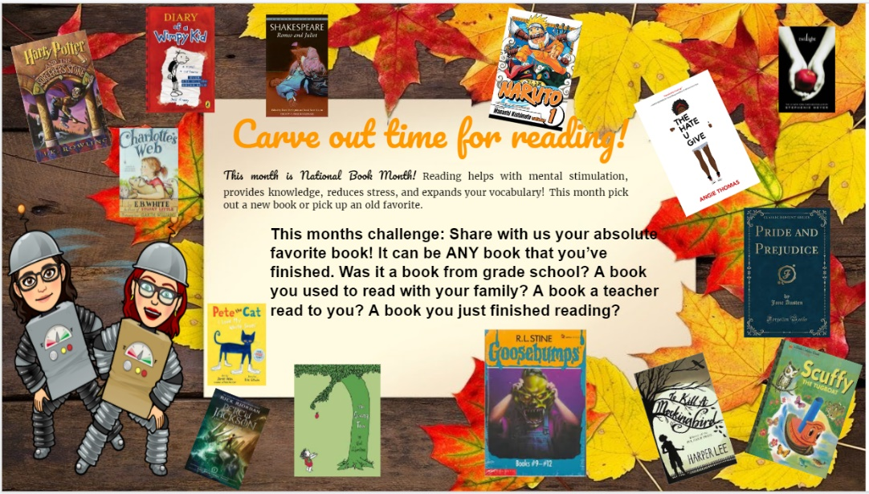.

**6**. Attention Mt. Whitney Pioneers-Our annual homecoming week has been changed to October 18th -22nd . To get all students involved and excited for the week are happy to announce our dress up week called “Lights, Camera, Action” These are the following dress up days ***for the week 10/18-10/22***:

Monday- Clueless(90’s fashion)

Tuesday- Austin powers(hippie day)

Wednesday-couples costumes(famous couples)

Thursday-Harry potter(class colors)

Friday-Friday night lights

**7**. ***Juniors and Seniors***- Scicon is back!! We are looking for **Scicon Counselors** for **Pinkham from October 18th-21st**, **3 boys**. We also need **Scicon Counselors** for **Annie R Mitchell from Oct. 25th-Oct. 28th, 3 girls and 2 boys** as well as **Liberty Elementary** from **Oct. 25th – 28th, 2 boys**. We have most counselors signed up. Please see Mrs. Reyes to see if you qualify for an application before school, during lunch, or after school.

**8**. Join XL for a month of Halloween fun!

On October 4th join XL for a Movie: We will be showing Coraline

On October 11th join XL to watch The Nightmare before Christmas

On the October 19th come to our Halloween Paint Night – where you will learn to paint your own Halloween themed painting.

On October 26th come decorate a pumpkin that you can take home just in time for Halloween!

9. Students, Please help us keep the school clean by throwing away all trash in the trash cans. Let’s show our Pioneer Pride.

10. If you know anyone who is vandalizing our restrooms, please report any information to the front office. Reports will remain confidential.

11.Pioneers! Mt. Whitney High School is offering current Juniors and Seniors the opportunity to take the ASVAB (Armed Services Vocational Aptitude Battery) Test on November 17. This test is free and it is a great way to identify skill strengths and explore career ideas! You can find more information about the test here: <https://www.asvabprogram.com/student> . The deadline to sign up is November 12th and only those who sign up will be allowed to test. Sign up on the link below.

<https://forms.gle/nMZ2ofqPMapGsmNF8>

12.  ASB is selling Pink Out Shirts for the Oct. 22 game vs. Lemoore. All profits will be donated to a Breast Cancer organization in honor of Mrs. Paim. T-shirts are $10.00 and can be purchased at Amaral during lunch or at the football game.

Mooooo. It’s that time again Cowhide Spirit week Oct. 25-29.  Get your outfits ready for Cowhide Week’s Dress up Days.

Monday-Olympic rings - Class Colors (Seniors/white, Juniors/green, Sophomores/red, Freshmen/yellow)

Thursday-Scare Out the nerves - Dress up in your halloween costume

Tuesday-Pre-Game Hype - Dress to impress

Wednesday-Going for gold - Dress in gold, silver, bronze, glitter

Friday --Gameday/Showdown/The Big Match - Spirit day

*MC900446010[1]*

*Club Notes*

1. Earth Aid meetings will be held on Thursdays, starting next week to avoid conflicts with other lunch meetings. Please bring your lunch and a friend...we will continue our recycling efforts! 12:50 in H-1
2. Anime club will be meeting today in room H-3.
3. PLS, which is the poetry club, will meet Tuesday on October 19th in J5 at lunch.

***cid:image007.jpg@01D1B831.05320ED0* Senior Notes 

1. Time to order your Cap and Gown!! Jostens packets were distributed to your Civics or Economics teacher. If you do not have Civics or Economics, please stop by the Front Office, Attendance Office, Counseling Office, or Library for a packet.

***cid:image008.png@01D1B831.05320ED0College Visit Sign-ups cid:image009.png@01D1B831.05320ED0***

**NONE AT THIS TIME**

Senior Scholarships 

**To unsubscribe or subscribe to the Daily Bulletin:**

<http://mailman.visalia.k12.ca.us/mailman/listinfo/mwhs-bulletin>

Have questions regarding the bulletin? Contact:

**Veronica Reyes, MWHS**

[**vreyes@vusd.org**](mailto:vreyes@vusd.org)