cid:image001.jpg@01D1B831.05320ED0Mt. Whitney High Schoolcid:image001.jpg@01D1B831.05320ED0

***A California Distinguished School & Home of the Pioneers!***

*Go Pioneers!*

Tuesday, November 9, 2021



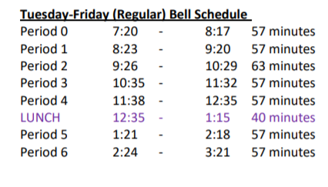

cid:image003.jpg@01D1B831.05320ED0Student Notescid:image003.jpg@01D1B831.05320ED0

**1**. Landed a job and need a work permit? Come to the front office and pick up an application with Mrs. Reyes

**2. Student replacement IDs are $10**. Please fill out a half sheet in the Finance Center and pay Ms. Chavez.

**3.**

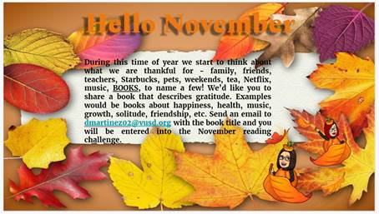.

4. Pioneers! Mt. Whitney High School is offering current Juniors and Seniors the opportunity to take the ASVAB (Armed Services Vocational Aptitude Battery) Test on November 17. This test is free and it is a great way to identify skill strengths and explore career ideas! You can find more information about the test here: <https://www.asvabprogram.com/student> . The deadline to sign up is November 12th and only those who sign up will be allowed to test. Sign up on the link below.

<https://forms.gle/nMZ2ofqPMapGsmNF8>

5. XL will be having all tutoring in the library from now on. For our morning, it will run 7am-8am Tuesday thru Friday. After-school hours 3:30pm to 5:30pm, if you need tutoring please go to the Library.

6. Looking to spend time playing an awesome game with friends? **Dungeons and Dragons club** is looking for more members. Please come to the Library Wednesday or Thursday at 3:30 to sign up

7. XL has started Art Studio class. Join us to learn how draw and paint, or just create your own pieces of art after-school on Tuesday and Thursday in room S-11

8. Join XL to help usher in the Holiday spirit during our November events:

**Every Friday:** Harry Potter Movies starting the series with Sorcerer’s Stone (popcorn will be provided.) **November 10th**: Fall Paint Night: Come paint your own painting that showcases the beauty of the Fall Season. **November 17th**: Thanksgiving Raffle – Win prizes to kick of the Thanksgiving break

9. Looking to get a head start on your career path?

Join us every Thursday for our College and Career Workshops: For November We have…

11/11: Career Training at SJVC

11/18: Advance Career Institute – Topic: Hauling and Welding BIG STUFF

10. Congratulations to our FFA Cotton Judging team who placed 5th in the state last Saturday.  Team consisting of Rachel Majarian, Aidan Brown, Taylor Heine and Kylee Filiponi also placed 2nd high team in Bolls, 5th high team in Lint and 5th high team overall in seeds.  For individual awards, Rachel Majarian was 3rd high individual in Bolls and 6th high overall out of 45 contestants.  Aidan Brown was 5th high in bolls and 4th high in lint and 8th high overall.  Congratulations on a job well done!

11. Are you ready to learn a new dance routine? XL is hosting a dance class Nov. 17 at 3:30 in the dance room. You do not need experience to join, everyone is welcomed!

*MC900446010[1]*

*Club Note*

1. GSA club will meet TODAY and continue that alternating schedule.
2. Are you interested in E-Sports? Do you want to know what E-Sports is? Stop by J6 for information, and join the Remind @mwesport for updates about practices and tournaments. Practice for the Spring season starts soon!
3. Pioneer Partners are meeting TODAY during lunch in G-4 to help the students complete a couple of Thanksgiving art projects.   Pizza, water, and cookies will be provided.  Hope to see you there.

***cid:image007.jpg@01D1B831.05320ED0* Senior Notes 

1. Time to order your Cap and Gown!! Jostens packets were distributed to your Civics or Economics teacher. If you do not have Civics or Economics, please stop by the Front Office, Attendance Office, Counseling Office, or Library for a packet.

***cid:image008.png@01D1B831.05320ED0College Visit Sign-ups cid:image009.png@01D1B831.05320ED0***

**NONE AT THIS TIME**

Senior Scholarships 

**To unsubscribe or subscribe to the Daily Bulletin:**

<http://mailman.visalia.k12.ca.us/mailman/listinfo/mwhs-bulletin>

Have questions regarding the bulletin? Contact:

**Veronica Reyes, MWHS**

[**vreyes@vusd.org**](mailto:vreyes@vusd.org)