cid:image001.jpg@01D1B831.05320ED0Mt. Whitney High Schoolcid:image001.jpg@01D1B831.05320ED0

***A California Distinguished School & Home of the Pioneers!***

*Go Pioneers!*

Thursday, December 9, 2021



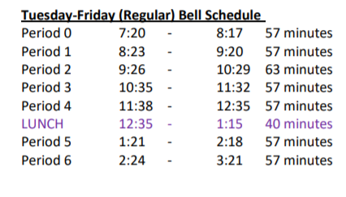

cid:image003.jpg@01D1B831.05320ED0Student Notescid:image003.jpg@01D1B831.05320ED0

**1**. Landed a job and need a work permit? Come to the front office and pick up an application with Mrs. Reyes

**2. Student replacement IDs are $10**. Please fill out a half sheet in the Finance Center and pay Ms. Chavez.

**3**. 

4.

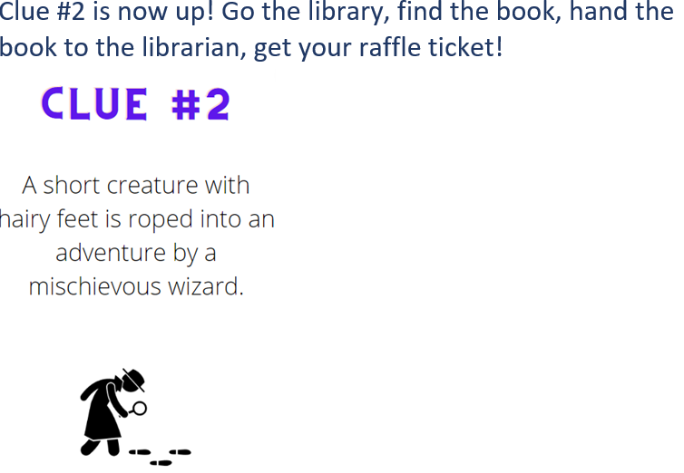

**5**. **Attention all MW students**:  Don’t wait to the last minute to get your grades up for your final semester grade.  Mrs. Johnson is offering the MW THINK TANK in B-24 on Tuesday’s and Thursdays from 3:30-4:30pm.  This is a time to work, get assistance and come up with a plan to get all the credit you can for this semester.   There is also two more Saturday Schools left of the semester- December 4th and 11th. Please stop by B-24 to sign up for this opportunity.  Space is limited. YOU CAN DO IT PIONEERS!!!

**6.** **Attention all students**, especially juniors and seniors: it is VERY important to remember to frequently check your student email. Your counselors will be sending out important information and reminders that you won't want to miss! If you don't have access to your student email, please let your counselor know

**7.** Stressed from school, tests, homework, or life in general?  After-School every Monday, Wednesday, and Friday stop by S11 to punch Bob The Boxer (Our boxing dummy) to let off a bit off steam.

**8**. The end of semester is closing in. Come to the library before and after school to get help from XL tutors, and get your grades up.

**9**. Join the after-school program for our Christmas Movie Series.

12/8 is Home Alone at 3:30PM

12/9 is Nightmare Before Christmas at 3:30PM

12/10 is Harry Potter: The Order of the Phoenix at 3:30PM

**10.** **ASB is hosting a holiday classroom door decorating contest**! It will take place from December 6th through the 10th. Sign up using the Google doc. that was sent to all staff via email. All teachers & staff are welcome. Judging will take place on Friday, December 10th starting 3rd period. Judges will choose a winner for these 4 categories: funniest, classiest, most creative, and best overall.

Holiday Dress Up Days will be happening December 6th through the 10th:

**TODAY:** Grandma got ran over by a reindeer (dress like a senior citizen or Mr. or Mrs. Clause)

**Thursday:** Winter Cabin wear plaid or flannels!

**Friday**: A very tacky Christmas- Wear ugly sweaters, or tacky gift-wrapping accessories!

**WE CAN'T WAIT TO SEE YOUR HOLIDAY SPIRIT!**

**11.** On December 14th, the afterschool program will be having a raffle to win prizes. Please stop by room S11 next to the cafeteria to sign up for the raffle

**12. The Mt. Whitney Choral Program** invites you to celebrate the Season with them this coming Thursday at 7pm at the L.J. Williams Theater. Tickets are $8 for general admission and $5 for Students. We'd love to see you there!

*MC900446010[1]*

*Club Note*

1. D&D Club is looking for new members. If you want to play one of the COOLEST board games ever, come to the library on Wednesday.
2. The interact club is hosting a canned food drive this week 12/6-12/10 and finals week 12/13-12/17. We are donating all cans to Bethlehem Center and any support from students and staff is greatly appreciated! Drop boxes will be located in the front office, ASB room, k-5, k-6, and x-2.

***cid:image007.jpg@01D1B831.05320ED0* Senior Notes**

1. Time to order your Cap and Gown!! Jostens packets were distributed to your Civics or Economics teacher. If you do not have Civics or Economics, please stop by the Front Office, Attendance Office, Counseling Office, or Library for a packet.
2. Seniors- We have a date to Gradnite!! 2022 Gradnite is scheduled for May 20th and 21st to Disneyland/California Adventure Parks! Price on tickets will become available soon. We will let you know when permission slips will be available for pick up.
3. Seniors- Deadline to order your Cap and Gown is December 15th. A flier has been sent to you via email. Please don’t delay. Order today!!

***cid:image008.png@01D1B831.05320ED0College Visit Sign-ups cid:image009.png@01D1B831.05320ED0***

**NONE AT THIS TIME**

Senior Scholarships 

**To unsubscribe or subscribe to the Daily Bulletin:**

<http://mailman.visalia.k12.ca.us/mailman/listinfo/mwhs-bulletin>

Have questions regarding the bulletin? Contact:

**Veronica Reyes, MWHS**

[**vreyes@vusd.org**](mailto:vreyes@vusd.org)