cid:image001.jpg@01D1B831.05320ED0Mt. Whitney High Schoolcid:image001.jpg@01D1B831.05320ED0

***A California Distinguished School & Home of the Pioneers!***

*Go Pioneers!*

Monday, December 13, 2021



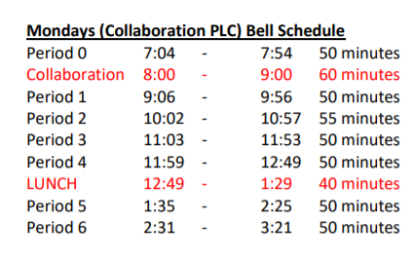

cid:image003.jpg@01D1B831.05320ED0Student Notescid:image003.jpg@01D1B831.05320ED0

**1**. Landed a job and need a work permit? Come to the front office and pick up an application with Mrs. Reyes

**2. Student replacement IDs are $10**. Please fill out a half sheet in the Finance Center and pay Ms. Chavez.

**3**. Once you figure out which book it is, come to the library, find the book, hand to the librarian, and get your raffle ticket! Good luck!

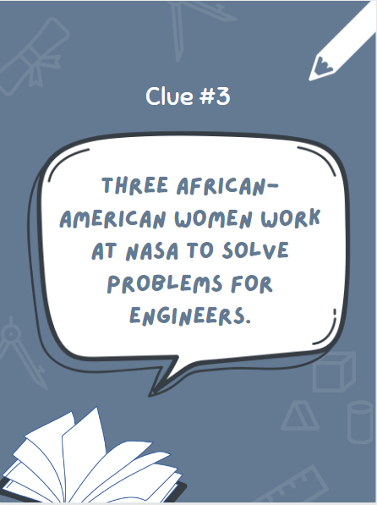

**4**. **Attention all MW students**:  Don’t wait to the last minute to get your grades up for your final semester grade.  Mrs. Johnson is offering the MW THINK TANK in B-24 on Tuesday’s and Thursdays from 3:30-4:30pm.  This is a time to work, get assistance and come up with a plan to get all the credit you can for this semester.   There is also two more Saturday Schools left of the semester- December 4th and 11th. Please stop by B-24 to sign up for this opportunity.  Space is limited. YOU CAN DO IT PIONEERS!!!

**5.** **Attention all students**, especially juniors and seniors: it is VERY important to remember to frequently check your student email. Your counselors will be sending out important information and reminders that you won't want to miss! If you don't have access to your student email, please let your counselor know

**6.** Stressed from school, tests, homework, or life in general?  After-School every Monday, Wednesday, and Friday stop by S11 to punch Bob The Boxer (Our boxing dummy) to let off a bit off steam.

**7**. The end of semester is closing in. Come to the library before and after school to get help from XL tutors, and get your grades up.

**8.** On December 14th, the afterschool program will be having a raffle to win prizes. Please stop by room S11 next to the cafeteria to sign up for the raffle

**9**. Mt Whitney students let’s start the New Year with some volleyball! All guys and girls are welcome Mondays and Wednesdays from 3:30-5 pm.  Want to try volleyball?  This is the perfect time. All skill levels are welcome.  If you have any questions, please stop by B-24. This will start January 19th. Mrs. Johnson

10. Any students who are interested in careers in the health field, the Academy of Health Sciences is accepting new members. If interested, please see Mr. Perrotta in H-5 or Mr. Naylor in I-7 this week. Students must have a 2.0 GPA minimum and a desire to explore health careers.

*MC900446010[1]*

*Club Note*

1. D&D Club is looking for new members. If you want to play one of the COOLEST board games ever, come to the library on Wednesday.
2. The interact club is hosting a canned food drive finals week 12/13-12/17. We are donating all cans to Bethlehem Center and any support from students and staff is greatly appreciated! Drop boxes will be located in the front office, ASB room, k-5, k-6, and x-2.

***cid:image007.jpg@01D1B831.05320ED0* Senior Notes**

1. Time to order your Cap and Gown!! Jostens packets were distributed to your Civics or Economics teacher. If you do not have Civics or Economics, please stop by the Front Office, Attendance Office, Counseling Office, or Library for a packet.
2. Seniors- We have a date to Gradnite!! 2022 Gradnite is scheduled for May 20th and 21st to Disneyland/California Adventure Parks! Price on tickets will become available soon. We will let you know when permission slips will be available for pick up.
3. Seniors- Deadline to order your Cap and Gown is December 15th. A flier has been sent to you via email. Please don’t delay. Order today!!

***cid:image008.png@01D1B831.05320ED0College Visit Sign-ups cid:image009.png@01D1B831.05320ED0***

**NONE AT THIS TIME**

Senior Scholarships 

**To unsubscribe or subscribe to the Daily Bulletin:**

<http://mailman.visalia.k12.ca.us/mailman/listinfo/mwhs-bulletin>

Have questions regarding the bulletin? Contact:

**Veronica Reyes, MWHS**

[**vreyes@vusd.org**](mailto:vreyes@vusd.org)