cid:image001.jpg@01D1B831.05320ED0Mt. Whitney High Schoolcid:image001.jpg@01D1B831.05320ED0

***A California Distinguished School & Home of the Pioneers!***

*Go Pioneers!*

Monday, January 10, 2022



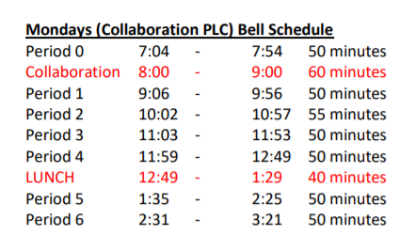

cid:image003.jpg@01D1B831.05320ED0Student Notes

**1**. Landed a job and need a work permit? Come to the front office and pick up an application with Mrs. Reyes

**2. Student replacement IDs are $10**. Please fill out a half sheet in the Finance Center and pay Ms. Chavez.

**3.** Students- we will not be printing 2nd semester schedules. Please find your 2nd Semester schedule on Schoology.

*MC900446010[1]*

*Club Note*

**NOT AT THIS TIME**

 Senior Notes**

1. Time to order your Cap and Gown!! Jostens packets were distributed to your Civics or Economics teacher. If you do not have Civics or Economics, please stop by the Front Office, Attendance Office, Counseling Office, or Library for a packet.
2. Seniors- We have a date to Gradnite!! 2022 Gradnite is scheduled for May 20th and 21st to Disneyland/California Adventure Parks! Price on tickets will become available soon. We will let you know when permission slips will be available for pick up.
3. Seniors- Order your cap and gown with three ways to order: 1-800-JOSTENS, Jostens.com; or visit their office at 1222 W Murray Ave on Tuesdays, Wednesdays, and Thursdays from 1:00pm-5:30pm. Deadline for a second chance to order will be March 1st. If you need more time, please see Mrs. Reyes

***cid:image008.png@01D1B831.05320ED0College Visit Sign-ups cid:image009.png@01D1B831.05320ED0***

**NONE AT THIS TIME**

Senior Scholarships 

**To unsubscribe or subscribe to the Daily Bulletin:**

<http://mailman.visalia.k12.ca.us/mailman/listinfo/mwhs-bulletin>

Have questions regarding the bulletin? Contact:

**Veronica Reyes, MWHS**

[**vreyes@vusd.org**](mailto:vreyes@vusd.org)