cid:image001.jpg@01D1B831.05320ED0Mt. Whitney High Schoolcid:image001.jpg@01D1B831.05320ED0

***A California Distinguished School & Home of the Pioneers!***

*Go Pioneers!*

Tuesday, January 25, 2022



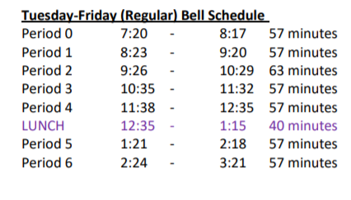

cid:image003.jpg@01D1B831.05320ED0Student Notes

**1**. Landed a job and need a work permit? Come to the front office and pick up an application with Mrs. Reyes

**2. Student replacement IDs are $10**. Please fill out a half sheet in the Finance Center and pay Ms. Chavez.

**3**. Welcome back Pioneers! The library December/January reading challenge is still going on. Come into the library, find the book, hand to the librarian, and get your raffle ticket. Good luck! And as always, happy reading Pioneers!

Here’s this week’s clue:

Here is the final clue for the December/January reading challenge. Come to the library, find the book, hand to the librarian, and get your raffle ticket.

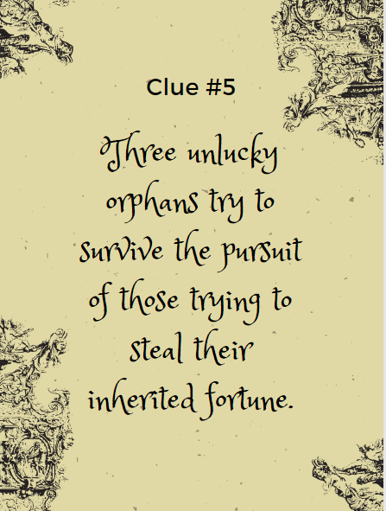

**4.** The After-School program is hosting FAFSA Night on January 27th & 28th starting at 3:30pm in the Library. We are going to walk students and parents through filling out the FAFSA application step by step

**5**. Interested in having some fun while learning new skills? The After-School program presents Volleyball Club with Mrs. Johnson! Come join us every Monday and Wednesday, South of the boys locker-room and North of the Track field. All skill levels are welcome!  For any questions contact Mrs. Johnson in B-24. See you there

**6**. Who's ready for some live theater?! Come on out and enjoy Mamma Mia the Musical put on by Mt. Whitney and El Diamante students. The shows will be February 3rd, 4th, and 5th at 7:00pm and February 5th at 2:00pm at the LJ Williams Theater. Tickets are $10 for students, and $12 for adults and can be purchased from cast members or at the door. We can't wait to show you this fun, upbeat musical!

**7**. The 2021-2022 Winter Formal will be held at Groppetti Community Stadium at Golden West High School on Saturday, February 12th! Come out and enjoy a night of dancing, partying, and hanging out with all of the Visalia Unified community! Masks are required, and every student who buys a ticket will be required to provide proof of a negative test within 72 hours of the dance. Our on-campus covid testing facility will be available to all students and ticket sales are happening Feb. 8th through the 11th.

*MC900446010[1]*

*Club Note*

**NOT AT THIS TIME**

 Senior Notes**

1. Time to order your Cap and Gown!! Jostens packets were distributed to your Civics or Economics teacher. If you do not have Civics or Economics, please stop by the Front Office, Attendance Office, Counseling Office, or Library for a packet.
2. Seniors- We have a date to Gradnite!! 2022 Gradnite is scheduled for Friday, May 20th and Saturday, May 21st to Disneyland/California Adventure Parks! Ticket price is $250. Permission slips will be available in the Front Office and Attendance Office starting January 18th with detailed information on steps to purchase your ticket.
3. Seniors- Order your cap and gown with three ways to order: 1-800-JOSTENS, Jostens.com; or visit their office at 1222 W Murray Ave on Tuesdays, Wednesdays, and Thursdays from 1:00pm-5:30pm. Deadline for a second chance to order will be March 1st. If you need more time, please see Mrs. Reyes

***cid:image008.png@01D1B831.05320ED0College Visit Sign-ups cid:image009.png@01D1B831.05320ED0***

**NONE AT THIS TIME**

Senior Scholarships 

**To unsubscribe or subscribe to the Daily Bulletin:**

<http://mailman.visalia.k12.ca.us/mailman/listinfo/mwhs-bulletin>

Have questions regarding the bulletin? Contact:

**Veronica Reyes, MWHS**

[**vreyes@vusd.org**](mailto:vreyes@vusd.org)