cid:image001.jpg@01D1B831.05320ED0Mt. Whitney High Schoolcid:image001.jpg@01D1B831.05320ED0

***A California Distinguished School & Home of the Pioneers!***

*Go Pioneers!*

Thursday, February 17, 2022



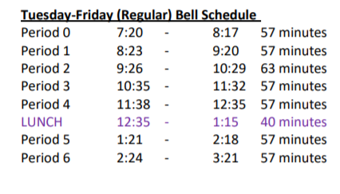

cid:image003.jpg@01D1B831.05320ED0Student Notes

**1.** Landed a job and need a work permit? Come to the front office and pick up an application with Mrs. Reyes

**2. Student replacement IDs are $10**. Please fill out a half sheet in the Finance Center and pay Ms. Chavez. Then please pick up your ID the next day from Mrs. Reyes in the front office

**3.** On February 16th at 4pm, XL is hosting a presentation from the Estes Institute of Cosmotology. The presentation will be held in the library.

**4.** Attention Students: Do you know someone or have you watched vandalism of restrooms? Please help us and inform the main office or administration.

**5**. Yearbook is accepting applications for next year’s yearbook staff.  If you are interested in joining this great opportunity, please apply using the google form that was sent out in Schoology.

**6**. Hello Students- Please show your Pioneer Pride by throwing away your trash in a trash can. We have over 100 trash cans for your use. We ask you to throw away your food after lunch also. Please keep Us keep our school clean. Thank you from the Grounds Workers

**7**. Congratulations to the winter drumline for placing first at their competition this weekend. We are proud of you!

**8**. If you had your picture taken last Friday for the Valentine’s Day photobooth, please stop by room S11 this week to pick up your picture.

**9.** Friday 2/25/21 the anime movie Spirted Away will be shown in the library starting 3:30pm.

*MC900446010[1]*

*Club Note*

**NOT AT THIS TIME**

 Senior Notes**

1. Seniors- Tickets go on sale March 3rd and March 4th before school from 7:30AM- 8:15AM and after school from 3:21PM-4:30PM in the Library. Ticket sales ends March 8th, no exception. Mark your calendar! 2022 Gradnite is scheduled for Friday, May 20th and Saturday, May 21st Disneyland/California Adventure Parks! Ticket price is $250. Permission slips are available in the Front Office and Attendance Office with detailed information on steps to purchase your ticket.
2. Seniors- Order your cap and gown with three ways to order: Jostens.com or visit their office at 1222 W Murray Ave on Tuesdays, Wednesdays, and Thursdays from 1:00pm-5:30pm. Deadline for a second chance to order will be March 1st. If you need more time, please see Mrs. Reyes

***cid:image008.png@01D1B831.05320ED0College Visit Sign-ups cid:image009.png@01D1B831.05320ED0***

**NONE AT THIS TIME**

Senior Scholarships 

**To unsubscribe or subscribe to the Daily Bulletin:**

<http://mailman.visalia.k12.ca.us/mailman/listinfo/mwhs-bulletin>

Have questions regarding the bulletin? Contact:

**Veronica Reyes, MWHS**

[**vreyes@vusd.org**](mailto:vreyes@vusd.org)