cid:image001.jpg@01D1B831.05320ED0Mt. Whitney High Schoolcid:image001.jpg@01D1B831.05320ED0

***A California Distinguished School & Home of the Pioneers!***

*Go Pioneers!*

**Wednesday, June 1, 2022**

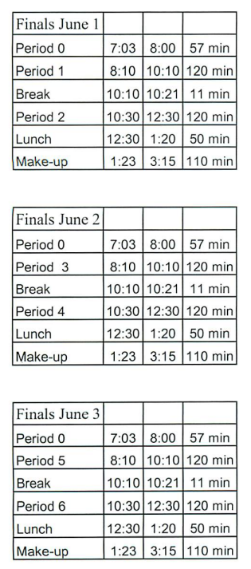

cid:image003.jpg@01D1B831.05320ED0Student Notes

**1.** Landed a job and need a work permit? Come to the front office and pick up an application with Mrs. Reyes

**2. Student replacement IDs are $10**. Please fill out a half sheet in the Finance Center and pay Ms. Chavez. Then please pick up your ID the next day from Mrs. Reyes in the front office

**3**. Yearbook is accepting applications for next year’s yearbook staff.  If you are interested in joining this great opportunity, please apply using the google form that was sent out in Schoology.

**4.** Tutoring is offered before and after school in the library. IT IS FREE for all students. If you need help with your homework, please go to the library Tuesday thru Friday at 7am OR Go to the library after school to get the help you need.

**5.** Prom pictures are in! Please come by the front office before school, during lunch, and after school to pick up your pictures.

**6**. Thank you to All of our Scicon Counselors this year for helping the return to Scicon a great experience for 6th graders. All of you came back with Good to Excellent evaluations. You represented Mt Whitney with Pride, Integrity, followed rules Scicon asked you to implement and carry through without hesitation. Thank you Again for making my job to recruit Scicon counselors beyond easy, Mrs. Reyes.

*MC900446010[1]*

*Club Note*

1. E-Sports team has open practice on Tuesdays and Wednesdays. If you have questions, please see Mrs. Russell in J-6

 Senior Notes**

1. If you have not ordered your cap and gown, please do so at josten.com or 1-800-jostens and your order will be delivered to the front office.
2. Seniors! Need help completing your COS priority class registration and creating your COS class schedule? Meet with our XL CCA after-school in the library! Every day from 2 to 5pm!
3. Looking for all Class of 2022 Seniors who attended Royal Oaks. Please come let us honor you! Meet in the front office at Royal Oaks on May 31st at 10:30 AM and don't forget to wear your caps
4. Attention seniors who had Ms. Vannorsdall or Miss Rapozo - your Senior letters are in

J-6. Please stop by between classes or during lunch to pick them up.

1. Next Wednesday on June 1st, we will have our commencement practice at the Mineral King Bowl starting at 7 am.  Please make sure you are cleared before arriving at the bowl, otherwise you will be sent back to campus to meet with Mrs. Wheaton in the library.  You will be able to enter the bowl through the east gate at the ramp area in the parking lot on the corner of Conyer and Mineral King. Also, if you are in need of a cap and gown, loaners will be provided at the ceremony.  You will be able to check them out and will have to return them at the diploma table after the ceremony before you will receive your diploma.  The time for our big event is getting closer so let's make sure we are ready.  If you have questions, please let me know or come to the main office for more details. Mr. Aguilar

***cid:image008.png@01D1B831.05320ED0College Visit Sign-ups cid:image009.png@01D1B831.05320ED0***

**NONE AT THIS TIME**

Senior Scholarships 

1. **Attention Seniors Who Attended Ridgeview**! A new scholarship was added late this year. Our forms were updated to include Scholarship #26 for a graduating senior who attended Ridgeview Middle School. If you have already submitted your application and qualify for this scholarship, please call Laura Pace at (559) 972-6976 or email [scholarships@visaliaedfoundation.org](mailto:scholarships@visaliaedfoundation.org) and we can modify your application to include this if you are eligible.
2. **Juniors** - This summer, COS will be offering the Jump Start Internship for students interested in industrial careers. From July 5th - July 28th, students who are interested in industrial careers, will have training in electrical, OSHA safety, exposure to industrial technology careers, industry tours of local manufacturers, and more. Upon completion of the internship, students will receive $1,500. High School juniors (incoming seniors) are encouraged to apply for the internship. If you have any questions, please reach out to Gary Potter, the Regional Director for Employer Engagement (Advanced Manufacturing), at [garypotter@whccd.edu](mailto:garypotter@whccd.edu), (559) 920-2845.  You can find the link to apply on Schoology.

**To unsubscribe or subscribe to the Daily Bulletin:**

<http://mailman.visalia.k12.ca.us/mailman/listinfo/mwhs-bulletin>

Have questions regarding the bulletin? Contact:

**Veronica Reyes, MWHS**

[**vreyes@vusd.org**](mailto:vreyes@vusd.org)