cid:image001.jpg@01D1B831.05320ED0Mt. Whitney High Schoolcid:image001.jpg@01D1B831.05320ED0

***A California Distinguished School & Home of the Pioneers!***

*Go Pioneers!*

**Friday, June 3, 2022**

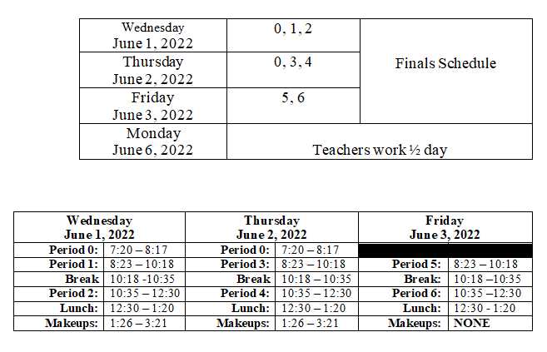

cid:image003.jpg@01D1B831.05320ED0Student Notes

**1.** Landed a job and need a work permit? Come to the front office and pick up an application with Mrs. Reyes

**2. Student replacement IDs are $10**. Please fill out a half sheet in the Finance Center and pay Ms. Chavez. Then please pick up your ID the next day from Mrs. Reyes in the front office

**3**. Yearbook is accepting applications for next year’s yearbook staff.  If you are interested in joining this great opportunity, please apply using the google form that was sent out in Schoology.

**5.** Prom pictures are in! Please come by the front office before school, during lunch, and after school to pick up your pictures.

*MC900446010[1]*

*Club Note*

**NOT AT THIS TIME**

 Senior Notes**

**NOT AT THIS TIME**

***cid:image008.png@01D1B831.05320ED0College Visit Sign-ups cid:image009.png@01D1B831.05320ED0***

**NONE AT THIS TIME**

Senior Scholarships 

1. **Attention Seniors Who Attended Ridgeview**! A new scholarship was added late this year. Our forms were updated to include Scholarship #26 for a graduating senior who attended Ridgeview Middle School. If you have already submitted your application and qualify for this scholarship, please call Laura Pace at (559) 972-6976 or email [scholarships@visaliaedfoundation.org](mailto:scholarships@visaliaedfoundation.org) and we can modify your application to include this if you are eligible.
2. **Juniors** - This summer, COS will be offering the Jump Start Internship for students interested in industrial careers. From July 5th - July 28th, students who are interested in industrial careers, will have training in electrical, OSHA safety, exposure to industrial technology careers, industry tours of local manufacturers, and more. Upon completion of the internship, students will receive $1,500. High School juniors (incoming seniors) are encouraged to apply for the internship. If you have any questions, please reach out to Gary Potter, the Regional Director for Employer Engagement (Advanced Manufacturing), at [garypotter@whccd.edu](mailto:garypotter@whccd.edu), (559) 920-2845.  You can find the link to apply on Schoology.

**To unsubscribe or subscribe to the Daily Bulletin:**

<http://mailman.visalia.k12.ca.us/mailman/listinfo/mwhs-bulletin>

Have questions regarding the bulletin? Contact:

**Veronica Reyes, MWHS**

[**vreyes@vusd.org**](mailto:vreyes@vusd.org)