cid:image001.jpg@01D1B831.05320ED0Mt. Whitney High Schoolcid:image001.jpg@01D1B831.05320ED0

***A California Distinguished School & Home of the Pioneers!***

*Go Pioneers!*

Friday, September 23, 2022

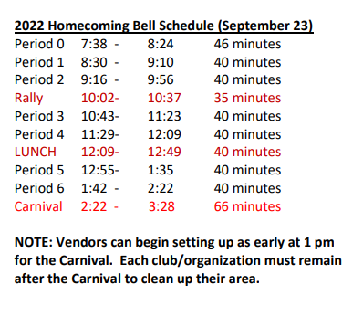

cid:image003.jpg@01D1B831.05320ED0Student Notescid:image003.jpg@01D1B831.05320ED0

1. Landed a job and need a work permit? Come to the front office and pick up an application with Mrs. Reyes

**2**. Come hang out after school with XL!!! At XL, you can make new friends, get snack and food service, access our computer lab, get tutoring, discover new hobbies, and play video games.

**3**. Have you purchased your ASB sticker yet? You'll get into home games for free and discounts on dances! They are on sale before school, at lunch, and after school in the finance office. Get yours today!

**4**. Do you like that show Stranger Things? You know the board game they play in it? Ya… We have a club for that. Go to S11 to sign up to play Dungeons and Dragons!

**5**. Anime Club will start meeting in the Library every Thursday after-school!

**6.** Chess Club has started and meets Wednesdays and Fridays after-school in the library. Come join Us!

**7**. If you are swimmer or wanting to join the swim team, the pool is going to be available a few days a week to work on your skills. Go to S11 to get additional information.”

**9**. Before and After-School, in the Library, academic tutoring support is available. Please stop by the Library during those times to find out more.

**10**. After school, on September 22nd in room S11, XL is hosting a Paint Night. If you like to paint, please join us as we kick off the Autumn season. All supplies will be provided.

*MC900446010[1]*

*Club Notes*

NOT AT THIS TIME

***cid:image007.jpg@01D1B831.05320ED0* Senior Notes 

1. Seniors- Jostens will be in the gym on October 11th from 12:12-12:42PM to conduct a Senior presentation. Orders will be handed out on Oct 18th from 8:30am-3:30pm during your Civics/Econ classes, location to be determined.

***cid:image008.png@01D1B831.05320ED0College Visit Sign-ups cid:image009.png@01D1B831.05320ED0***

**NONE AT THIS TIME**

Senior Scholarships 

**To unsubscribe or subscribe to the Daily Bulletin:**

<http://mailman.visalia.k12.ca.us/mailman/listinfo/mwhs-bulletin>

Have questions regarding the bulletin? Contact:

**Veronica Reyes, MWHS**

[**vreyes@vusd.org**](mailto:vreyes@vusd.org)