cid:image001.jpg@01D1B831.05320ED0Mt. Whitney High Schoolcid:image001.jpg@01D1B831.05320ED0

***A California Distinguished School & Home of the Pioneers!***

*Go Pioneers!*

Thursday, October 13, 2022



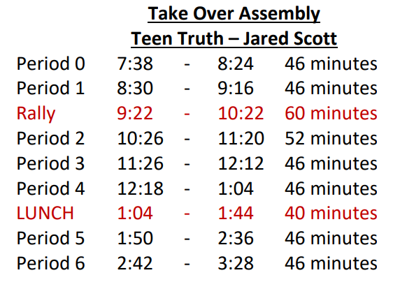

cid:image003.jpg@01D1B831.05320ED0Student Notescid:image003.jpg@01D1B831.05320ED0

1. Landed a job and need a work permit? Come to the front office and pick up an application with Mrs. Reyes

**2**. Come hang out after school with XL!!! At XL, you can make new friends, get snack and food service, access our computer lab, get tutoring, discover new hobbies, and play video games.

**3**. Have you purchased your ASB sticker yet? You'll get into home games for free and discounts on dances! They are on sale before school, at lunch, and after school in the finance office. Get yours today!

**4**. Dungeons and Dragons club is meeting after school, every Friday, in room M6. Please join us

**5**. Anime Club is meeting every Thursday after school in room M6.

**6.** Chess Club has started and meets Wednesdays and Fridays after-school in the library. Come join Us!

**7**. If you are swimmer or wanting to join the swim team, the pool is going to be available a few days a week to work on your skills. Go to S11 to get additional information.”

**8**. Before and After-School, in the Library, academic tutoring support is available. Please stop by the Library during those times to find out more.

**9**. Hello Pioneers! All are welcome to join XL’s Folklorico Dance class after school in the dance room on Tuesdays from 3:30-4:30.  Ms. Rodriguez is teaching the class (Mrs. A’s student teacher) and she is awesome!  No previous dance experience required.  Come on Tuesday to check it out!

11. Pioneers! Mt. Whitney High School is offering current Juniors and Seniors the opportunity to take the ASVAB (Armed Services Vocational Aptitude Battery) Test on November 9. This test is free and it is a great way to identify skill strengths and explore career ideas! You can find more information about the test here: <https://www.asvabprogram.com/student> . The deadline to sign up is November 4th and only those who sign up will be allowed to test. Sign up on the link sent to your student email

12. Friday, October 14 is our PINK OUT football game against El Diamante at the Mineral King Bowl! Let's fill our student section with Pink in honor of breast cancer awareness.

Pink out shirts will be available for $15 in front of the Amaral building at lunch. Stop by and pick yours up today so we can all wear pink at our next home football game on October 14.

All are welcome to our first ever night rally and trunk or treat on Monday, October 24. Join us in the Mt. Whitney gym at 7pm for our night rally, and then follow us out to the basketball courts for trunk or treat. Enjoy good food and family friendly fun! Don't forget to dress in your scariest costume for our costume competition!

Make sure you follow us on Instagram and TikTok @mtwhitneyasb for all the latest events, news and updates about the school! Clubs & students, don’t forget to tag us in any school related events and fun!

*MC900446010[1]*

*Club Notes*

1. Hey Key Clubbers, don't forget we are meeting this Friday in Room J-12 at 12:50 PM.  Grab something to eat and meet us there.  This week, Mrs. TJ is bringing a treat for all members:)  Don't forget you have to attend meetings to be eligible for Fall Rally!
2. Attention all students!!!  Save your coin so you can put a pie in the face of your favorite teacher/administrator.  On October 14th Key Club will be fundraising for the Pediatric Trauma Center and for the Key Club's annual Fall Rally.  Put together funds with your friends to pie a teacher/administrator.   This fun event will take place on the Quad during lunch on Friday the 14th.  Rumor has it that Mr. Aguilar himself has signed up for a pie in the face, so don't miss your chance:)
3. Attention Teachers and Administrators!  It is not too late to sign up for a Pie in the Face!  All the money goes to a great cause.  If you would like to help our campus Key Club, please sign up on the Google Form emailed to you.  It is going to be fun!
4. PLS (the poetry club) will meet on Tuesday 10/25 in J5 during lunch

***cid:image007.jpg@01D1B831.05320ED0* Senior Notes 

1. Seniors- Jostens will be in the gym on TODAY from 12:12-12:42PM to conduct a Senior presentation. Orders will be handed out on Oct 18th from 8:30am-3:30pm during your Civics/Econ classes, location to be determined.



If you need to meet with your counselor, please submit a request at vusd.org/domain/935 or stop by during walk-in hours at lunch.

Upcoming Events:

October

October

* 10/1 – 10/14 – Senior Meetings
* 10/1 - Mt. Whitney Local Scholarship Application opens
* 10/13 – CSU Application Workshop (Register at: <https://forms.gle/1j2dLhYFdN93fKBx6>)
* 10/20 – Fresno Pacific Application Workshop (Register at: <https://forms.gle/u7YTsWy2MEJMjRga8>)
* 10/26 – Financial AidWorkshop for FAFSA/CADAA (during school hours)
* 10/26 – Application Workshop for FAFSA/CADAA (3:30 – 6:00) in S-11

November

* 11/2 – COS Application Workshop
* 11/3 - COS Application Workshop
* 11/9 or 11/16 Financial AidWorkshop for FAFSA/CADAA (3:30 – 6:00) in S-11

December

* 12/13 - Financial AidWorkshop for FAFSA/CADAA (during school hours)

**Senior Scholarships (find details on Schoology Class of 2023 Group)**

*For any scholarship-related questions, please reach out to Mr. Viveros*

Additional scholarships can be found at FastWeb.com

* Opens 10/1 – Mt. Whitney Local Scholarship Application
* Due 10/8 – AES Engineering
* Due 10/12 – Dr. Pepper Tuition Giveaway
* Due 10/31 – Zombie Apocalypse Scholarship
* Due 10/31 – Coca Cola Scholars Program

**To unsubscribe or subscribe to the Daily Bulletin:**

<http://mailman.visalia.k12.ca.us/mailman/listinfo/mwhs-bulletin>

Have questions regarding the bulletin? Contact:

**Veronica Reyes, MWHS**

[**vreyes@vusd.org**](mailto:vreyes@vusd.org)