Mt. Whitney High School
A California Distinguished School & Home of the Pioneers
Go Pioneers!

Wednesday December 14, 2022

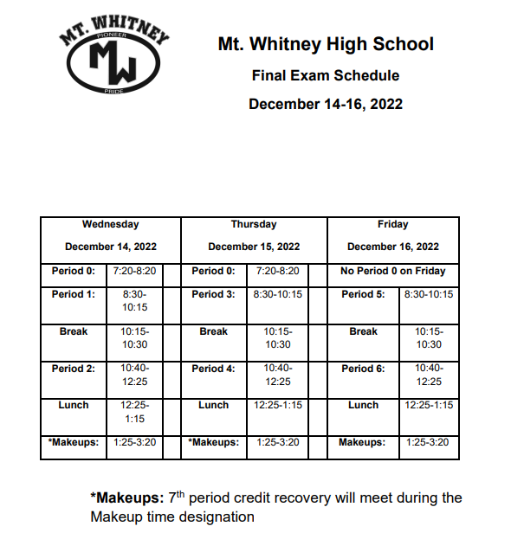

Student Notes

1. Landed a job and need a work permit? Come to the front office and pick up an application with Mrs. Villalobos
2. If you want a place to stay warm during the early morning hours, the library is open Monday thru Friday at 7:15am. Also, tutoring is available in the morning too.

3. Have you purchased your ASB sticker yet? You'll get into home games for free and discounts on dances! They are on sale before school, at lunch, and after school in the finance office. Get yours today!

4. Need some help with homework? Tutoring is available for FREE after-school in the library Monday thru Thursday.

5. Starting next semester, a Boxing class will be coming to Mt. Whitney High School. Stop by S11 and talk to Scott for more details.

6. On December 14th, 15th, and 16th join XL in room S11 for their Movie and Ornament Decorating Christmas Special.
The movies are:
Dec. 14th - Spirited with Ryan Reynolds
Dec 15th - Guardians of the Galaxies: Holiday Special
Dec 16th – Elf

7. Hello Pioneers! All are welcome to join XL’s Folklorico Dance class after school in the dance room on Tuesdays from 3:30-4:30. Ms. Rodriguez is teaching the class (Mrs. A’s student teacher) and she is awesome! No previous dance experience required. Come on Tuesday to check it out!
8. Drama Club is holding special elections. Please come by the Drama room and scan the QR code you are interested in running for an office

9. It's time for Cocoa and Cram! Freshmen: come to K-7 during lunch Monday and Tuesday December 12 and 13 for help preparing for your finals. Link Leaders will be available to answer your questions on all Freshman class subjects.

Club Notes

*ASB selling MW Croc charms for $4 during lunch!

*Chess Club meets every day, during lunch, in room S11. Also, the club meets Monday and Wednesday in the library after-school. If you play chess or want to learn, you are invited to join us.

* Juniors and Seniors, we are still in need of 4 male Scicon counselors. If you have good grades and would like to join Mtn.View 1/9/22-1/13/22 or 1/23/23-1/27/22 please see Mrs. Villalobos in the main office for a application!

Senior Notes

Mt. Whitney High School Seniors and Parents. Don’t forget to purchase your cap and gown. Additional details are available by following this link:
https://eng7e.seismic.com/ls/7ed522a8-6ef6-433e-a669-a571dd80545b/5PhYnsTJGBqR8onu .

.
Senior Scholarships (find details on Schoology Class of 2023 Group)
For any scholarship-related questions, please reach out to Mr. Viveros
Additional scholarships can be found at FastWeb.com

December
- 12/16 – Mt. Whitney Local Scholarship Application
- Due 12/31 - The Cirkled In “No Sweat” Scholarship
January
- Due 1/10 - Alert1 Students for Seniors Scholarship
- Due 1/31 - eQuality Scholarships (LGBTQ+)
- Due 1/19 Asian American and Native American Pacific Islander-Serving Institution (AANAPISI) Scholarship Program (De
- https://docs.google.com/document/d/1MSM1gLDpOFl0o6wa-wJkbBHvJ_Oh

- If you need to meet with your counselor, please submit a request at vusd.org/domain/935 or stop by during walk-in hours at lunch.

Upcoming Events:

- Mt. Whitney Bands Proudly Present their 2022 Winter Concert Directed by Kelsey Bettencourt. Wednesday December 14th, 7:00pm @ LJ Williams Theater. Tickets are $8 and $5 for students.

Sports Bulletin
Please copy and paste this link into your web browser
https://docs.google.com/document/d/1MSM1gLDpOFl0o6wa-wJkbBHvJ_OhZoihxFZSILm47GI/edit

To unsubscribe or subscribe to the Daily Bulletin:
http://mailman.visalia.k12.ca.us/mailman/listinfo/mwhs-bulletin

Have questions regarding the bulletin? Contact:
Stephanie Villalobos, MWHS
svillalobos@vusd.org

