Mt. Whitney High School
A California Distinguished School & Home of the Pioneers
Go Pioneers!

Tuesday January 31st, 2023
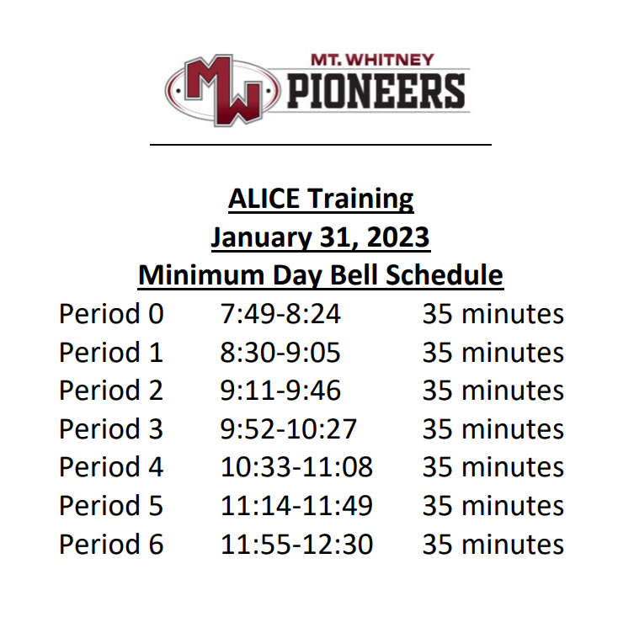

Student Notes

1. Landed a job and need a work permit? Come to the front office and pick up an application with Mrs. Villalobos
2. If you want a place to stay warm during the early morning hours, the library is open Monday thru Friday at 7:15am. Also, tutoring is available in the morning too.

3. Have you purchased your ASB sticker yet? You'll get into home games for free and discounts on dances! They are on sale before school, at lunch, and after school in the finance office. Get yours today!

4. Need some help with homework? Tutoring is available for FREE after-school in the library Monday thru Thursday.

5. “In the library, February 6th thru 8th. XL is be hosting a job workshop series. On the 6th and 7th, you will go over Résumé creation, interview prep, job search tips. On February 8th, we will Career Technical Education workshop talking about trade schools and vocations.”

6. Would you like to audition for a dance class for next school year? Dance Clinics will be February 23, 27 and auditions will be on March 1st. You can be in Intro to Dance without auditioning, just indicate your interest on your registration form for next school year. Come see Mrs. A and pick up an audition packet in the dance room if you would like to audition J

7. If you would like to be in the Pioneer Partners dance in the dance show, we are meeting every Tuesday at lunch in M-10 at 1:00. We will be learning a dance with our friend from PIVOT and performing it in the dance show on March 24 & 25.

8. “On February 14th, just like last year! During lunch, XL is hosting a Valentine’s Day Photo booth near the cafeteria. Come join us to take a photo with your friends. We also will have game to play and prizes you can win. Photos will be printed the next day, so make sure to come after to pick up your photo.”

9. If you are interested in joining the stage crew for the musical, please come by B-27 and pick up information. We need students to run spotlights, move sets, and set up props

10. If you are a current student and are interested in being apart of MWHS AVID for the 2023-2024 school year apply by completing the Google Form listed on Minga. Applications will close Friday February 24th for current students. If you have any questions please see Mrs. Naylor in K5.

Club Notes

*Chess Club meets every day, during lunch, in room S11. Also, the club meets Monday and Wednesday in the library after-school. If you play chess or want to learn, you are invited to join us.

*MW ASB is hosting our first ever Love Week Themed Tailgate on Wednesday, February 15th from 5-8pm in the north parking lot. There will tons of food vendors, games, a raffle, entertainment, bounce houses, and much more! This is a free community event, so invite your friends and family. We are so excited, and we can’t wait to see you there!

*CSF Rush week in this week, Wednesday through Friday. Be sure to bring your application, $5 dues, and a copy of your unofficial transcript. If you need an application, see Mrs. Strambi in I-9.

Senior Notes

Mt. Whitney High School Seniors and Parents. Don’t forget to purchase your cap and gown. Additional details are available by following this link:
https://eng7e.seismic.com/ls/7ed522a8-6ef6-433e-a669-a571dd80545b/5PhYnsTJGBqR8onu .

*GRAD NITE tickets will be sold Feb 6th-15th for $285.00 in the Library during lunch and after school until 4:00pm. Permission Slip Packets are available for pick in the Library and Counseling office.

Senior Scholarships (find details on Schoology Class of 2023 Group)
For any scholarship-related questions, please reach out to Mr. Viveros
Additional scholarships can be found at FastWeb.com

January
- Due 1/31 - eQuality Scholarships (LGBTQ+)
February
- Due 2/10- The California Table Grape Commission (https://www.grapesfromcalifornia.com/wp-content/uploads/2022/10/20221007-ag-scholarship-application.pdf)

- Due 2/15- VUTA- Visalia Unified Teachers Association (https://drive.google.com/file/d/1AIrXOu0ULYdGf62Zli-KoOfzpSAS5rpX/

- Due 2/15- February 15, 2023 HSF- Hispanic Scholarship Fund (https://www.hsf.net/scholarship

Due 2/17- TCSBA- Tulare County School Boards Association (https://tcoe.org/docs/default-source/administration/2023-tcsba-scholarship-packet.pdf)
April
- Due 4/3- Karen Jones Memorial Scholarship

- If you need to meet with your counselor, please submit a request at vusd.org/domain/935 or stop by during walk-in hours at lunch.

Upcoming Events:

Sports Bulletin :
Please copy and paste this link into your web browser
https://docs.google.com/document/d/1MSM1gLDpOFl0o6wa-wJkbBHvJ_OhZoihxFZSILm47GI/edit

To unsubscribe or subscribe to the Daily Bulletin:
http://mailman.visalia.k12.ca.us/mailman/listinfo/mwhs-bulletin
Have questions regarding the bulletin? Contact:
Stephanie Villalobos, MWHS
svillalobos@vusd.org

