Mt. Whitney High School
A California Distinguished School & Home of the Pioneers
Go Pioneers!
Thursday February 23rd, 2023

Tuesday-Friday (Regular) Bell Schedule
Period 0 7:27 - 8:24 57 minutes
Period 1 8:30 - 9:27 57 minutes
Period 2 9:33 - 10:36 63 minutes
Period 3 10:42 - 11:39 57 minutes
Period 4 11:45 - 12:42 57 minutes
LUNCH 12:42 - 1:22 40 minutes
Period 5 1:28 - 2:25 57 minutes
Period 6 2:31 - 3:28 57 minutes

Student Notes

1. Landed a job and need a work permit? Come to the front office and pick up an application with Mrs. Villalobos
2. If you want a place to stay warm during the early morning hours, the library is open Monday thru Friday at 7:15am. Also, tutoring is available in the morning too.

3. Have you purchased your ASB sticker yet? You'll get into home games for free and discounts on dances! They are on sale before school, at lunch, and after school in the finance office. Get yours today!

4. Need some help with homework? Tutoring is available for FREE after-school in the library Monday thru Thursday.

5. Would you like to audition for a dance class for next school year? Dance Clinics will be Today and the 27th and auditions will be on March 1st. You can be in Intro to Dance without auditioning, just indicate your interest on your registration form for next school year. Come see Mrs. A and pick up an audition packet in the dance room if you would like to audition!
6. It's time for Muscle ball (volleyball)! Sign your team up by March 2nd to play in the tournament. Pick up an Official Roster and other paperwork in Amaral or K-7. Mandatory Captain's meeting in K-7 on March 2nd at lunch.
7. Come watch the Muscle Ball tournament at lunch in the grass area Monday, March 6th-Wednesday March 7th. The Championship Game will be Thursday, March 9th, 6pm in the gym. The winner will play the Staff Team. It's a fundraiser so come support the teams, staff, and Mt. Whitney! $2 at the door.
8. If you are a current student and are interested in being a part of MWHS AVID for the 2023-2024 school year apply by completing the Google Form listed on Minga. Applications will close Tomorrow Friday February 24th for current students. If you have any questions please see Mrs. Naylor in K5.
9. Mrs. Allan is looking for a lost pair of prescription glasses for one of her students. They were lost Friday during lunch. Please return to G-4 if found for a reward!

10. The Black Student Union is going to be meeting on Tomorrow during lunch for elections in room C-2.

Club Notes:

*Chess Club meets every day, during lunch, in room S11. Also, the club meets Monday and Wednesday in the library after-school. If you play chess or want to learn, you are invited to join us.

*Join Link Crew for the 23-24 school year!
- Help new students feel comfortable on our campus.
- Gain Leadership experience
- Participate in school activities
- Pick-up an application in K-7, attendance, and counseling
- If you have questions, see Mrs. Bolden in K-7

Visual And Performing Arts

Best wishes to our Percussion and Color Guard, they will be competing this Saturday at Sierra Pacific High School.
Senior Notes

*Juniors and Seniors if you have good grades and love nature,we are in need of 2 male counselors to attend with Liberty and 2 male counselors to attend with St. Pauls for the week of March 13th-17th! Please see Mrs. Villalobos in the front office for an application.

Senior Scholarships (find details on Schoology Class of 2023 Group)
For any scholarship-related questions, please reach out to Mr. Viveros
Additional scholarships can be found at FastWeb.com

April
- Due 4/3- Karen Jones Memorial Scholarship

- If you need to meet with your counselor, please submit a request at vusd.org/domain/935 or stop by during walk-in hours at lunch.

Upcoming Events:

Spring Fling Saturday March 11, 8pm-11pm here at the gym. This years theme is NEON NIGHT. Tickets will be $15 with ASB, $20 W/O ASB or $40 at the door. Ticket sale dates is to be determind

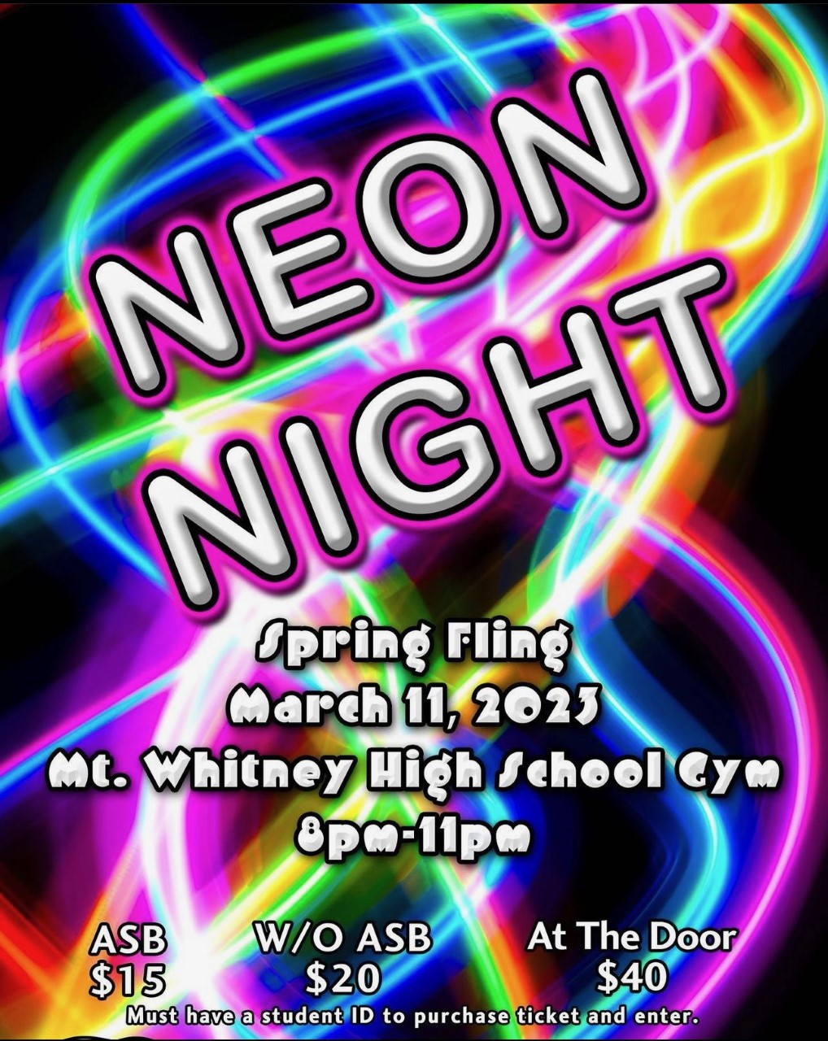

Sports Bulletin :
Please copy and paste this link into your web browser
https://docs.google.com/document/d/1MSM1gLDpOFl0o6wa-wJkbBHvJ_OhZoihxFZSILm47GI/edit

To unsubscribe or subscribe to the Daily Bulletin:
http://mailman.visalia.k12.ca.us/mailman/listinfo/mwhs-bulletin
Have questions regarding the bulletin? Contact:
Stephanie Villalobos, MWHS
svillalobos@vusd.org

