Mt. Whitney High School
A California Distinguished School & Home of the Pioneers
Go Pioneers!

Monday March 6, 2023
Mondays (Collaboration PLC) Bell Schedule
Period 0 7:04 - 7:54 50 minutes
Collaboration 8:00 - 9:00 60 minutes
Period 1 9:06 - 9:56 50 minutes
Period 2 10:02 - 10:57 55 minutes
Period 3 11:03 - 11:53 50 minutes
Period 4 11:59 - 12:49 50 minutes
LUNCH 12:49 - 1:29 40 minutes
Period 5 1:35 - 2:25 50 minutes
Period 6 2:31 - 3:21 50 minutes
Student Notes

1. Landed a job and need a work permit? Come to the front office and pick up an application with Mrs. Villalobos
2. If you want a place to stay warm during the early morning hours, the library is open Monday thru Friday at 7:15am. Also, tutoring is available in the morning too.

3. “Boxing Class has officially started!!! Beginning on Tuesday March 7th after-school in the weight room!!! Go to the weight room and ask for Coach David. All supplies need will be provided.”

4. Need some help with homework? Tutoring is available for FREE after-school in the library Monday thru Thursday.

6. Come watch the Muscle Ball tournament at lunch in the grass area TODAY, March 6th-Wednesday March 8th. The Championship Game will be Thursday, March 9th, 6pm in the gym. The winner will play the Staff Team. It's a fundraiser so come support the teams, staff, and Mt. Whitney! $2 at the door.

Club Notes:

*Join Link Crew for the 23-24 school year!
- Help new students feel comfortable on our campus.
- Gain Leadership experience
- Participate in school activities
- Pick-up an application in K-7, attendance, and counseling
- If you have questions, see Mrs. Bolden in K-7

Visual And Performing Arts

Senior Notes

*Juniors and Seniors if you have good grades and love nature, we need 2 male counselors to attend with Liberty and 1 male counselor to attend with St. Pauls for the week of March 13th-17th! Please see Mrs. Villalobos in the front office for an application.

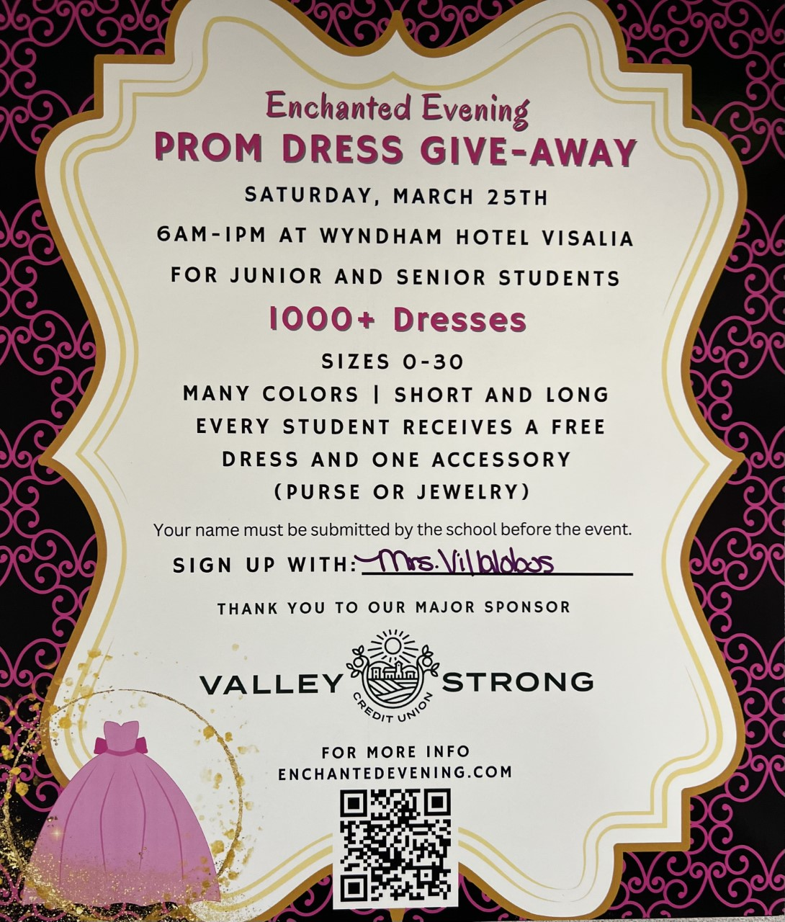
*Juniors and Seniors if you need a prom dress. Valley Strong is hosting “Enchanted Evening” Prom Dress Giveaway. Saturday, March 25th 6am-1pm at Wyndham Hotel. If you would like to attend this event please sign up with with Mrs.Villalobos in the front office

Senior Scholarships (find details on Schoology Class of 2023 Group)
For any scholarship-related questions, please reach out to Mr. Viveros
Additional scholarships can be found at FastWeb.com

March:
https://sites.google.com/vusd.us/mwscholarships/march
Please visit the site above for scholarship information and deadlines.
April
- Due 4/3- Karen Jones Memorial Scholarship

- If you need to meet with your counselor, please submit a request at vusd.org/domain/935 or stop by during walk-in hours at lunch.

Upcoming Events:

Spring Fling Saturday March 11, 8pm-11pm here at the gym. This years theme is NEON NIGHT. Tickets will be sold in the finance office March 7th through the 10th at lunch and after school. Tickets are $20 w/o ASB sticker or $15 with an ASB sticker and $40 at the door!

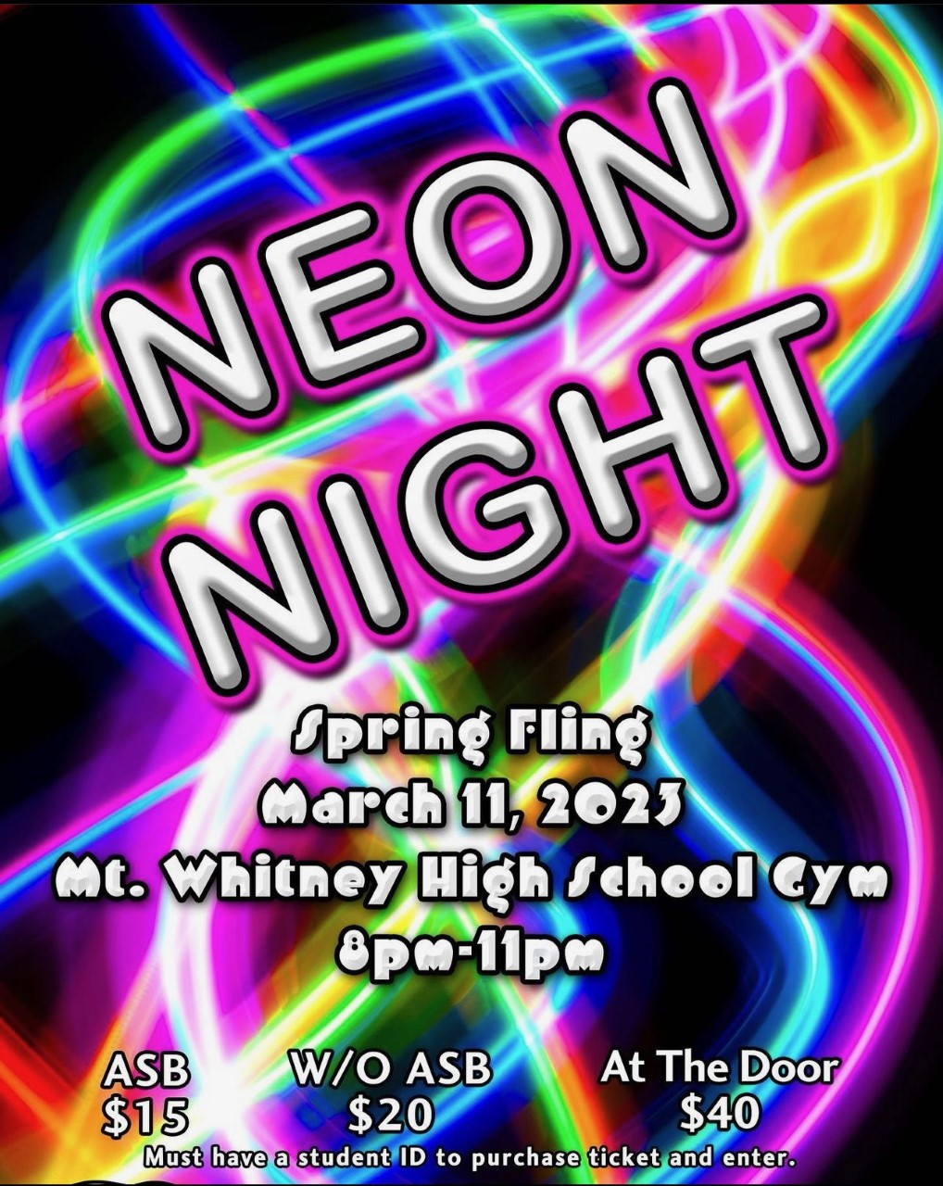

Sports Bulletin :
Please copy and paste this link into your web browser
https://docs.google.com/document/d/1MSM1gLDpOFl0o6wa-wJkbBHvJ_OhZoihxFZSILm47GI/edit

To unsubscribe or subscribe to the Daily Bulletin:
http://mailman.visalia.k12.ca.us/mailman/listinfo/mwhs-bulletin
Have questions regarding the bulletin? Contact:
Stephanie Villalobos, MWHS
svillalobos@vusd.org

