Mt. Whitney High School
A California Distinguished School & Home of the Pioneers
Go Pioneers!

Wednesday March 8th, 2023
Student Notes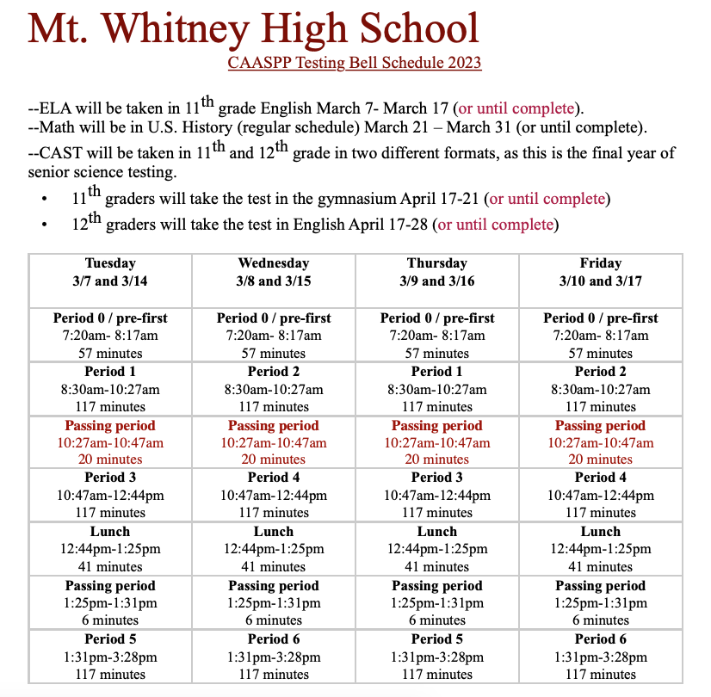

1. Landed a job and need a work permit? Come to the front office and pick up an application with Mrs. Villalobos
2. If you want a place to stay warm during the early morning hours, the library is open Monday thru Friday at 7:15am. Also, tutoring is available in the morning too.

4. Need some help with homework? Tutoring is available for FREE after-school in the library Monday thru Thursday.

6. Come watch the Muscle Ball tournament at lunch in the grass area TODAY March 8th. The Championship Game will be TOMORROW, March 9th, 6pm in the gym. The winner will play the Staff Team. It's a fundraiser so come support the teams, staff, and Mt. Whitney! $2 for students and . "Adults $5.00
Staff and students, come out to Mt. Whitney pride fundraiser this Thursday March 9th at 6pm to watch our winning muscleball team play our all star staff team. We are asking everyone to wear orange as we honor the life of 2011 graduate Calline Piper.

8. Attention Students: ASB is now accepting applications for new students to join the class for the 23/24 school year. You must fill out an application to be considered for the class.If you wish to run for an ASB officer position, there are 10 officer positions available and you must fill out a packet in order to run for a position. The officer campaign meeting will be this Friday March 10th at lunch in the Amaral. Class applications and Election packets are available in the front office, counseling office, or the ASB room.

Club Notes:

*Join Link Crew for the 23-24 school year!
- Help new students feel comfortable on our campus.
- Gain Leadership experience
- Participate in school activities
- Pick-up an application in K-7, attendance, and counseling
- If you have questions, see Mrs. Bolden in K-7

Visual And Performing Arts

*Choir will be participating in the COS Choral Festival this Friday. Lets wish them good luck!

Senior Notes

*Juniors and Seniors if you have good grades and love nature, we need of 1 male counselor to attend with St. Pauls for the week of March 13th-17th! Please see Mrs. Villalobos in the front office for an application.

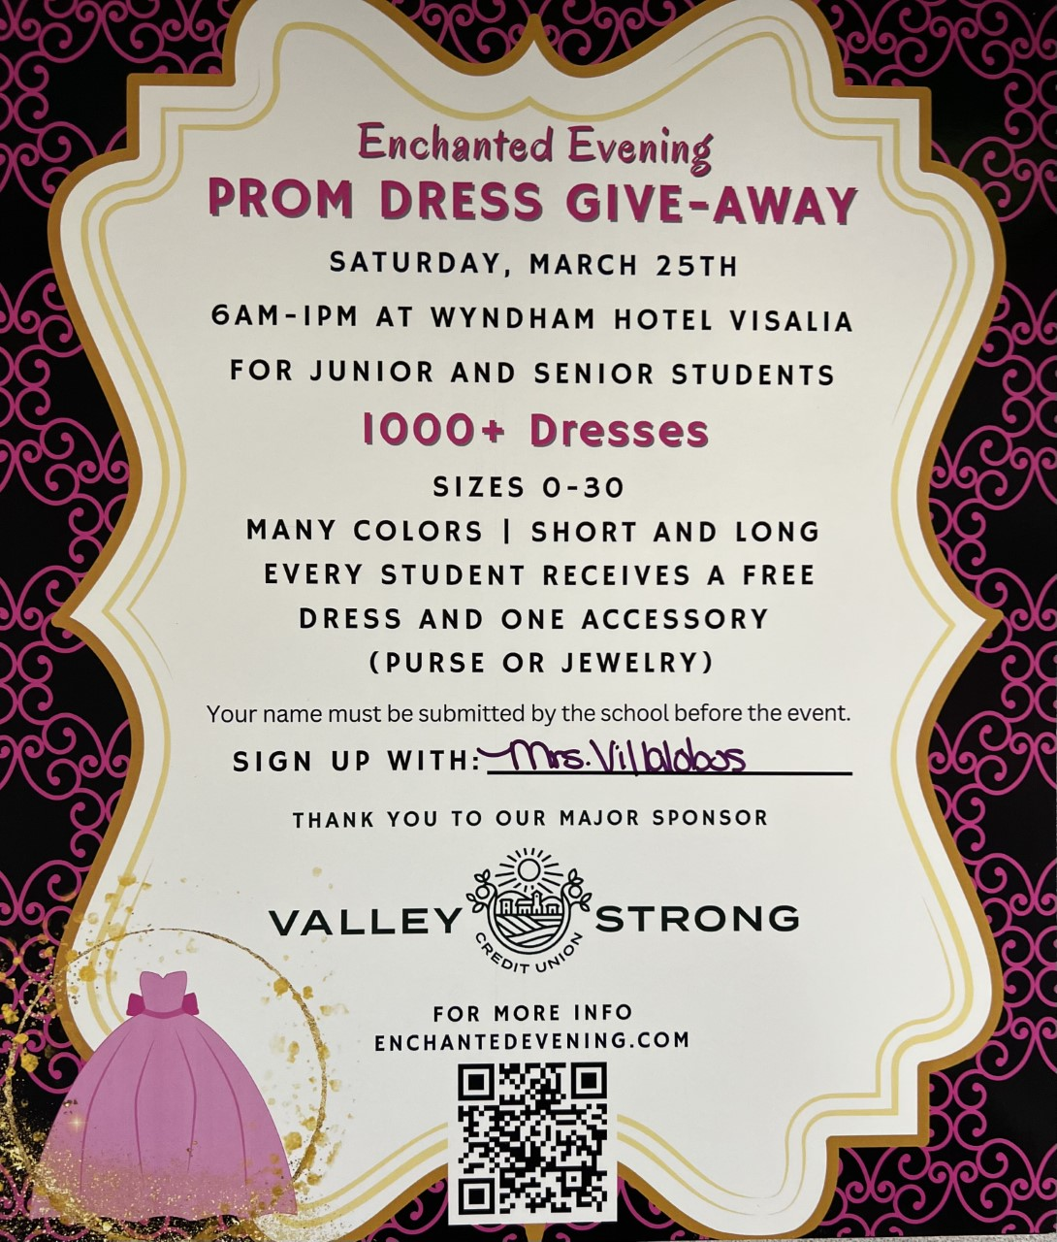
*Juniors and Seniors if you need a prom dress. Valley Strong is hosting “Enchanted Evening” Prom Dress Giveaway. Saturday, March 25th 6am-1pm at Wyndham Hotel. If you would like to attend this event please sign up with with Mrs.Villalobos in the front office

Senior Scholarships (find details on Schoology Class of 2023 Group)
For any scholarship-related questions, please reach out to Mr. Viveros
Additional scholarships can be found at FastWeb.com

March:
https://sites.google.com/vusd.us/mwscholarships/march
Please visit the site above for scholarship information and deadlines.
April
- Due 4/3- Karen Jones Memorial Scholarship

- If you need to meet with your counselor, please submit a request at vusd.org/domain/935 or stop by during walk-in hours at lunch.

Upcoming Events:

Spring Fling Saturday March 11, 8pm-11pm here at the gym. This years theme is NEON NIGHT. Tickets will be sold in the finance office TODAY through the 10th at lunch and after school. Tickets are $20 w/o ASB sticker or $15 with an ASB sticker and $40 at the door!

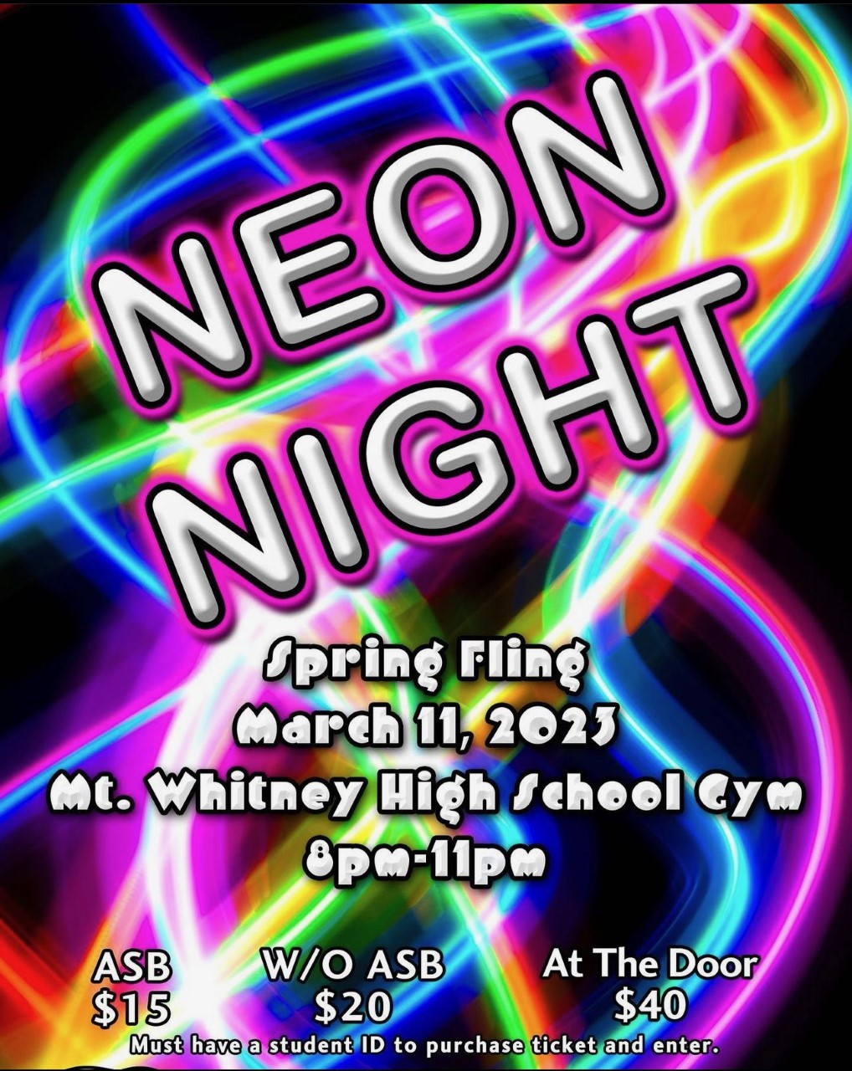

Sports Bulletin :
Please copy and paste this link into your web browser
https://docs.google.com/document/d/1MSM1gLDpOFl0o6wa-wJkbBHvJ_OhZoihxFZSILm47GI/edit

To unsubscribe or subscribe to the Daily Bulletin:
http://mailman.visalia.k12.ca.us/mailman/listinfo/mwhs-bulletin
Have questions regarding the bulletin? Contact:
Stephanie Villalobos, MWHS
svillalobos@vusd.org

