Mt. Whitney High School
A California Distinguished School & Home of the Pioneers
Go Pioneers!

Monday March 20th, 2023

Mondays (Collaboration PLC) Bell Schedule
Period 0 7:04 - 7:54 50 minutes
Collaboration 8:00 - 9:00 60 minutes
Period 1 9:06 - 9:56 50 minutes
Period 2 10:02 - 10:57 55 minutes
Period 3 11:03 - 11:53 50 minutes
Period 4 11:59 - 12:49 50 minutes
LUNCH 12:49 - 1:29 40 minutes
Period 5 1:35 - 2:25 50 minutes
Period 6 2:31 - 3:21 50 minutes

Student Notes

1. Landed a job and need a work permit? Come to the front office and pick up an application with Mrs. Villalobos
2. If you want a place to stay warm during the early morning hours, the library is open Monday thru Friday at 7:15am. Also, tutoring is available in the morning too.

3. Need some help with homework? Tutoring is available for FREE after-school in the library Monday thru Thursday.

Club Notes:

4. Join Link Crew for the 23-24 school year!
- Help new students feel comfortable on our campus.
- Gain Leadership experience
- Participate in school activities
- Pick-up an application in K-7, attendance, and counseling
- If you have questions, see Mrs. Bolden in K-7
5. Juniors and seniors if you are interested in getting a Food Handlers Card please see Ms. Bacci.
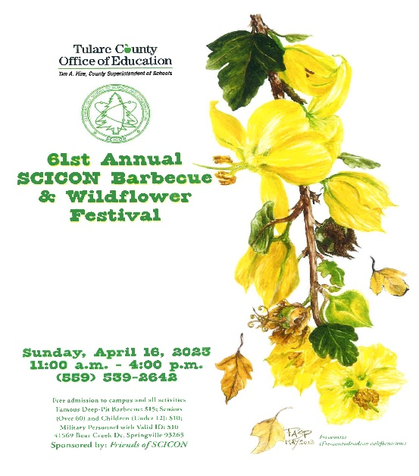
Visual And Performing Arts
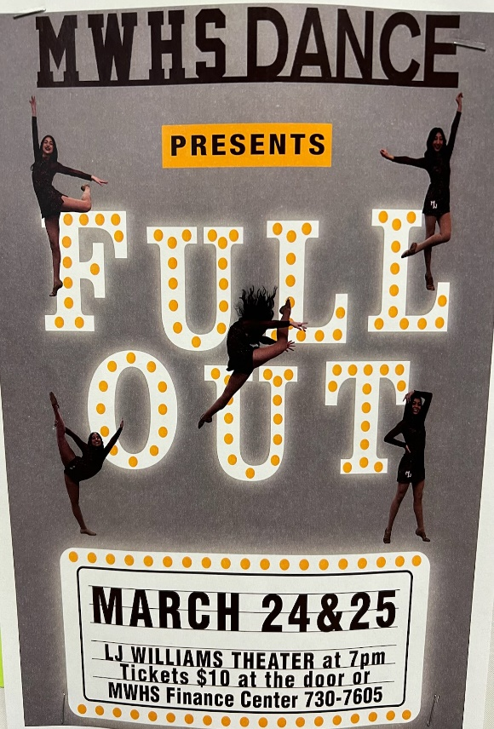

3/23/23 – Orchestra will be participating in the CMEA Orchestra Festival at Tulare Union High School

Senior Notes

*Juniors and Seniors if you need a prom dress. Valley Strong is hosting “Enchanted Evening” Prom Dress Giveaway. Saturday, March 25th 6am-1pm at Wyndham Hotel. If you would like to attend this event please sign up with with Mrs.Villalobos in the front office by March 23rd.

Senior Scholarships (find details on Schoology Class of 2023 Group)
For any scholarship-related questions, please reach out to Mr. Viveros
Additional scholarships can be found at FastWeb.com

March:
https://sites.google.com/vusd.us/mwscholarships/march
Please visit the site above for scholarship information and deadlines.
April
- Due 4/3- Karen Jones Memorial Scholarship

- If you need to meet with your counselor, please submit a request at vusd.org/domain/935 or stop by during walk-in hours at lunch.

Upcoming Events:

3/20/2023 – Open House in the gym 5:30

Sports Bulletin :
Please copy and paste this link into your web browser
https://docs.google.com/document/d/1MSM1gLDpOFl0o6wa-wJkbBHvJ_OhZoihxFZSILm47GI/edit

To unsubscribe or subscribe to the Daily Bulletin:
http://mailman.visalia.k12.ca.us/mailman/listinfo/mwhs-bulletin
Have questions regarding the bulletin? Contact:
Stephanie Villalobos, MWHS
svillalobos@vusd.org

