Mt. Whitney High School
A California Distinguished School & Home of the Pioneers
Go Pioneers!

Monday March 27th, 2023

Mondays (Collaboration PLC) Bell Schedule
Period 0 7:04 - 7:54 50 minutes
Collaboration 8:00 - 9:00 60 minutes
Period 1 9:06 - 9:56 50 minutes
Period 2 10:02 - 10:57 55 minutes
Period 3 11:03 - 11:53 50 minutes
Period 4 11:59 - 12:49 50 minutes
LUNCH 12:49 - 1:29 40 minutes
Period 5 1:35 - 2:25 50 minutes
Period 6 2:31 - 3:21 50 minutes
Student Notes

1. Landed a job and need a work permit? Come to the front office and pick up an application with Mrs. Villalobos
2. If you want a place to stay warm during the early morning hours, the library is open Monday thru Friday at 7:15am. Also, tutoring is available in the morning too.

3. Need some help with homework? Tutoring is available for FREE after-school in the library Monday thru Thursday.

Club Notes:

4. Dress up days for Mr. Pioneer are

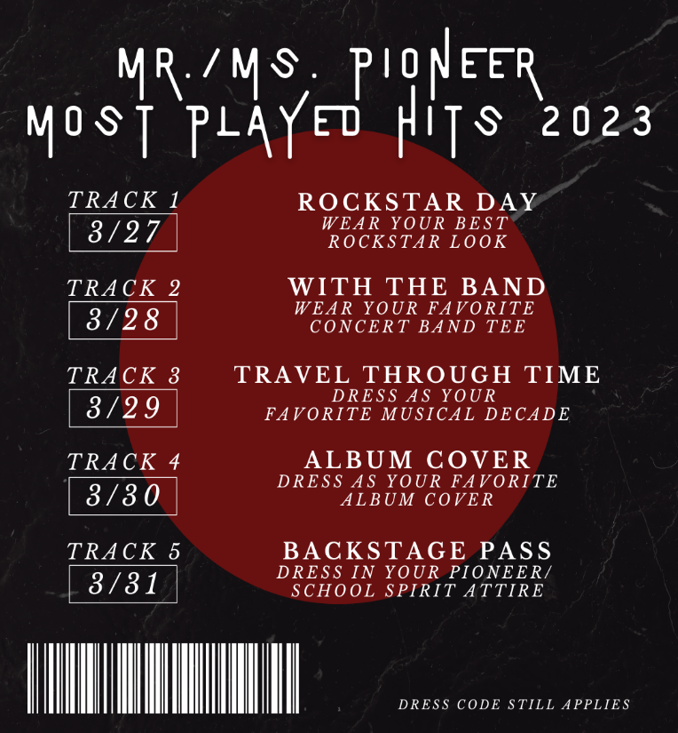

5. Juniors and seniors if you are interested in getting a Food Handlers Card please see Ms. Bacci in M4

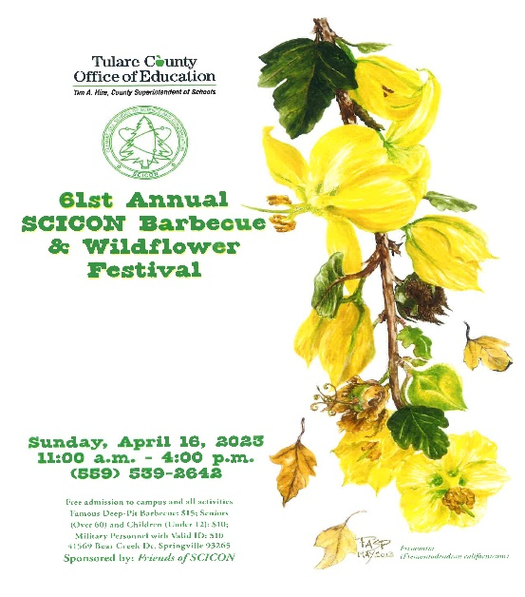
Visual And Performing Arts

03/30/2023 – CMEA Band Festival @ Liberty Middle School

Senior Notes

Senior Scholarships (find details on Schoology Class of 2023 Group)
For any scholarship-related questions, please reach out to Mr. Viveros
Additional scholarships can be found at FastWeb.com

March:
https://sites.google.com/vusd.us/mwscholarships/march
Please visit the site above for scholarship information and deadlines.
April
- Due 4/3- Karen Jones Memorial Scholarship

- If you need to meet with your counselor, please submit a request at vusd.org/domain/935 or stop by during walk-in hours at lunch.

Upcoming Events:

Sports Bulletin :
Please copy and paste this link into your web browser
https://docs.google.com/docume3nt/d/1MSM1gLDpOFl0o6wa-wJkbBHvJ_OhZoihxFZSILm47GI/edit

To unsubscribe or subscribe to the Daily Bulletin:
http://mailman.visalia.k12.ca.us/mailman/listinfo/mwhs-bulletin
Have questions regarding the bulletin? Contact:
Stephanie Villalobos, MWHS
svillalobos@vusd.org

