Mt. Whitney High School
A California Distinguished School & Home of the Pioneers
Go Pioneers!

Thursday March 30th, 2023
Tuesday-Friday (Regular) Bell Schedule
Period 0 7:26 - 8:24 57 minutes
Period 1 8:30 - 9:27 57 minutes
Period 2 9:33 - 10:36 63 minutes
Period 3 10:42 - 11:39 57 minutes
Period 4 11:45 - 12:42 57 minutes
LUNCH 12:42 - 1:22 40 minutes
Period 5 1:28 - 2:25 57 minutes
Period 6 2:31 - 3:28 57 minutes
Student Notes

1. Landed a job and need a work permit? Come to the front office and pick up an application with Mrs. Villalobos
2. If you want a place to stay warm during the early morning hours, the library is open Monday thru Friday at 7:15am. Also, tutoring is available in the morning too.

3. Need some help with homework? Tutoring is available for FREE after-school in the library Monday thru Thursday.

Club Notes:

4. Dress up days for Mr. Pioneer are

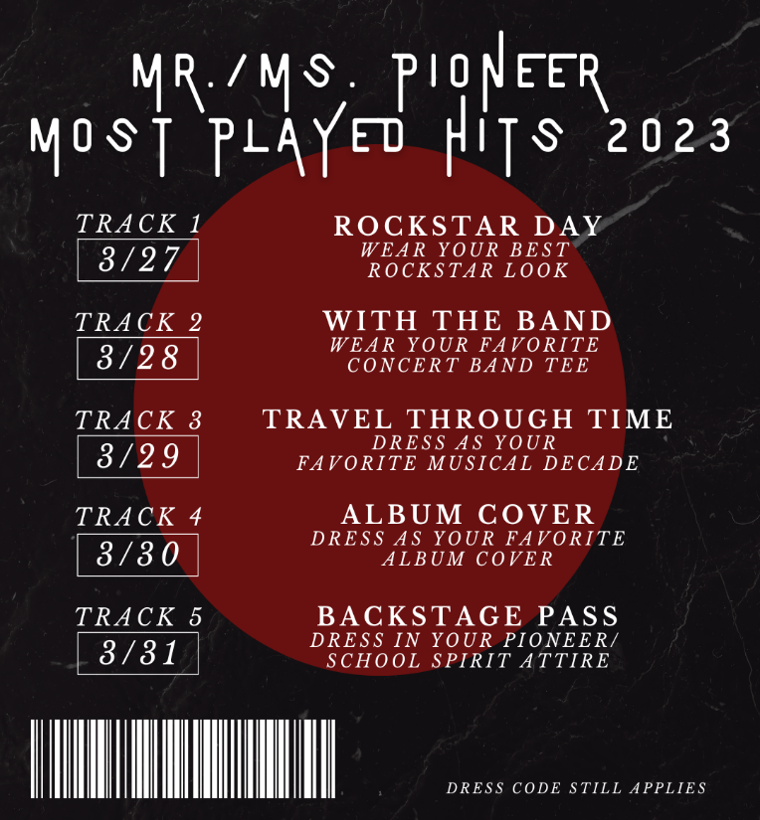

5. Juniors and seniors if you are interested in getting a Food Handlers Card please see Ms. Bacci in M4
6. This is a reminder for wrestling banquet this Friday at 6:00 in the cafeteria.
7. ASB will host Mr. & Ms. Pioneer Rally this Friday after 2nd period
8. Attention all Key Club Members: There will be a mandatory meeting in J-12 on Friday. It will begin promptly at 1:00 PM. We will be electing our new officers for next year at this meeting. Don't be late:) Bring your lunch and vote for next years leaders!

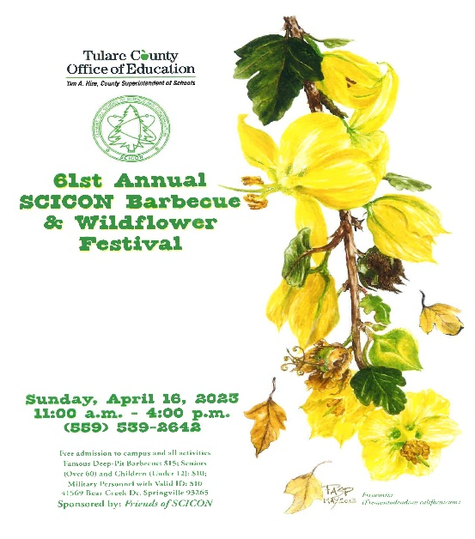
Visual And Performing Arts

03/30/2023 – CMEA Band Festival @ Liberty Middle School

Senior Notes

SENIORS for those who have low attendance percentages please see Ms. Johnson in B24 for to reserve your seat for Saturday Academy April 14th,21st and 28th.

Senior Scholarships (find details on Schoology Class of 2023 Group)
For any scholarship-related questions, please reach out to Mr. Viveros
Additional scholarships can be found at FastWeb.com

March:
https://sites.google.com/vusd.us/mwscholarships/march
Please visit the site above for scholarship information and deadlines.
April
- Due 4/3- Karen Jones Memorial Scholarship

- If you need to meet with your counselor, please submit a request at vusd.org/domain/935 or stop by during walk-in hours at lunch.

Upcoming Events:

Sports Bulletin :
Please copy and paste this link into your web browser
https://docs.google.com/docume3nt/d/1MSM1gLDpOFl0o6wa-wJkbBHvJ_OhZoihxFZSILm47GI/edit

To unsubscribe or subscribe to the Daily Bulletin:
http://mailman.visalia.k12.ca.us/mailman/listinfo/mwhs-bulletin
Have questions regarding the bulletin? Contact:
Stephanie Villalobos, MWHS
svillalobos@vusd.org

