Mt. Whitney High School
A California Distinguished School & Home of the Pioneers
Go Pioneers!

Wednesday April 12, 2023
Tuesday-Friday (Regular) Bell Schedule
Period 0 7:26 - 8:24 57 minutes
Period 1 8:30 - 9:27 57 minutes
Period 2 9:33 - 10:36 63 minutes
Period 3 10:42 - 11:39 57 minutes
Period 4 11:45 - 12:42 57 minutes
LUNCH 12:42 - 1:22 40 minutes
Period 5 1:28 - 2:25 57 minutes
Period 6 2:31 - 3:28 57 minutes
Student Notes

1. Landed a job and need a work permit? Come to the front office and pick up an application with Mrs. Villalobos
2. If you want a place to stay warm during the early morning hours, the library is open Monday thru Friday at 7:15am. Also, tutoring is available in the morning too.

3. Need some help with homework? Tutoring is available for FREE after-school in the library Monday thru Thursday.

Club Notes:

4. “On May 4th in Room S11, there will be a Loteria Night starting after-school. There will be free food, candy, and if you win… Prizes.”

5. Juniors and seniors if you are interested in getting a Food Handlers Card please see Ms. Bacci in M4 before April 23rd.
6. Attention all junior and senior girls! It is time for powderpuff! Where our Junior class girls and senior class girls compete in a championship flag football game! Here's what you need to know:
The link to sign up has been emailed to all 11th and 12th graders. You can also find the sign up link on the MW ASB Instagram. The Signup deadline is this Friday, April 14th. There will be a powderpuff lunch meeting this Friday, April 14th at lunch in the ASB room! Championship Game will be Thursday, April 20th at 7:00 pm at Mt. Whitney.

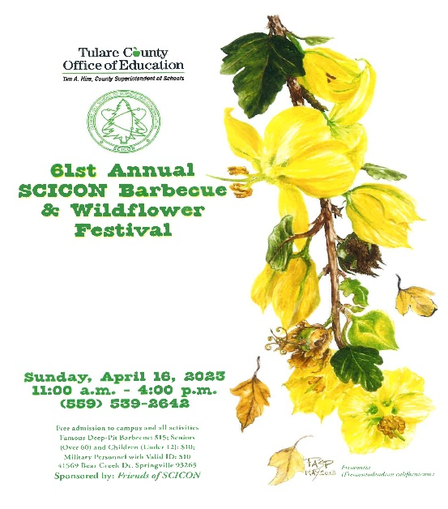

Visual And Performing Arts

Senior Notes

*ATTENTION CSF SENIORS: We will have a brief meeting at lunch in I-9 on Thursday April 13th to discuss next week's Lifetime Luncheon. See you Thursday.
SENIORS for those who have low attendance percentages please see Ms. Johnson in B24 for to reserve your seat for Saturday Academy April 14th,21st and 28th.

Senior Scholarships (find details on Schoology Class of 2023 Group)
For any scholarship-related questions, please reach out to Mr. Viveros
Additional scholarships can be found at FastWeb.com

APRIL:
https://sites.google.com/vusd.us/mwscholarships/april
Please visit the site above for scholarship information and deadlines.

*Students who plan on taking a class during the Summer/Fall 2023 at COS must submit concurrent & dual enrollment permission forms and other registration documents by April-14, 2023. Please send forms via email directly to: concurrentenrollment@cos.edu If you have any questions or need to get the permission form signed by your counselor, drop by during before/after school or during lunch and a counselor will be more than happy to assist.

- If you need to meet with your counselor, please submit a request at vusd.org/domain/935 or stop by during walk-in hours at lunch.

Upcoming Events:

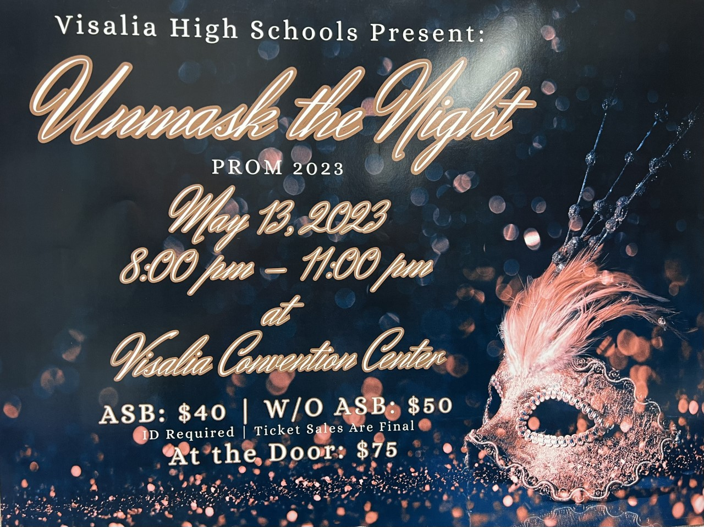
Ticket Sale dates TBD

Sports Bulletin :
Please copy and paste this link into your web browser
https://docs.google.com/docume3nt/d/1MSM1gLDpOFl0o6wa-wJkbBHvJ_OhZoihxFZSILm47GI/edit

To unsubscribe or subscribe to the Daily Bulletin:
http://mailman.visalia.k12.ca.us/mailman/listinfo/mwhs-bulletin
Have questions regarding the bulletin? Contact:
Stephanie Villalobos, MWHS
svillalobos@vusd.org

