Mt. Whitney High School
A California Distinguished School & Home of the Pioneers
Go Pioneers!

Monday April 17, 2023
Mondays (Collaboration PLC) Bell Schedule
Period 0 7:04 - 7:54 50 minutes
Collaboration 8:00 - 9:00 60 minutes
Period 1 9:06 - 9:56 50 minutes
Period 2 10:02 - 10:57 55 minutes
Period 3 11:03 - 11:53 50 minutes
Period 4 11:59 - 12:49 50 minutes
LUNCH 12:49 - 1:29 40 minutes
Period 5 1:35 - 2:25 50 minutes
Period 6 2:31 - 3:21 50 minutes

Student Notes

1. Landed a job and need a work permit? Come to the front office and pick up an application with Mrs. Villalobos
2. If you want a place to stay warm during the early morning hours, the library is open Monday thru Friday at 7:15am. Also, tutoring is available in the morning too.

3. Need some help with homework? Tutoring is available for FREE after-school in the library Monday thru Thursday.

Club Notes:

4. “On May 4th in Room S11, there will be a Loteria Night starting after-school. There will be free food, candy, and if you win… Prizes.”

5. Juniors and seniors if you are interested in getting a Food Handlers Card please see Ms. Bacci in M4 before April 23rd.
6. Championship Game will be Thursday, April 20th at 7:00 pm at Mt. Whitney.

Visual And Performing Arts

Senior Notes

SENIORS for those who have low attendance percentages please see Ms. Johnson in B24 for to reserve your seat for Saturday Academy April ,21st and 28th.

Senior Scholarships (find details on Schoology Class of 2023 Group)
For any scholarship-related questions, please reach out to Mr. Viveros
Additional scholarships can be found at FastWeb.com

APRIL:
https://sites.google.com/vusd.us/mwscholarships/april
Please visit the site above for scholarship information and deadlines.

*If you need to meet with your counselor, please submit a request at vusd.org/domain/935 or stop by during walk-in hours at lunch.

Upcoming Events:

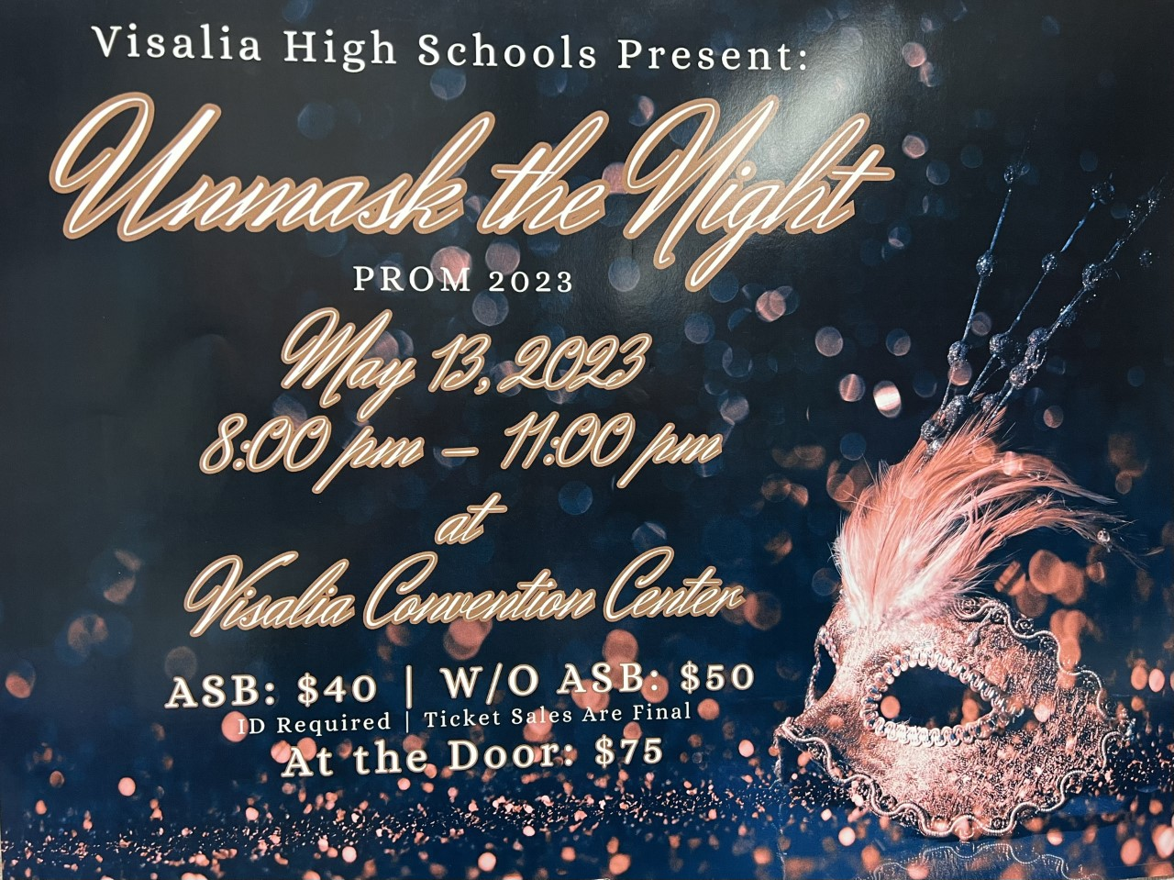
Ticket Sales start Monday, May 1st in the finance office at lunch and after school. Ticket sales will end Friday, May 12th at lunch.
If you are bringing a non-VUSD guest please pick up a guest pass with Mrs. Villalobos in the front office. All guest passes must be signed, approved and turned in by May 11th. Students and guest must not have any disciplinary actions prior to Prom.

Sports Bulletin :
Please copy and paste this link into your web browser
https://docs.google.com/docume3nt/d/1MSM1gLDpOFl0o6wa-wJkbBHvJ_OhZoihxFZSILm47GI/edit

To unsubscribe or subscribe to the Daily Bulletin:
http://mailman.visalia.k12.ca.us/mailman/listinfo/mwhs-bulletin
Have questions regarding the bulletin? Contact:
Stephanie Villalobos, MWHS
svillalobos@vusd.org

