Mt. Whitney High School
A California Distinguished School & Home of the Pioneers
Go Pioneers!

Wednesday April 19, 2023
Tuesday-Friday (Regular) Bell Schedule
Period 0 7:26 - 8:24 57 minutes
Period 1 8:30 - 9:27 57 minutes
Period 2 9:33 - 10:36 63 minutes
Period 3 10:42 - 11:39 57 minutes
Period 4 11:45 - 12:42 57 minutes
LUNCH 12:42 - 1:22 40 minutes
Period 5 1:28 - 2:25 57 minutes
Period 6 2:31 - 3:28 57 minutes
Student Notes

1. Landed a job and need a work permit? Come to the front office and pick up an application with Mrs. Villalobos
2. If you want a place to stay warm during the early morning hours, the library is open Monday thru Friday at 7:15am. Also, tutoring is available in the morning too.

3. Need some help with homework? Tutoring is available for FREE after-school in the library Monday thru Thursday.

Club Notes:

4. “On May 4th in Room S11, there will be a Loteria Night starting after-school. There will be free food, candy, and if you win… Prizes.”

5. Juniors and seniors if you are interested in getting a Food Handlers Card please see Ms. Bacci in M4 before April 23rd.
6. Attention all Junior and Sophomores, if you are interested in taking a Duel Enrollment Course next year, please see Mr. Lopez in B-206 for more information.
7. Join the Earth Science Club for an Earth Day Celebration and Contest on the lawn near the MW Astronomy Building (behind H5). There will be prizes for the game and refreshments will be served. Everyone is welcome!
8.Earth Science Club Meeting TODAY H4 to discuss game and prizes for Friday Earth Day Celebration

9. Congratulations to Trinity Contreras for placing first and William Cannon-Madrid for placing second at the Tulare/Kings Expo Culinary Arts competition at COS on Friday, April 14th. If you see these two future chefs on campus, congratulate them!

10. This Thursday night, ASB invites all Pioneers to wear black to our Blackout baseball game. Come watch our varsity baseball boys take on Redwood at the Mt. Whitney varsity field at 7pm. Our first ten students will receive a free MW croc charm and baseball has blackout t-shirts to give out at the game! See you all there.

11. The powderpuff championship game has been changed to Monday Apri 24th at Mt Whitney, at 7PM

12. Interested in running for a class leadership position!? ASB will be electing new sophomore, junior, and senior class positions for the next school year. If you would like to run or want to find out more information, please attend the class election meeting this Wednesday in the ASB room. Pizza will be provided!

13. Snack bar by the cafeteria is open today during lunch.

14. Mt. Whitney, you are invited to the Youth Civic Engagement Student Showcase on Monday, April 24th at the El Diamante Theatre. 9 of our senior Pioneers will be presenting to the community their projects on civic engagement. Join us and support them from 5:30-8pm to see how they and other students have been able to have their voice heard in our community. The event is free and offers light refreshments.

15. It’s Audition Time for Speeches at MWHS Commencement 2023

There will be two speech opportunities at this year's commencement ceremony:
#1- the Welcome Speech-- a pre-written speech in English and Spanish; and
#2- the Senior Speech-- written by the applicant.

#1- The Welcome Speech will be a pre-written speech. We need someone to read the English version and someone to read the Spanish version. When you sign up, you will be given a copy of the speech for you to practice.

#2- The Senior Speech will be written by the applicant- due by noon on Thursday, May 4th.

Auditions will be held on Wednesday, May 10th, after school in Mrs. Bolden’s classroom, K7. You may sign up with Ms. Villalobos beginning April 19th and select the speeches you want to audition for

Visual And Performing Arts

4/27/23 Band and Dance perform at the Disneyland Parade

Senior Notes

SENIORS for those who have low attendance percentages please see Ms. Johnson in B24 for to reserve your seat for Saturday Academy April ,21st and 28th.

Senior Scholarships (find details on Schoology Class of 2023 Group)
For any scholarship-related questions, please reach out to Mr. Viveros
Additional scholarships can be found at FastWeb.com

APRIL:
https://sites.google.com/vusd.us/mwscholarships/april
Please visit the site above for scholarship information and deadlines.

*If you need to meet with your counselor, please submit a request at vusd.org/domain/935 or stop by during walk-in hours at lunch.

Upcoming Events:

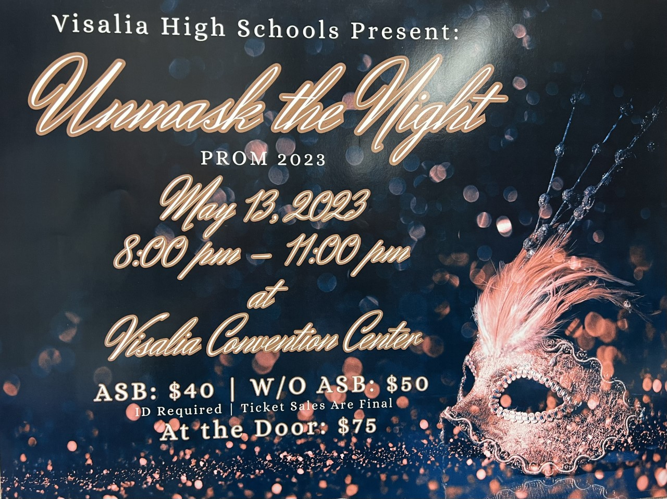
Ticket Sales start Monday, May 1st in the finance office at lunch and after school. Ticket sales will end Friday, May 12th at lunch.
If you are bringing a non-VUSD guest please pick up a guest pass with Mrs. Villalobos in the front office. All guest passes must be signed, approved and turned in by May 11th. Students and guest must not have any disciplinary actions prior to Prom.

Sports Bulletin :
Please copy and paste this link into your web browser
https://docs.google.com/docume3nt/d/1MSM1gLDpOFl0o6wa-wJkbBHvJ_OhZoihxFZSILm47GI/edit

To unsubscribe or subscribe to the Daily Bulletin:
http://mailman.visalia.k12.ca.us/mailman/listinfo/mwhs-bulletin
Have questions regarding the bulletin? Contact:
Stephanie Villalobos, MWHS
svillalobos@vusd.org

