Mt. Whitney High School
A California Distinguished School & Home of the Pioneers
Go Pioneers!

Tuesday May 2, 2023
Tuesday-Friday (Regular) Bell Schedule
Period 0 7:26 - 8:24 57 minutes
Period 1 8:30 - 9:27 57 minutes
Period 2 9:33 - 10:36 63 minutes
Period 3 10:42 - 11:39 57 minutes
Period 4 11:45 - 12:42 57 minutes
LUNCH 12:42 - 1:22 40 minutes
Period 5 1:28 - 2:25 57 minutes
Period 6 2:31 - 3:28 57 minutes
Student Notes

1. Landed a job and need a work permit? Come to the front office and pick up an application with Mrs. Villalobos
2. If you want a place to stay cool during the early morning hours, the library is open Monday thru Friday at 7:15am. Also, tutoring is available in the morning too.

3. Need some help with homework? Tutoring is available for FREE after-school in the library Monday thru Thursday.

Club Notes:

4. “On May 4th in Room S11, there will be a Loteria Night starting after-school. There will be free food, candy, and if you win… Prizes.”

5. Color Guard clinics for next year will be held TODAY thru May 5th 5 - 8 pm outside the band room. Auditions will be May 10th and 11th. Wear comfortable clothing, all other equipment will be provided.
6. Attention all Junior and Sophomores, if you are interested in taking a Duel Enrollment Course next year, please see Mr. Lopez in B-206 for more information.
7. It’s Audition Time for Speeches at MWHS Commencement 2023

There will be two speech opportunities at this year's commencement ceremony:
#1- the Welcome Speech-- a pre-written speech in English and Spanish; and
#2- the Senior Speech-- written by the applicant.

#1- The Welcome Speech will be a pre-written speech. We need someone to read the English version and someone to read the Spanish version. When you sign up, you will be given a copy of the speech for you to practice.

#2- The Senior Speech will be written by the applicant- due by noon on Thursday, May 4th.

Auditions will be held on Wednesday, May 10th, after school in Mrs. Bolden’s classroom, K7. You may sign up with Ms. Villalobos and select the speeches you want to audition for, there are only 2 spots left!

8. Hello Mt. Whitney! If you were in the Pioneer Partners dance in the dance show, go by M-10 to talk to Mrs. A about performing in the May 5 rally. We will practice on Wed, May 3rd at lunch.

9. Juniors and Seniors this is your last chance to become a Scicon Counselor for this school year. Counselors will attend with Washington or Liberty Elementary May 22nd-May 26th. Please see Mrs. Villalobos in the front office for an application.

10. Attention CSF Seniors: there will be a mandatory meeting on Wednesday May 10th at lunch in I-9. See Mrs. Strambi in I-9 or email with any questions. Thanks!

11. Attention CSF Sophomores and Juniors: there will be a mandatory meeting on Friday May 19th at lunch in I-9. We will be electing our club officers for next year. If you are a current CSF member, are a junior, and would like to run for an officer position, sign up in I-9 at lunch. Last day to sign up is Thursday May 18th. Current CSF officers: it is mandatory that you attend this meeting. See Mrs. Strambi in I-9 or email with any questions.

12. TODAY May 2nd- come to the ASB room for a coloring competition!
Wednesday, May 3rd- head out to the grass area in front of the choir room for games & prizes!
Thursday May 4th there will be a booth and music in the quad!
Friday, May 5th we will have our spring celebration rally after the second period and we will have our extended lunch schedule to celebrate cultural food day with food, music, games, and multiple vendors!

13. Attention members of the Black Student Union there will be a meeting today during lunch in room C-2

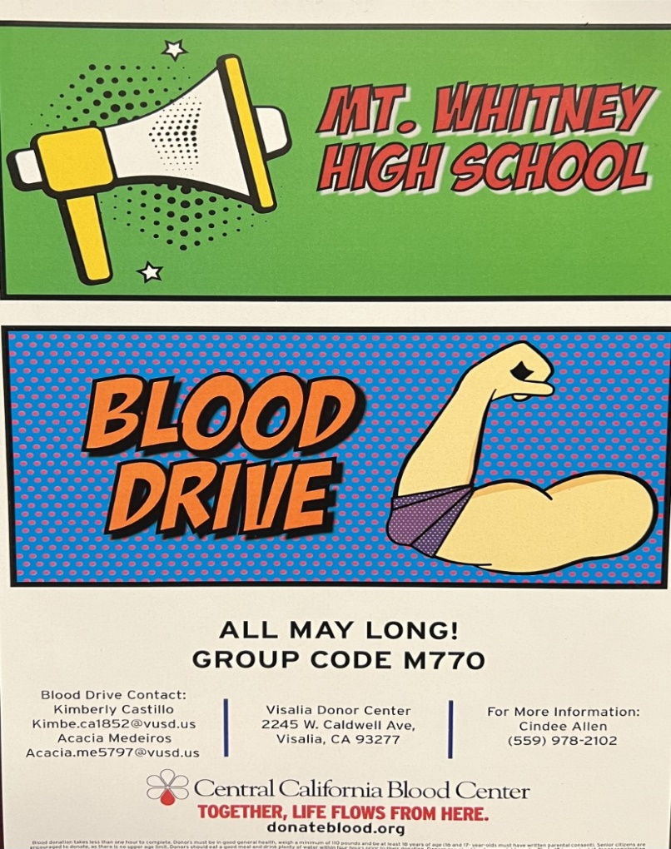
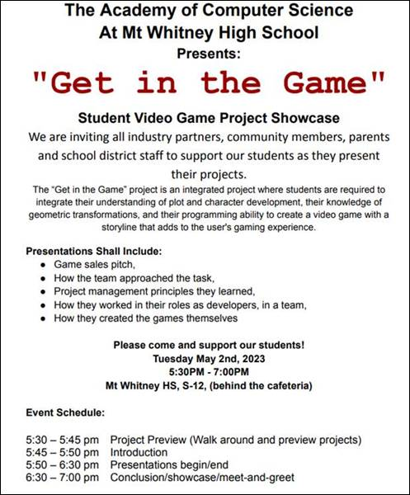

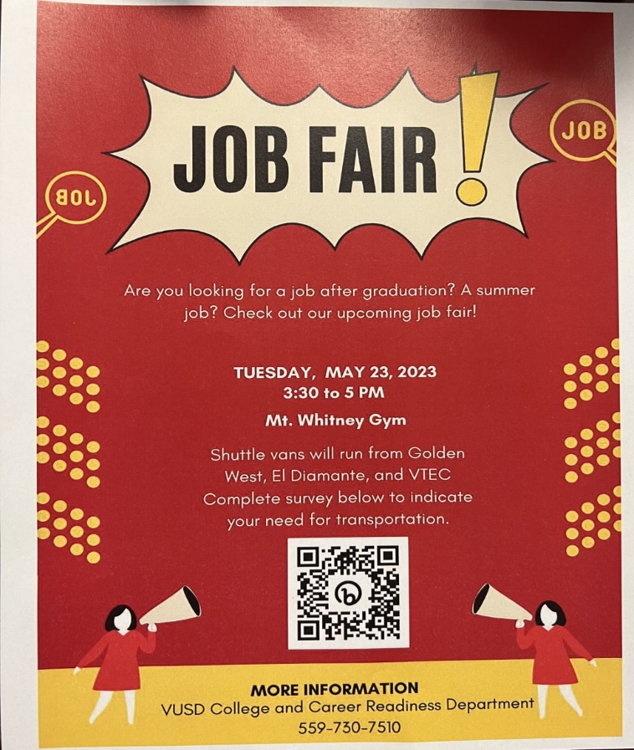

Visual And Performing Arts

Senior Notes

SENIORS for those who have low attendance percentages please see Ms. Johnson in B24 for to reserve your seat for Saturday Academy May 6th, May 13th, May 20th and May 27th

Senior Scholarships (find details on Schoology Class of 2023 Group)
For any scholarship-related questions, please reach out to Mr. Viveros
Additional scholarships can be found at FastWeb.com

APRIL:
https://sites.google.com/vusd.us/mwscholarships/april
Please visit the site above for scholarship information and deadlines.

*If you need to meet with your counselor, please submit a request at vusd.org/domain/935 or stop by during walk-in hours at lunch.

Upcoming Events:

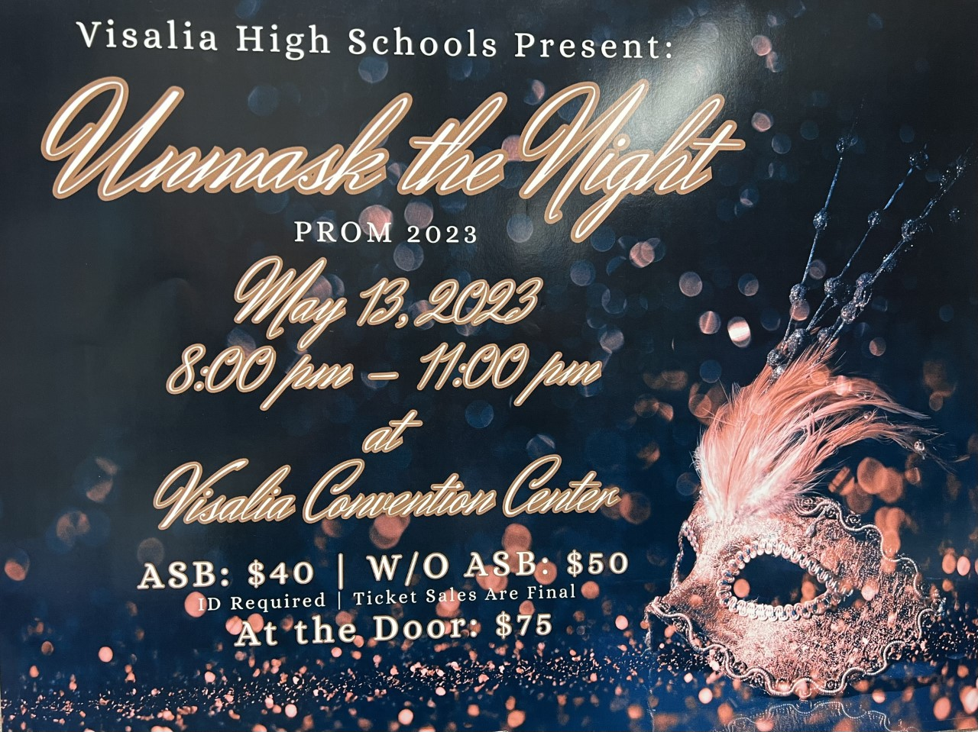
Ticket Sales start Today in the finance office at lunch and after school. Ticket sales will end Friday, May 12th at lunch.
If you are bringing a non-VUSD guest please pick up a guest pass with Mrs. Villalobos in the front office. All guest passes must be signed, approved and turned in by May 11th. Students and guest must not have any disciplinary actions prior to Prom.

Sports Bulletin :
Please copy and paste this link into your web browser
https://docs.google.com/docume3nt/d/1MSM1gLDpOFl0o6wa-wJkbBHvJ_OhZoihxFZSILm47GI/edit
To unsubscribe or subscribe to the Daily Bulletin:
http://mailman.visalia.k12.ca.us/mailman/listinfo/mwhs-bulletin
Have questions regarding the bulletin? Contact:
Stephanie Villalobos, MWHS
svillalobos@vusd.org

