Mt. Whitney High School
A California Distinguished School & Home of the Pioneers
Go Pioneers!

Monday May 8, 2023

Mondays (Collaboration PLC) Bell Schedule
Period 0 7:04 - 7:54 50 minutes
Collaboration 8:00 - 9:00 60 minutes
Period 1 9:06 - 9:56 50 minutes
Period 2 10:02 - 10:57 55 minutes
Period 3 11:03 - 11:53 50 minutes
Period 4 11:59 - 12:49 50 minutes
LUNCH 12:49 - 1:29 40 minutes
Period 5 1:35 - 2:25 50 minutes
Period 6 2:31 - 3:21 50 minutes

Student Notes

1. Landed a job and need a work permit? Come to the front office and pick up an application with Mrs. Villalobos
2. If you want a place to stay cool during the early morning hours, the library is open Monday thru Friday at 7:15am. Also, tutoring is available in the morning too.

3. Need some help with homework? Tutoring is available for FREE after-school in the library Monday thru Thursday.

Club Notes:

5. Auditions for Color Gaurd will be May 10th and 11th. Wear comfortable clothing, all other equipment will be provided.
6. Attention all Junior and Sophomores, if you are interested in taking a Duel Enrollment Course next year, please see Mr. Lopez in B-206 for more information
7. Juniors and Seniors this is your last chance to become a Scicon Counselor for this school year. Counselors will attend with Washington or Liberty Elementary May 22nd-May 26th. Please see Mrs. Villalobos in the front office for an application.

8. Attention CSF Seniors: there will be a mandatory meeting on Wednesday May 10th at lunch in I-9. See Mrs. Strambi in I-9 or email with any questions. Thanks!

9. Attention CSF Sophomores and Juniors: there will be a mandatory meeting on Friday May 19th at lunch in I-9. We will be electing our club officers for next year. If you are a current CSF member, are a junior, and would like to run for an officer position, sign up in I-9 at lunch. Last day to sign up is Thursday May 18th. Current CSF officers: it is mandatory that you attend this meeting. See Mrs. Strambi in I-9 or email with any questions.

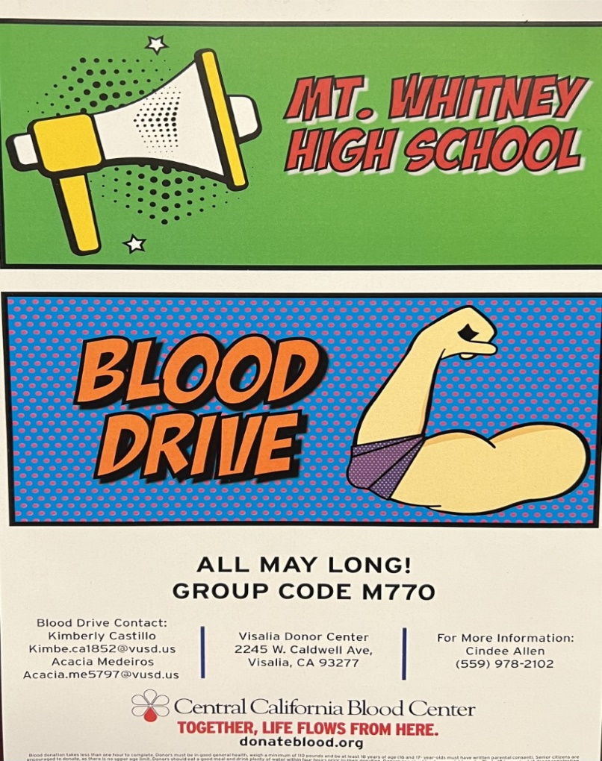

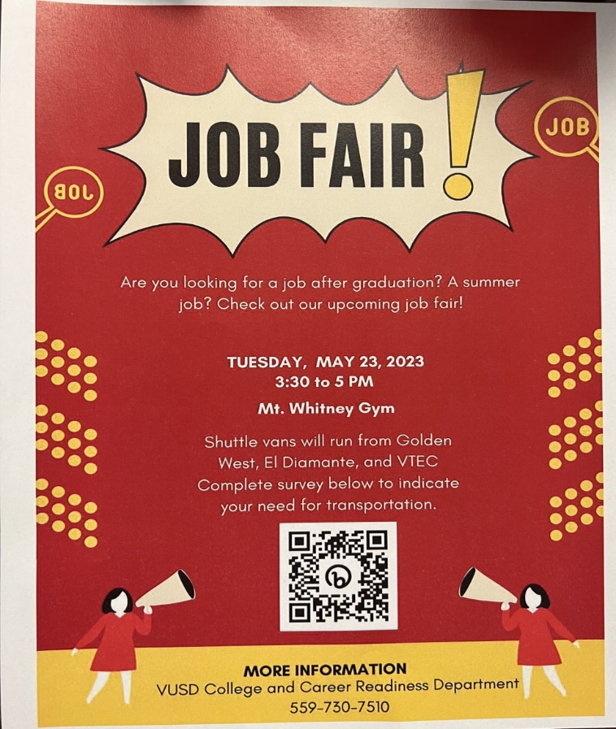

Visual And Performing Arts

*5/10/23- Band at LJ Williams Theater
*5/12/23-VAPA Assembly in the Gym after 2nd period
*5/18/23- Choir at LJ Williams Theater
*5/19/23- Choir at LJ Williams Theater
*5/20/23- Choir at LJ Williams Theater
*5/22/23-Orchestra at LJ Williams Theater

Senior Notes

*5/15/23 Scholarship Night at MW Gym 6pm
*5/16/23 Senior BBQ/Slideshow
*5/16-17/23 Grad Nite
*5/23/23 Farewell Assembly
SENIORS for those who have low attendance percentages please see Ms. Johnson in B24 for to reserve your seat for Saturday Academy May 13th, May 20th and May 27th

Senior Scholarships (find details on Schoology Class of 2023 Group)
For any scholarship-related questions, please reach out to Mr. Viveros
Additional scholarships can be found at FastWeb.com

May:
https://sites.google.com/vusd.us/mwscholarships/may

Please visit the site above for scholarship information and deadlines.

*If you need to meet with your counselor, please submit a request at vusd.org/domain/935 or stop by during walk-in hours at lunch.

Upcoming Events:

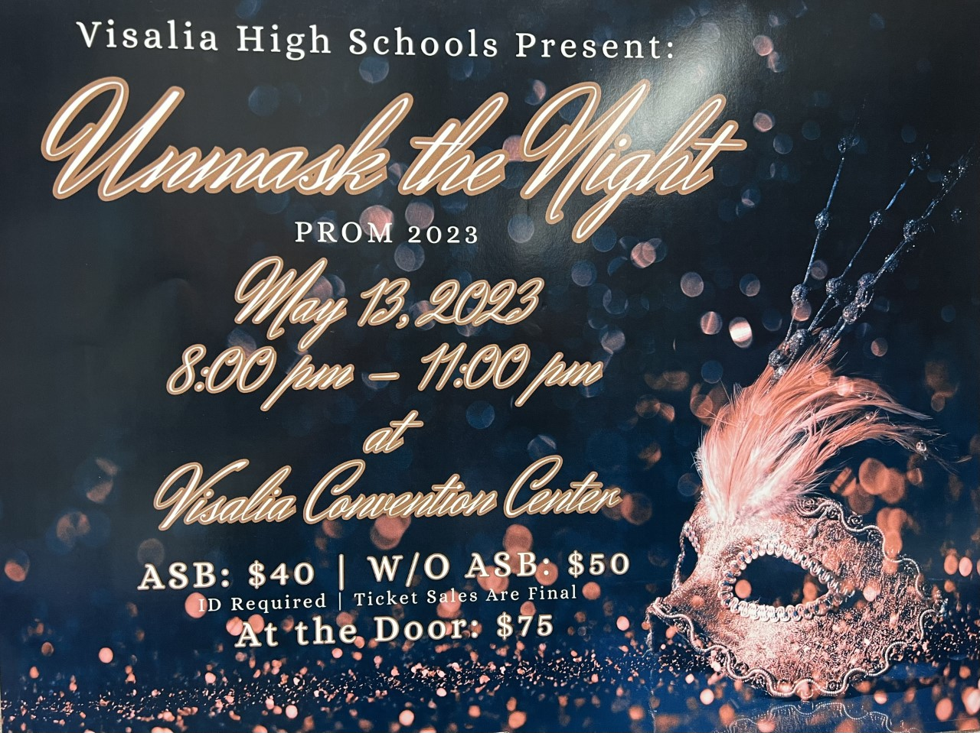
Ticket Sales are on sale in the finance office at lunch and after school. Ticket sales will end Friday, May 12th at lunch.
If you are bringing a non-VUSD guest please pick up a guest pass with Mrs. Villalobos in the front office. All guest passes must be signed, approved and turned in by May 11th. Students and guest must not have any disciplinary actions prior to Prom.

Sports Bulletin :
Please copy and paste this link into your web browser
https://docs.google.com/docume3nt/d/1MSM1gLDpOFl0o6wa-wJkbBHvJ_OhZoihxFZSILm47GI/edit
To unsubscribe or subscribe to the Daily Bulletin:
http://mailman.visalia.k12.ca.us/mailman/listinfo/mwhs-bulletin
Have questions regarding the bulletin? Contact:
Stephanie Villalobos, MWHS
svillalobos@vusd.org

