Mt. Whitney High School
A California Distinguished School & Home of the Pioneers
Go Pioneers!

Friday May 19, 2023

Tuesday-Friday (Regular) Bell Schedule
Period 0 7:26 - 8:24 57 minutes
Period 1 8:30 - 9:27 57 minutes
Period 2 9:33 - 10:36 63 minutes
Period 3 10:42 - 11:39 57 minutes
Period 4 11:45 - 12:42 57 minutes
LUNCH 12:42 - 1:22 40 minutes
Period 5 1:28 - 2:25 57 minutes
Period 2:31 - 3:28 57 minutes

Student Notes

1. Landed a job and need a work permit? Come to the front office and pick up an application with Mrs. Villalobos
2. If you want a place to stay cool during the early morning hours, the library is open Monday thru Friday at 7:15am. Also, tutoring is available in the morning too.

3. Need some help with homework? Tutoring is available for FREE after-school in the library Monday thru Thursday.

Club Notes:

4. Juniors and Seniors this is your last chance to become a Scicon Counselor for this school year. Counselors will attend with Washington or Liberty Elementary May 22nd-May 26th. Please see Mrs. Villalobos in the front office for an application.

5. Camp Royal
Rotary District 5230’s Camp Royal has beautiful natural surroundings where young adults learn about Rotary International, leadership and service. Camp Royal is a week-long Leadership camp at Sequoia Lake in Kings Canyon National Park for Rotary District 5230.The next Camp Royal session will take place June 11th – 16th, 2023 and is open to high school students who have completed the 11th grade and demonstrated exceptional leadership ability. Camp Royal is a remarkable experience for our youth and one they will remember forever.
Lake Reflections Camp Royal Offers a Peaceful Environment to Learn About Service Projects
On the Lake Have Fun While Learning About Service Projects
Impact Learn How to Make a Meaningful and Lasting Impact in Your Community
Friends forever Service Projects create lifelong friendships
All interested Juniors, stop at the counseling office to pick up a packet, deadline to submit the completed application is Thursday, May 18th at Lunch.

6. Yearbooks will be distributed on Tuesday after school. Lines will form in front of the Choir Room by last name to get your receipt to pick up your book. If there are any extra books, they will be available to purchase in room B-203 but only with cash. Cost will be $100.

Visual And Performing Arts

*5/19/23- Choir at LJ Williams Theater
*5/26/23 Hey Mt. Whitney! Come see the dance program’s annual Student Showcase Friday, May 26 at 4pm in the Gym. You will see students from Advanced Dance and Elevate performing their choreography final. It’s a short one-hour show and tickets are just $5. There will be candy, chips, and drinks for sale starting at 3:30. We hope you can come and cheer on your favorite dancer!

Senior Notes
*5/23/23 Farewell Assembly
*5/23/23- Job Fair at MW Gym

Seniors - please take a minute to complete the Senior Spring Survey at: https://forms.gle/34WuNrBgtwwS8JSV6. The link is also available on Schoology and in your email.

SENIORS for those who have low attendance percentages please see Ms. Johnson in B24 to reserve your seat for Saturday Academy May 20th and May 27th

Senior Scholarships (find details on Schoology Class of 2023 Group)
For any scholarship-related questions, please reach out to Mr. Viveros
Additional scholarships can be found at FastWeb.com

May:
https://sites.google.com/vusd.us/mwscholarships/may
Please visit the site above for scholarship information and deadlines.

*If you need to meet with your counselor, please submit a request at vusd.org/domain/935 or stop by during walk-in hours at lunch.

Upcoming Events:

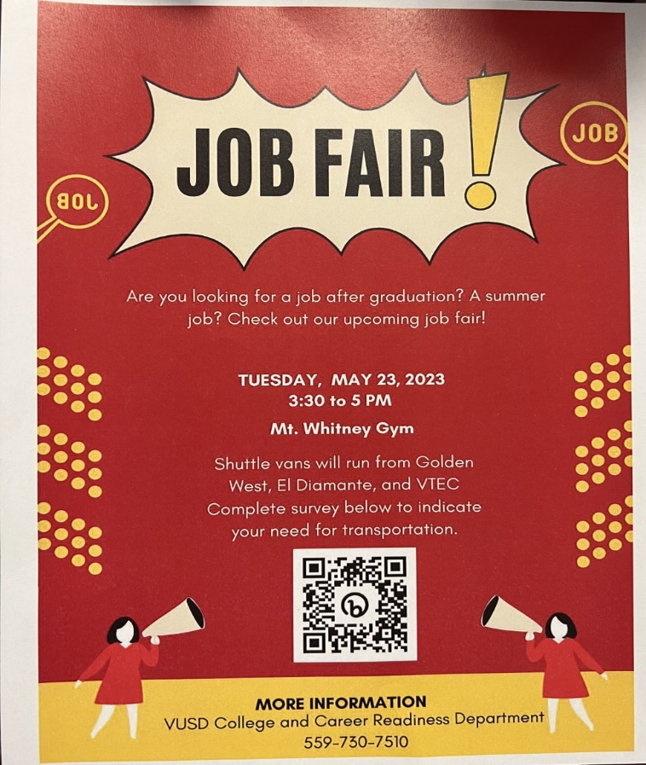
Sports Bulletin :
Please copy and paste this link into your web browser
https://docs.google.com/docume3nt/d/1MSM1gLDpOFl0o6wa-wJkbBHvJ_OhZoihxFZSILm47GI/edit
To unsubscribe or subscribe to the Daily Bulletin:
http://mailman.visalia.k12.ca.us/mailman/listinfo/mwhs-bulletin
Have questions regarding the bulletin? Contact:
Stephanie Villalobos, MWHS
svillalobos@vusd.org

