VISALIA TECHNICAL EARLY COLLEGE

***HOME OF THE WOLVERINES***

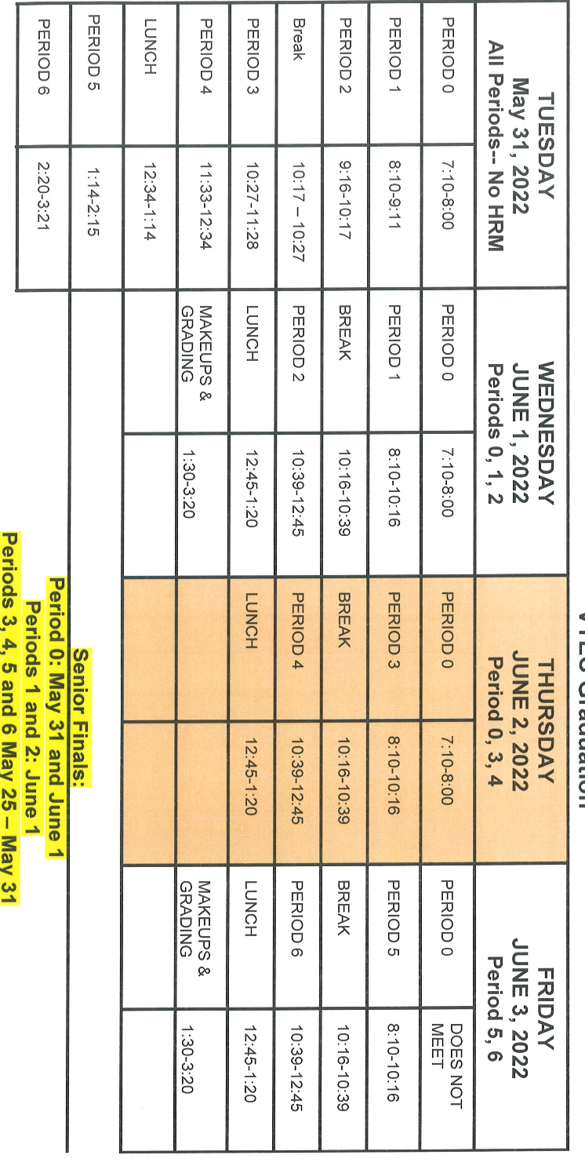

**Daily Bulletin - Volume 10; Issue 179**

**THURSDAY, JUNE 2, 2022**

**June 1st, 2nd and 3rd – Finals – Students Released at 12:45pm**

**Students**

**2022/2023 Round Up – Thursday, August 4th – See Attached Flyer**

**June 2nd -** Graduation – LJ Williams Theater at 4pm

**The Yearbook has been delayed** in shipping from the binding plant where it is assembled. It will be shipped June 6th. The arrival date will be announced soon. Sorry for the delay. Stay tuned for more info. Any questions – see Mrs. Taylor in Room 15.

**Replacement ID cards** are $5 – see Mrs. Gutierrez in the office.

**Third party food deliveries** will NOT be accepted in the office (parent lunch drop-off ok). Students must meet third party deliveries during lunch only in front of the school. Any deliveries before or after lunch will not be accepted. Thank you –

**Students – VTEC is a closed campus**. You will not be allowed to go to your car between classes or at break.

**VTEC car magnets** available for sale in the office - $5.00

**Senior Scholarships**

Here is a list of current scholarship with approaching deadlines. If you have any questions or need assistance with applying, please see Mrs. Lalanne.

California Association of Administrator of State and Federal Programs 06/30/2022