VISALIA TECHNICAL EARLY COLLEGE

***HOME OF THE WOLVERINES***

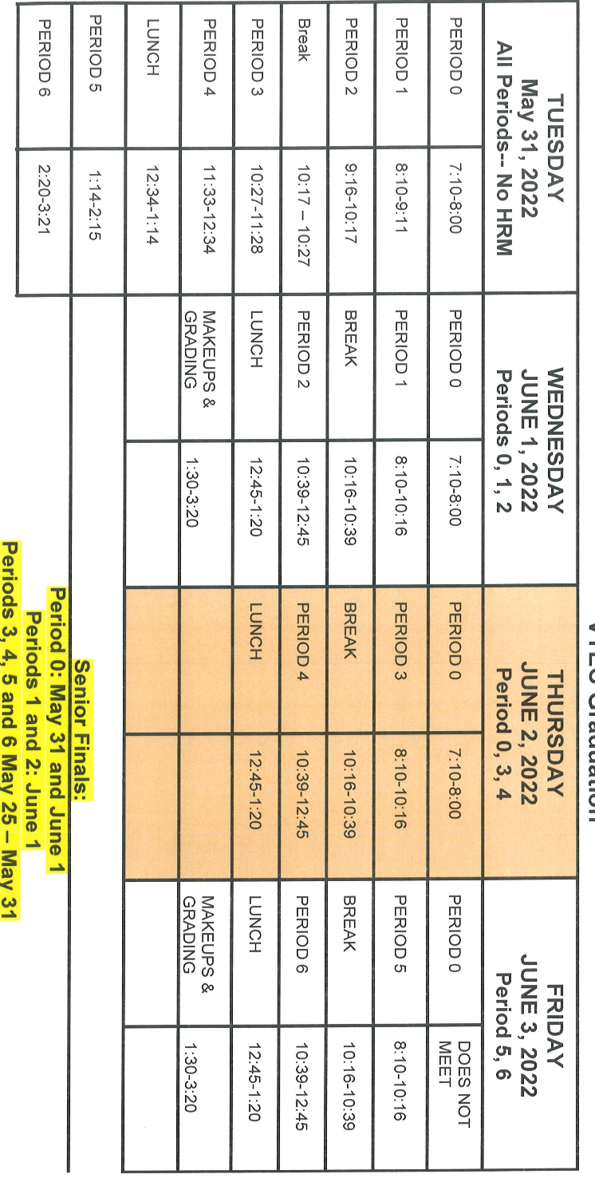

**Daily Bulletin - Volume 10; Issue 180**

**FRIDAY, JUNE 3, 2022**

**June 1st, 2nd and 3rd – Finals – Students Released at 12:45pm**

**Students**

**2022/2023 Round Up – Thursday, August 4th – See Attached Flyer**

**The Yearbook has been delayed** in shipping from the binding plant where it is assembled. It will be shipped June 6th. The arrival date will be announced soon. Sorry for the delay. Stay tuned for more info. Any questions – see Mrs. Taylor in Room 15.

**Students – VTEC is a closed campus**. You will not be allowed to go to your car between classes or at break.

**VTEC car magnets** available for sale in the office - $5.00