VISALIA TECHNICAL EARLY COLLEGE

***HOME OF THE WOLVERINES***



**Daily Bulletin - Volume 11; Issue 111**

**WEDNESDAY, FEBRUARY 15, 2023**



**No School for Students on Monday, February 20th**

**Tuesday February 21st – All 6 Periods/No Homeroom**

**Bell Schedule for February 21st:**

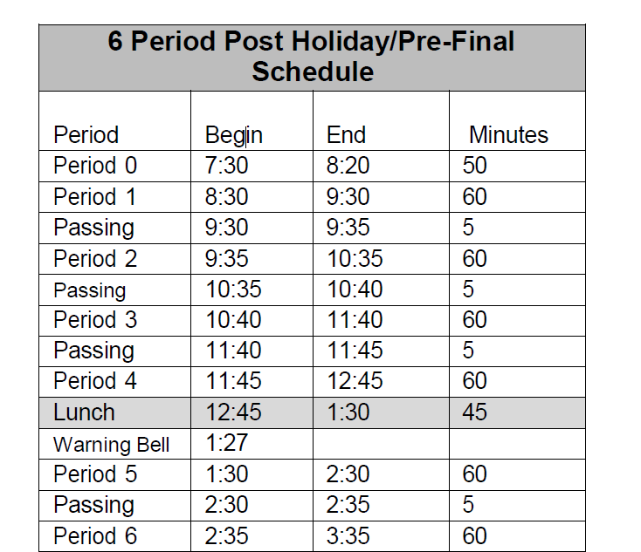

**Seniors -**Mark your calendars! **Friday, February 17th at 8:30am** in Room 4 Verissimo Photography will be here to take your **senior cap-n-gown photo** for the yearbook!  See Mrs. Gutierrez or Mrs. Roebuck with any questions.

**Horticulture Pizza Sales -** Pizza sales begin this Friday during lunch. $2 per slice. Cash only.

**Denim and Diamond Tickets** are available for sale in the office. Tickets are $60 each. Cash or check accepted. The event is Saturday, March 4th.

Starting Monday, February 6th, 10th -12th grade students will be prevented from going off campus based on academics.  Student will not be allowed to leave campus if they have any of the following combinations.  We are only using PowerSchool as an indicator of their grades.

* Two or more Fs
* One F and any Ds
* 3 Ds

**FFA Canned Food Drive –**February 20-24th. Every 10 items counts as an hour of community service. Turn your canned food/non-perishable items into your Ag teacher. See flyer in office.

**VTEC’s Open Enrollment** opens February 1st. On-line interest Application will be on the VTEC website beginning February 1st. In addition, parents need to complete an Enrollment Packet that is available in the VTEC office**. Parent information night February 8th at 6pm**. See attached flyer. Please call the office with any questions – 622-3212.

**Seniors – Grad Bash – June 2, 2022.** Cost is $157 per student and includes ticket, transportation, meal voucher and a bag. All payments are due by April 10, 2023 to Mrs. Kavadas in Finance. See Ms. VanAuken or Mr. Braun with any questions.

**Parents –** The district has made COVID test kits available to families. Contact the office if you ae in need of a COVID test kit. FREE to VUSD families.

**YEARBOOKS are on sale in the office from 1pm-4pm. Forms are available in the office.**

**See pricing below:**

**Winter Price: $60 -** November 2, 2022 – March 1,2023

**Spring Price: $65** - March 2- Until Sold Out

**Seniors** – It's that time of year to purchase your Senior page. A full page (8x10) is $25. A half page (5x7) is $15. All photos and parent letters/messages are due by March 15th. Please submit all photos and parent letters/messages to the email address: [*staylor@vusd.us*](mailto:staylor@vusd.us). Also, please label the photos with the student's name. You can purchase your Senior page in the office with Mrs. Kavadas from 1-4pm.

**Students Late From Lunch –** If you are tardy returning to school following lunch, your ID will be taken and you will lose your off campus lunch privileges for 5 days.

**Students late on Friday –** If students are late to school on Friday, they will be assigned lunch detention.

**Third party food deliveries** will NOT be accepted in the office (parent lunch drop-off ok). Students must meet third party deliveries during lunch only in front of the school. Any deliveries before or after lunch will not be accepted. Thank you –

**Students** – Friendly reminder that the front parking lot is for staff and visitors only. There is student parking in the lot north of the office. Thank you –

**FFA Calendar** link: <https://bit.ly/VTECFFACalendar22-23>

**Seniors –**

**Seniors -**Mark your calendars! **Friday, February 17th at 8:30am** in Room 4 Verissimo Photography will be here to take your **senior cap-n-gown photo** for the yearbook!  See Mrs. Gutierrez or Mrs. Roebuck with any questions.

It's that time of year to **purchase your Senior page**. A full page (8x10) is $25. A half page (5x7) is $15. All photos and parent letters/messages are due by March 15th. Please submit all photos and parent letters/messages to the email address: [*staylor@vusd.us*](mailto:staylor@vusd.us). Also, please label the photos with the student's name. You can purchase your Senior page in the office with Mrs. Kavadas from 1-4pm.

**Seniors – Grad Bash – June 2, 2022.** Cost is $157 per student and includes ticket, transportation, meal voucher and a bag. All payments are due by April 10, 2023 to Mrs. Kavadas in Finance. See Ms. VanAuken or Mr. Braun with any questions.

**Scholarships ~**

**Check out the Class of 2023 Schoology Page –**

**OR See Mrs. Lalanne in the Office**

**Link to a VTEC Google Scholarship Spreadsheet is available on the 2023 Schoology page. The spreadsheet identifies scholarships that have due dates each month.  The spreadsheet will be updated as we become aware of different scholarships so make sure you check it frequently.  If you have any questions or need assistance in completing applications, please do not hesitate to come see Mrs. Lalanne.

The **VTEC Scholarship Application for 2023 is now available to all VTEC seniors**. Below you will find the Google docs link for the scholarship:

[https://docs.google.com/document/d/1iHkyIM60Hd2YJkN0qItFvY0I5GkMZjC_LYyjV0iAFO8/edit](https://protect-us.mimecast.com/s/2GMkCZ69BxU7N4ynIzGdPO?domain=docs.google.com)

The **Scholarship application is due, March 15, 2023 at 4 pm to the school office. No late applications will be accepted.** See Mrs. Lalanne if you have questions or needed assistance.

**COS Information ~**

**Scholarship Foundation –**

Meeting dates ~

**February 16th @ 6pm** - Denim & Diamond Planning Meeting

**March 2nd @ 6pm** – Foundation meeting

**March 4th** – Denim & Diamond event