VISALIA TECHNICAL EARLY COLLEGE

***HOME OF THE WOLVERINES***



**Daily Bulletin - Volume 11; Issue 153**

**WEDNESDAY, APRIL 26, 2023**

**STAFF DEVELOPMENT DAY – MONDAY, MAY 1ST**

**Students Released at 12:55PM**

**Bell Schedule for Friday, April 28th – Assembly Schedule**

**Friday Assembly Schedule**

|  |  |  |
| --- | --- | --- |
| Period | Begin | End |
| Period 0 | 7:30 | 8:20 |
| **Assembly** | 9:30 | 10:10 |
| Period 1 | 10:10 | 10:53 |
| Passing | 10:53 | 10:58 |
| Period 2 | 10:58 | 11:42 |
| Passing | 11:42 | 11:47 |
| Period 3 | 11:47 | 12:31 |
| Lunch | 12:31 | 1:13 |
| Period 4 | 1:13 | 1:57 |
| Passing | 1:57 | 2:02 |
| Period 5 | 2:02 | 2:46 |
| Passing | 2:46 | 2:51 |
| Period 6 | 2:51 | 3:35 |

**Bell Schedule for Monday, May 1st –**

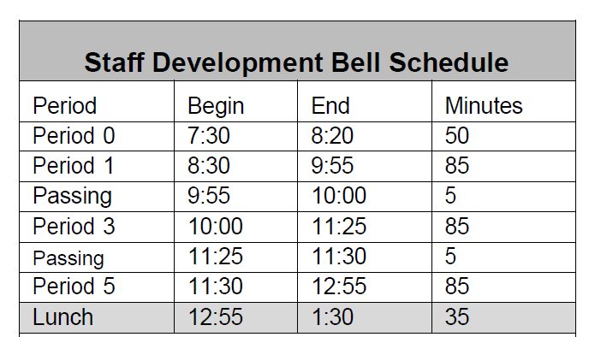

**Seniors -** Attached is a Request for Transcript form.  This form needs to be completed prior to June 14th. Once final grades have posted in June, I will mail your transcript to the schools you request on the attached form. Please complete the form and turn it in to the office. The form is also available in the office. Please note – my last day of work for the summer is June 14th. If you have any questions, please ask.

**Seniors –**Graduation Welcome and Senior speech Try-Outs are May 1st and 2nd. Sign up in the office with Mrs. Gutierrez.

**Seniors** – **Senior Sunset** is May 31st at 7:30pm in the Arbor.

**Seniors -Graduation practice** – June 1st at 8am at the LJ Williams Theater.

**Finals Schedule Attached – please see front office if you have any questions.**

**Prom Tickets on Sale in the Finance Office –** Prom is May 13th, 8pm-11pm at the Visalia Convention Center. Tickets are $40 with an ASB sticker, $50 w/o ASB and $75 at the door. Tickets can be purchased from 1pm-4pm in the Finance office.

**Horticulture Pizza Sales -** Pizza sales Friday during lunch. $2 per slice. Cash only.

**Parents –** The district has made COVID test kits available to families. Contact the office if you ae in need of a COVID test kit. FREE to VUSD families.

**YEARBOOKS are on sale in the office from 1pm-4pm. Forms are available in the office.**

**Spring Price: $65** **Until Sold Out!**

**10th -12th grade students will be prevented from going off campus based on academics.**   Student will not be allowed to leave campus if they have any of the following combinations.  We are only using PowerSchool as an indicator of their grades. **Two or more Fs; One F and any Ds; 3 Ds.**

**Students Late From Lunch –** If you are tardy returning to school following lunch, your ID will be taken and you will lose your off campus lunch privileges for 5 days.

**Students late on Friday –** If students are late to school on Friday, they will be assigned lunch detention.

**Third party food deliveries** will NOT be accepted in the office (parent lunch drop-off ok). Students must meet third party deliveries during lunch only in front of the school. Any deliveries before or after lunch will not be accepted. Thank you –

**Students** – Friendly reminder that the front parking lot is for staff and visitors only. There is student parking in the lot north of the office. Thank you –

**FFA Calendar** link: <https://bit.ly/VTECFFACalendar22-23>

**Seniors –**

**Seniors -** Attached is a Request for Transcript form.  This form needs to be completed prior to June 14th. Once final grades have posted in June, I will mail your transcript to the schools you request on the attached form. Please complete the form and turn it in to the office. The form is also available in the office. Please note – my last day of work for the summer is June 14th. If you have any questions, please ask.

**Scholarships ~**

**Check out the Class of 2023 Schoology Page –**

**OR See Mrs. Lalanne in the Office**

**Link to a VTEC Google Scholarship Spreadsheet is available on the 2023 Schoology page. The spreadsheet identifies scholarships that have due dates each month.  The spreadsheet will be updated as we become aware of different scholarships so make sure you check it frequently.  If you have any questions or need assistance in completing applications, please do not hesitate to come see Mrs. Lalanne.

**Scholarship Foundation –** Like and Follow us on Facebook: [VTEC Scholarship Foundation | Visalia CA | Facebook](https://protect-us.mimecast.com/s/G95ZC82DvnCOW66NSnn3l7?domain=facebook.com)

Meeting dates ~

Thursday, May 11th at 6pm